Sample Paper – 2009
Class – X
Subject – Information Technology

Max marks:- 40 Time:- 2 hours

1. a) What is the primary goal of DBMS? (1)
b) What is the default setting of text data type? (1)
c) Define data validation. (1)
d) Mention the field types for which ‘default value’ property is not applicable. (1)
e) What do you understand by forms? Do you think they are required? Why? (2)
f) When is Auto number data type preferred over number data type? Explain
with an example. (2)
g) What do you mean by look up value? How is it useful for MS Access users? (2)

2. a) What do you mean by ISP? (1)
b) Write the names of two web browsers with the companies to which they belong to. (1)
c) What do you mean by web address? Give an example. (1)
d) When is an email address mentioned in the cc field? (1)
c) Explain any 2 disadvantages of using emails. (2)
d) What are the roles of the following options in the web browser?
a) Forward b) Refresh/ Reload (2)
e) Differentiate between web page and web site. (2)

3. a) What is the significance of title tag? (1)
b) What is the purpose of <body> tag in a HTML code? (1)
c) Why do we insert comments in a HTML document even if it is not
displayed in the web page? (1)
d) What are the values present in the type attribute used in lists? (1)
e) Write the expansion of the following tags used in html:-
a) <em> b) <kbd> c) <i> d) <hr> (2)
f) Write the code to insert an image “picture.gif” on the web page and
align it to centerAlso add a comment if the image is not inserted. (2)
g) What is the purpose of type and start attributes in lists? (2)
h) What is the purpose of name and # attributes of <A> tag? (2)

4. Write the complete html code to generate a page in the format and style given below:-

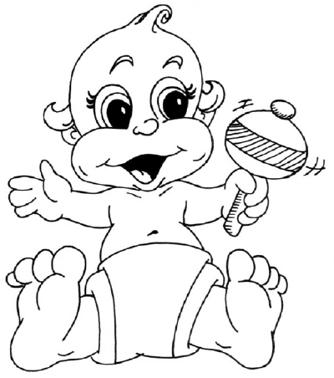
KIDS LEARNING ZONE

COME! ENJOY YOURSELVES

- Home
- Activities
- Kids Club
o See a story
o Send a story

Contact us for all enquiries

- Title of the page is “website for kids”
- The headings should be center aligned of levels 1 and 3 respectively in purpl

- e font color of face “TREBUCHET”
- Background color is pink
- Link color is blue, active link red and visited link green
- Image used is “baby.gif”
- The pages are linked as follows:-

Home as home.html
Activities as act.html
See a story as see.html
Send a story as send.html
Email link to kidsclub@abc.com

Note:- You can use any other attributes that are not mentioned above to produce a similar output

___________________________

Paper Submitted by:
Mrs.Srividya
Email vidyasmani@gmail.com
Phone No. 09947789932

