Guess Paper – 2009
Class – XII
Subject – INFORMATICS PRACTICES

General Instructions
- The question paper is divided into three sections.
- Section – A consists 30 marks. 3. Section – B and Section – C are of 20 marks each.
3. Answer the questions after carefully reading the text with serial no.

Section – A

- Answer the following questions :
- What do you understand by the term SDLC ? Name its essential components? 2
- Define: MySQL, Tomcat. 2
- Explain the concept of object-oriented modeling.? Why do we use UML? 2
- What is a Financial Accounting system? Name any two entities or tables that could be a part of this system? 2
(e) Define weak & strong entities? Identify the weak & strong entities in given entities by drawing a ER diagram?
SUPPLIER & PRODUCT 2

2. Answer the following questions in the references of Visual Basic:
(a) “Visual Basic is not an Object Oriented Language” Justify this statement. 2
(b) Explain the term ADO.? How is it useful as a database access technology? 2
(c) How can you convert existing forms to child forms of an MDI application? What is the significance of Windows menu option in an MDI application? 2
(d) What is the difference between actual parameter and formal parameter? What is the significance of passing parameters by Value and by Reference? 2

(e) What is Iteration or conditional control statements ? Name two statements which provide iteration and conditional control in Visual Basic.? 2

3. Answer the following questions in the references of Oracle :
(a) Explain the LIKE operator of SQL, specifying its syntax and usage. 2
(b) What are pl/sql exceptions? Name two predefined exception? 2
(c). Differentiate between trigger and stored procedures in PL/SQL? 2
(d) What are Cursor attributes? What do these attributes evaluate to when associated with IMPLICIT and EXPLICIT cursors? Write a PL/SQL block to find the factors of a number entered by user. 4

Section – B
(VISUAL BASIC)
4. Read the following case study and answer the questions that follow:
Home Decor Furnishing is a company that manufactures and sells various furnishing items in three qualities (Economy, Business and Elite) and three sizes (Kids, Adults and Giants). The cost of each furnishing item is calculated on basis of a Base Cost, which is the cost of the item in Business quality and Adults size. The cost is changed by – 10% and +20% in case of Economy and Elite quality respectively. Similarly the cost is changed by –5% and +15% in case of Kids and Giants sizes respectively. The interface for gathering users choice is as given below :

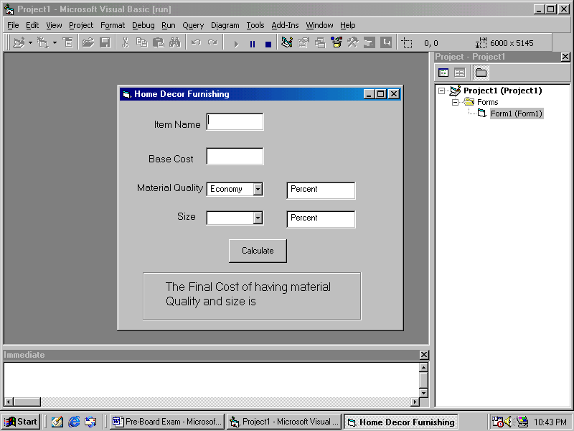
Add the following functionality to the interface:
- The combo box cmbquality must contain economic, Business and Luxury when the form loads in the memory and focus on text box txtitem. 2
- The combo boxes cmbquality and cmbsize should respectively be set to default values of Economy and Adults initially. 2
- When a user chooses a choice other than the default choices, the labels lblchangeforquality and lblchangeforsize should display the message.
‘Percent Increase / Decreases in cost ..% according to the logic explained above. 3
- When user clicks the Calculate button the final message should be displayed in the label lblyourchoice as indicated in the form image. 3

- Read the following text and answer the questions that follow:
- A student of ABCD School, Davis Mathews wanted an application to find Even or Odd out of a given number. He had written the following code snippet and he is unable to correct some of the errors in the code. You are requested to help him in correcting the code segment. Find the errors and rewrite the corrected code underlining the correction made. 2
Dim n as integer
N = val(txtnumber)
If n mod 2 = 0
Msgbox “It is an Even”
Else
Msgbox “it is an odd”
Endif
(b) What is the output of the following programs: 2
Dim i as integer, num as integer
For i = -10 to 5 step 3
If i mod 2 = 0 then
Num = num + i
End if
Print num
Next
(c). Write a Visual Basic procedure to print Fibonacci Series. No of elements in the series should be up to the number given as parameter into the procedure.
The Fibonacci series is as follows 0,1 ,1,2,3,5,8, ….. 4
(d) Write the output that the following code segment: 2
First = "Education"
Second = "cat"
PRINT First + "@"+ Second
PRINT INSTR(First, Second)
PRINT Mid(LCASE(First),4,3)
PRINT INT(18.2)+LEN(Second)

Section – C
(ORACLE SECTION)
- Read the questions given below and answer accordingly :
- Write the output produced by the following part of code in PL/SQL : 2
DECLARE
Y NUMBER;
X NUMBER;
BEGIN
Y:=2;
FOR X IN 1..5
LOOP
Y:=X+(Y*2);
DBMS_OUTPUT.PUT_LINE(Y);
END LOOP;
END;

- Find the error(s), if any, in the following code : 2
DECLARE
v_empno NUMBER[4];
v_empname VARCHAR2(20);
begin BOOLEAN :=’True’
START
SELECT empno,ename,salary
into v_empno,v_ename
FROM emp
FOR empno = 1234 and 2345
END

(c). Which is a Protocol? What is the difference between TCP and IP protocol? 2

(d). Write a PLSQL procedure to check whether square root of a number is prime or not? 4

7. Answer the following questions based on the following Employee Table :
Column Name | Data Type | Constraint
ID | Number(4) | Primary Key
First_Name | Varchar2(30) | Not null
Last_Name | Varchar2(30) | Not null
Email_ID | Varcharr2(10)
Salary | Number(9,2) | More than 6500
DOB | Date

- Write the SQL command to create the table Hostel including its constraints. 2
- Write the SQL command to display the details of all the employees whose birth date is after 17th May 2008 salary wise. 2
- Write a PL/SQL code to display first name, email_id of the all employees where birth date is before 24 Mar 2009. 3
(d) Create a Trigger CNGTRIG1 to change Salary to 50,000 every time the Salary entered by the user exceeds 30,000. An appropriate message should also be displayed. 3

Best of Luck for Board Exams

Paper Submitted by:
Mohd Hashim
Email hashim.mca05@gmail.com
Phone No. 9950589919

