Guess Paper – 2009
Class – X
Subject – Mathematics

SECTION-A

- Pie is a/an ___________________ number.
- If sum and product of reciprocals of zeroes of a quadratic polynomial is 2 and 1 respectively then what are the two zeroes taken?
- What is the other name of quadratic formula?
- What is left after subtracting sum of terms and the last term of an A.P?(subtraction in formula)
- Prove the following identity:
(1 + tanAtanB )² + ( tanA – tanB )² = sec²Asec²B
- How is sine complementary to cosecant?
- L and M are the mid points of AB and BC respectively of $Δ\text{ABC}$, right angled at B prove
that $4{\text{LC}}^{2}={\text{AB}}^{2}+4{\text{BC}}^{2}$
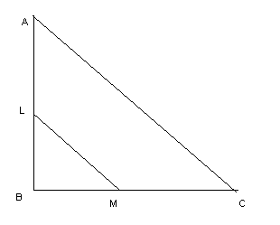
- If the points ( a, 0 ), ( 0, b ) and ( x, y ) are collinear, then prove that
x + y = 1
a b

- What is the mode of first n natural numbers?
- In fig. l and m are two parallel tangents at A and B. The tangent at C makes an intercept DE between l and m. Prove that LDFE = 90⁰.
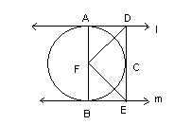

SECTION-B

- In fig. a circle touches all the four sides of a quadrilateral ABCD whose sides are AB = 6cm, BC = 7cm and CD = 4cm. Find AD.
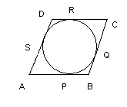
- In fig ABC is a right triangle, right angled at B. Medians AD and CE are of respective lengths 5cm and2√5 cm .Find the length of AC.
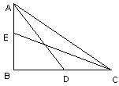
- DEFG is a square and ∟BAC is right angle. Prove that DE²=BD.EC
A
B
C
D
E
F
G

- From fig, find the length of AC, if AB ┴ BD and CD ┴ BD.

C

A 11cm

      - 6cm

B 12 cm D

- The prime factorization of 2310 is 2 x 3 x a x 7 x b. Find a and b.

SECTION-C

- Prove that (1+ cot θ - cosec θ) (1+ tan θ + sec θ) = 2
OR
((1+ cot θ + tan θ) (sin θ - cos θ)) / (sec ³ θ – cosec ³ θ) = sin ² θ. cos ² θ
- . If k is the ratio of the zeros of the polynomial x² – px + q, prove that
k² + 1 = p² – 2q
k q

- Water flows @ 10mt. per minute through a cylindrical pipe 5 mm in diameter. How long would it take to fell in a conical vessel whose diameter at the base is 40cm 24cm?
- If the mth term of an A.P. is 1/n and the nth term is 1/m, show that the sum of mn terms is ½(nm + 1).
- A polygon has 10 sides .The lengths of the sides starting with the smallest form an AP .If the perimeter of the polygon is 420 Cm and the length of the longest side is twice that of the shortest side .Find the first term and the common difference of the AP
OR

If m times the m^{th} term of an A.P. is equal to n times the n^{th} term, show that the (m+n)^{th} terms of an A.P is zero.
- A party of tourists booked a room in a hotel for Rs 1200 , three of the members failed to pay as a result others had to pay Rs 20 more (each) . How many tourists were there in the party.
- A regular hexagon is circumscribed by a circle of radius 14 Cm .Find the area of the shaded region
- Prove that no number of the type $4k+2$ be perfect square
- Construct a cyclic quadrilateral ABCD AB = 3cm, BC = 6cm, CA = 4cm and AD = 2cm. Also construct a quadrilateral similar to ABCD whose sides are 1.5 times corresponding sides of ABCD.
- In fig, S and T trisect the side QR of a right triangle PQR. Prove that
8 PT² = 3 PR² + 5 PS²
P

Q S T R

Paper Submitted by:
MEHUL JAIN
Email mehuljain3@in.com
Phone No. 9490086570

