Guess Paper – 2009
Class – XII
Subject – Informatics Practices

Time: - 3 hrs M.M. - 70

The question paper consists of three parts. SEC- A ,SEC- B and SEC- C

[SEC-A]

/* BUSINESS COMPUTING */ [2* 5=10]

1. Differentiate between conceptual view and internal view?

2. Explain the following terms:
i. MYSQL and PHP ii. Python and Tomcat

iii. W3C and FSF iv. MoZilla and FLOSS

3. Explain the term Feasibility study, MIS, DFD and System Testing Using Suitable examples.

4. Explain the terms Software, Hardware and Firmware using suitable example.

5. What does Object Oriented Modeling Technique mean? Why do we use UML?

[SEC-B]
[Visual Basic Part]
[2*5 =10]

6. (a) Differentiate using a suitable example, between MsgBox () and InputBox () functions in Visual Basic.

(b) What is ADO data control? To whom you can connect this?

(c) What do you understand by the term Record Source of an ADO data control?

(d) What are modules? What types of modules are supported in VB? Give example to support your answer.

(e) Distinguish between call by Val and call by Reference in visual basic.
[2*5 =10]

7. (a) Rewrite the corrected code after removing syntax errors from the following VB Code:

DIMENSION Total AS INT
Total=30.0
DO WHILE Total>=20
Total=Total-5
End Do
PRINT Total

(b) What you know about Mid statement? How is it differ from Mid ( ) function?

(c) Rewrite the following code using FOR..NEXT without effecting the output:

Dim Num As Integer
Num = 1
DO WHILE Num <= 5
Num = Num + 1
PRINT num ;
LOOP

(d) Write the following code segment using FOR… LOOP without effecting the output of the code
Num=6
Temp=Num
DO WHILE Num>=1
Temp=Temp-1
IF Temp MOD 2 = 0 THEN
PRINT Temp," is Even"
ELSE
PRINT Temp," is Odd"
END IF
Num=Num-2
LOOP

(e) Write the output that the following code segment:
Msg = "Technology"
PRINT MID(LTRIM(Msg),1,4)+ " and " +" Kids"
PRINT (3 > 8 * 2) AND (3 ^ 2 < 10)
PRINT VAL("100 Ways") + LEN(Msg)
PRINT INSTR(Msg,"log")

- Read the following case study and answer the questions that follow. [10]
The FOR U SHOP has computerized its billing. A new bill is generated for each customer.The sho allows three different payment modes. The discount rate is based on the payment mode. The following is the data entry screen used to generate the bill:

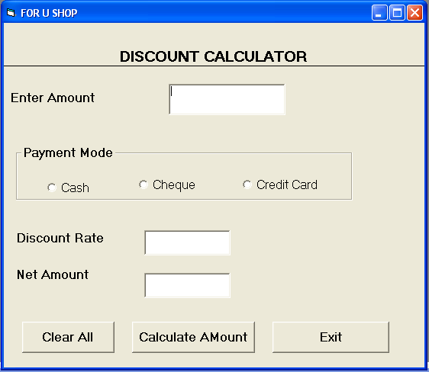

Object Type | Object Name | Description
Form | frmDiscount | The main form
Text Box | TxtAmt | To input total Shopping Amount
Text Box | TxtDisc | To display Discount Rate
Text Box | TxtNet | To display Net Price
Option Buttons | Optcash | To select mode of payment as cash
Option Buttons | Optcheque | To select mode of payment as cheque
Option Buttons | OptCredit | To select mode of payment as credit card
Command Buttons | Cmdcalc | To calculate discount and Net amount
Command Buttons | Cmdclear | To clear all textboxes
Command Buttons | Cmdexit | To exit from the application

(a) Write the code for the CmdClear command button to clear all the textboxes.

(b) Write the code for the form load event of FrmDiscount so as to
(i) Disable the TxtDisc and the Txtnet textboxes and set default choice in the option button as cash.
(ii) Set the focus to the textbox.

(c) Write the code for the change event of the TxtAmt textbox to ensure that the user does not enter a negative or zero value. If a negative or zero value is entered then the textbox should be made blank and warning message should be displayed.

(d) Write the code for code for Cmdexit to display the message “APPLICATION IS SHUTING DOWN” and exit from the application.

(e) Write the code for the CmdCalc command button to display the discount rate and net price in the TxtDisc and TxtNet textboxes respectively. Note that net price is calculated as shopping amount- discount amount. The discount amount is calculated according to the discount rate which is based on the payment mode and total shopping amount to the following table.

Payment Mode | Shopping Amount | Discount Rate
Cash | <10000 | 20%
Cash | >=10000 | 25%
Cheque | <15000 | 10%
Cheque | >=15000 | %15
Credit Card | <10000 | 10%
Credit Card | >=10000 | 12%

[SEC-C]

[Oracle Part] [2*5 =10]

9. (a) Explain the usage of %TYPE and %ROWTYPE attribute in variable declaration in a PL/SQL block within the help of an example.

(b) How do we restrict duplicate rows in SELECT Query? Give example.

(c) What are the guidelines to declare the variables?

(d) Explain the usage of bind variable in PL/SQL with help of an example.

(e) What is looping statement? Differentiate between an entry control and an exit control loop.

[2*5 =10]

10. (a) Write the output produced by the following part of code in PL/SQL:
DECLARE
P NUMBER;
Q NUMBER;
BEGIN
P := 5;
FOR Q IN 1..4
LOOP
P := P + Q;
DBMS_OUTPUT.PUT_LINE(P);
END LOOP;
END;

(b) Write the output produced by the following part of code in PL/SQL

BEGIN
FOR I IN REVERSE 1..10
LOOP
IF MOD(I, 2) = 0 THEN
DBMS_OUTPUT.PUT_LINE(TO_CHAR(I*10));
END IF;
END LOOP;
END;

Identify the type of relationship represented by the following statement and drawn an entity relationship diagram to show it.

“Each garment must have one and only one price.Each price may be for one or more garments.”

(d) (i) Find Error in the following code, underline errors and rewrite the correct code.
DECLARE
NUMBER Total ;
BEGIN;
Total:=30;
LOOP
Total:=total***3;
DBMS_OUTPUT.PUT_LINE(total);
EXIT WHEN total>2000;
ENDLOOP;
END;

(ii) Rewrite the following PL/SQL loop so that you do not use loop at all.
FOR I IN 1..2 LOOP
IF I=1 THEN
Calc_bonus(p_id,200000);
ELSIF I=2 THEN
Calc_bonus(c_id,500000);
END IF;
END LOOP;

(e) Write the SQL Command to create the above table including its Constraints.

Column Name | Data Type | Size | Constraint
Cust_id  Custname  Permanent_address  Postall_address  Tot_purchase_cost | Number  Varchar2  Varchar2  Varchar2  number | 7  30  20  20  7,2 | Primary key  Not null  Not less than 2000

[2*5 =10]

11. (a) Write a PL/SQL cursor to replace by adding ‘Mr’ if gender is ‘M’ otherwise ‘Mrs’
to the existing E_Name.

(b) Write a PL/SQL procedure to display the monthly of teacher no-T13 after calculating DA as 45%
and deduct PF as 15%, Monthly Salary is:( SAL+DA+HRA).the procedure will procedure
will receive TNO as will receive TNO as will receive TNO as IN parameter and monthly
salary will as OUT parameter.

(c) Write a trigger to avoid data entry for emp table having e_name=’Manpreet Singh’.

(d) Write PL/SQL script obtain an empno from user.If his/her salary is < 2000/-then
Delete that Record from emptable.

(e) Write a pl/sql function Myproduct which will aceept two arguments of number type and
return to product of both values.

JAWAHAR NAVODAYA VIDYALAYA SAMITI
BHOPAL REASON

^{BEST OF LUCK}
SUNIL S. MAHALIK PGT (COMP.SC)
Email (sunil.mahalik @gmail.com) JNV
CUTTACK (ORISSA)

