Guess Paper – 2009
Class – X
Subject - Mathematics

General Instructions:-
- All Questions are compulsory.

- The question paper consist thirty questions divided into 4 sections A, B, C and D. Section A comprises of ten questions of 1 mark each, Section B comprises of five questions of 2 marks each, Sections C comprises ten question of 3 marks each and Section D comprises of five questions of 6 marks each.

- All questions of Section A are to be answered in one word, one sentence or as per the exact requirement of the question.

- There is no overall choice. However, internal choice has been provided in one question of 2 marks each, three questions of 3 marks each and two questions of 6 marks each. You have to attempt only one of the alternatives in all such questions.

- In question on construction, drawing should be neat and exactly as per given measurements.
- Use of calculators is not permitted.

SECTION – A

1 Write the rational number 5/6in decimal form.

2 State the fundamental theorem of Arithmetic.

3 Find the value of “k” for which the system of equation a unique solution:-
x – ky = 2 , 3x + 2y = -5

4 From a point P the length of tangent to a circle is 15cm and distance of P from the centre of the circle is 17cm. Then what is the radius of the circle?

5 If the mean is 26 and median is 27 then what is mode?

6 Which term of the AP: 84, 80, 76,………… is zero?

7 If a dice is thrown once , what is the probability of getting an “ace”?

8 If the diameter of a semicircle is 14cm, find its perimeter. (use ∏ = 22/7)

9 Evaluate:- 9 tan² A – 9 sec² A

- Find the no. of zeroes:-

SECTION – B

11 ABC is an isosceles triangle right angled at B. Two equilateral triangles are constructed with side BC and AC as shown in Fig. 1.
Prove that area of ∆ BCD = ½ area of ∆ ACE.
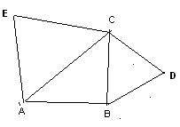

12 Evaluate: (cos² 25° + cos² 65°) + cosec θ sec (90° – θ ) – cot θ tan (90° – θ)
OR
Prove that (1 + cot θ – cosec θ)(1 + tan θ + sec θ) = 2

13 Find the 10th term from the last of the A.P. 4,9,14,……………254.

14 Find the probability that a number selected at random from the numbers 1, 2, 3,……..35 is a (i) prime number (ii) multiple of 4

15 Find the mean of the following:-

Class  Interval | 0-10 | 10-20 | 20-30 | 30-40 | 40-50
Frequency | 12 | 11 | 8 | 10 | 9

SECTION – C

16 Prove that 5+$\sqrt{3}$ is an irrational number.

17 In fig, a circle touches the side BC of ∆ ABC at P and touches AB and AC produced at Q and R respectively. Prove that AQ = ½ the perimeter of ∆ ABC

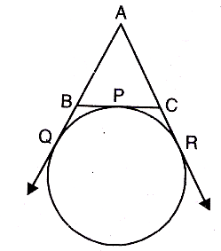
18 If in an A.P. the sum of m terms is n and the sum of n terms is m , prove that the sum of its (m+n) terms is –(m+n).

19 In Fig. ABC is a right angle triangle, right angle at A. Semicircles are drawn on AB and AC and BC as diameters. Find the area of the shaded portion.
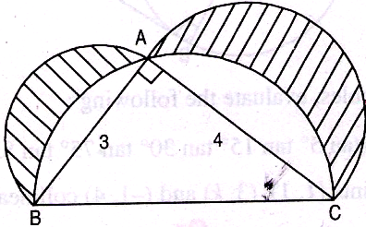

20 Prove that an equilateral triangle described on the two sides of an right angled triangle are together equal to the equilateral triangle on the hypotenuse in terms of their areas.

21 The line joining of the points (2, 1) and (5, - 8) is trisected at the points P and Q. If point P lies on the line 2x – y + k = 0, find the value of k.

22 If A (-5, 7), B (-4, -5), C (- 1, 6) and D (4, 5) are the vertices of a quadrilateral ABCD. Find the area of quadrilateral ABCD.

23 Construct a triangle ABC with BC = 4.2 cm, ∠B = 45° and altitude through A is 2.5 cm. Draw another triangle similar to this triangle with scale factor ½.

24 Which term of the AP 5, 9, 13,……………… is 81? Also find the sum of the A.P.
.

25 A toy is in the form of a cone mounted on a hemisphere of common base radius 7cm. The total height of the toy is 31cm. Find the T.S.A. of the toy.

SECTION – D

26 Prove that in a right angled triangle the square of the hypotenuse is equal to the sum of the squares of the other two sides. Using this result prove that if from the vertex A of a ∆ABC intersects BC at D such that DB=3CD ,prove that 2AB² = 2AC² + BC²

27 A hemispherical bowl of 30cm contains some liquid. This liquid is to be filled into cylindrical shaped bottles each of diameter 5cm and height 6cm. Find the number of bottles necessary to empty the bowl.

28 The angle of elevation of a tower from two points P and Q at a distance of “a” and “b” respectively from the base and in the same straight line with it are complementary. Prove that the height of the tower is $\sqrt{\text{ab}}$.

29 Solve the following system of linear equations graphically; x – y = 1 , 2x + y = 8
Also shade the area bounded by these two lines and the Y axis.

- The mean of the following distribution is 25. Determine the value of P

Class  Interval | 0-10 | 10-20 | 20-30 | 30-40 | 40-50
Frequency | 5 | 18 | 15 | P | 6

Submitted by: Mr.Kamlesh Sharma[M.Sc.(Maths)]
S.S.D. Public School,Hathras
gauradon@gmail.com
Phone No. 9259542645

