Sample Paper – 2009
Class – X
Subject – Mathematics

Max. Marks: 100 Time: 3Hrs

I. Answer the following. 10 x 1M= 10 M

- Find the circumcentre of the triangle whose vertices are (0,0), (6,0) and (0,6).
- The length of tangent of a circle from a point P which is 13 cm away from the centre is 5cm. Then find the radius of the circle.
- Form a quadratic equation; “Sum of squares of 2 consecutive numbers is equal to square of 3rd number”.
- Find the centroid of the triangle whose vertices are (3, 6), (-2, -4) and (-1,-2).
- Write the inconsistency condition for the system of linear equations in 2 variables.
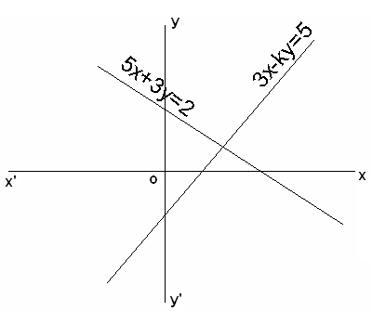
- If the volumes of a cylinder and a cone of equal base are equal then find the ratio between their heights.
- Find the value of K in the figure. (By Suhruth)
- Find the roots of quadratic equation whose factors are (2x- p), (3x+ q).
- Write the general form of the prime factorization of the denominator of a rational number whose decimal expression is a terminating decimal.
- If the radii of 2 spheres are in the ratio 1:2 then find the ratio of their volumes.

II Answer the following. 10 x 2 M = 20 M
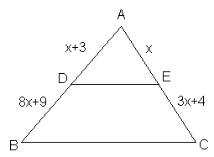
- Solve for x, y; 7x-15y=2; x+2y =3.
- For what value of ‘K’ given quadratic equation have 2 equal roots 2x²+kx+3=0.
- Find ‘x’, if DE // BC.
- Prove that √5 is an irrational.
- Find the value of K if the points (7, -2), (5, 1), (3, k) are collinear.
- Draw 2 concentric circles with 3cm and 5cm radius respectively. Take a point P which is 10cm away from the center draw 2 tangents to each circle from that point.
- If the triangle ABC is an acute angled triangle. If AB =6cm, BC= 8cm and AC= 5cm and AD is altitude to BC. Find the length of BD.
- ABC is any scalene triangle. AD is the internal angular bisector and AE is external angular bisector then show that AD² + AE² = DE²
- Divide 57 into 2 parts whose product is 782.
- A cylindrical tube of radius 12cm contains water to a depth of 20cm. a spherical iron ball is dropped into the tube and thus the level of water is raised by 6.75cm. What is the radius of the iron ball?

III Answer the following. 10 x 4 M = 40 M

- The diagonals of a quadrilateral ABCD intersect each other at ‘O’ such that AO/BO = CO/DO. Show that ABCD is trapezium.
- A triangle ABC is drawn to circumscribe a circle of radius 4cm such that the segments BD and DC into which BC is divided by the point if contact D are of lengths 8cm and 6cm respectively. Find the sides AB and AC.
- A cylindrical bucket 32cm high and with base radius 18cm is filled with sand. This bucket is emptied on the ground then a conical heap of sand is formed. If the height of the conical heap is 24cm. Find the radius and slant height of the heap.
- Draw a triangle ABC with sides BC=6cm AB=5cm and Angle ABC =60. Then construct a triangle whose sides are 3/4th of corresponding sides of ABC.
- Find the HCF of 96 and 404 by the prime factorization method. Hence find their LCM.
- Solve (x+1) (x+2) (x-5) (x-6)-144=0.
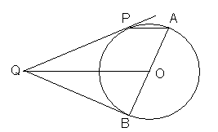
- Solve graphically 2x+y-6=0, 2x-y+2=0. And find the area of the region bounded by these 2 lines and x-axis.
- In triangle ABC A(5,6), B(2,2) and C(5,0) are vertices and AD is angular bisector. Then find the co-ordinates of point D. (OR)
The line joining the points (2,1) and (5,-8) is trisected at the points P and Q. If the point P lies on the line 2x-y+k=0. Find ‘k’.
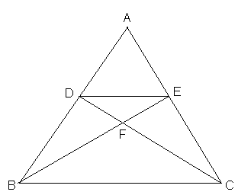
- PQ is a tangent to a circle with centre O at the point P. OQ // AP where AP is a chord through A, the end point of diameter AB. Prove that BQ is tangent at B.
- In the figure DE // BC and AD: DB = 5:4 then
find area of DEF / area of CFB.

IV Answer the following. 5 x 6M = 30 M

- “In right triangle, the square of hypotenuse is equal to the sum of squares of other 2 sides”. Prove the converse of this with statement.
(b).In an equilateral triangle, prove that 3 times the square of one side is equal to 4times the square of its altitudes.
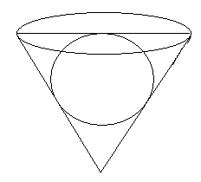
- A metallic right circular cone 20cm height and whose vertical angle is 60, is cut into 2 parts at the middle of its height by a plane parallel to its base. If the frustum so obtained drawn into a wire of diameter 1/16 cm, find the length of the wire. (OR)
A conical vessel of radius 6cm and height 8cm is completely filled with water. A sphere is lowered into water and its size is such that when it touches the sides, it is just immersed as shown in the figure. Then find the fraction of water overflows.
- Roohi travels 300km to her home partly by train and partly by bus. She takes 4 hours if she travels 60km by train and rest by bus. If she travels 100km by train and rest by bus she takes 10 minutes longer. Find the speed of the train and bus separately.
- A swimming pool is filled with 3 pipes of uniform flow. The first 2 pipes operating simultaneously fill the pool in the same time as the time taken by the 3rd pipe alone to fill the pool. The second pipe fills the pool 5hrs faster than 1st pipe and 4hrs slower than 3rd pipe. Find the time required by each pipe to fill the pool individually.

- Prove that “the tangents drawn from the external point to the circle are equal in length”.
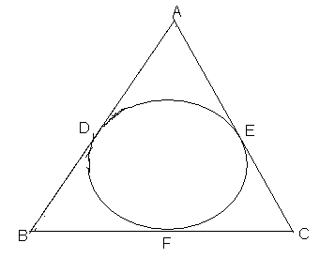
(b) Prove that AB-BF = AC- CF.

Paper Submitted by:
Hara Gopal
Email:- haragopal_r@yahoo.co.in
Phone No. +919885911608

Success is no where if you don’t have confidence
If you believe yourself Success is now here

