Guess Paper – 2009
Class – X
Subject –MATHEMATICS

TIME: 03 HOURS MAX.MARKS: 80

GENERAL INSTRUCTIONS:-
1. All questions are compulsory.
2. The question paper consists of thirty questions divided into 4 sections A, B, C and D. Section A comprises of 10 questions of 01 mark each. Section B comprises of 05 questions of 02 marks each, Section C comprises of 10 questions of 03 marks each and Section D comprises of 05 questions of 06 marks each.
3.There is no overall choice. However, internal choice has been provided in one question of Sec: B, three questions of Sec: C and two questions of Sec: D. You have to attempt only one of the alternatives in all such questions.
4.In question on construction, drawing should be neat and exactly as per the given measurements.
5 Use of calculators is not permitted.

SECTION: A
1.Find the HCF of 128 and 200 using fundamental theorem of Arithmetic.
2.Express cot85⁰⁺cos75⁰ in terms of trigonometric ratios of angle between 0 and 45⁰
3. In fig O is the centre of a circle. The length of the arc APB is 2/15 of the circumference of the circle. Find the central angle x.

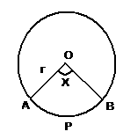

4. The probability that “Delhi Devils” win the IPL tournament is 0.68. Find the probability of not winning the game by “Delhi Devils”.
5. If the mean of 10 observations is 28. One observation of value 19 is removed, what is the new mean?
6. If the decimal expansion of a rational number is 20.725, what are the prime factors of the denominator of the number?
7. ABC is an isosceles triangle right angled at C prove that AB²=2AC²
8. If (-1) is zero of the polynomial x³-2k=0 Find k.
9. Find the number of terms in the following A.P.
7, 20, 33,……..,657
10. In fig.
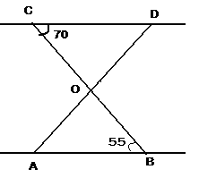

SECTION: B
11. From 52 playing cards, Jack, queen and king of club are removed. From the remaining cards, one card is drawn at random. What is the probability of getting (a) Queen (b) a club (c) a black king
12. In what ratio does the line 4x+y=11 divide the line Segment joining the points (1.3) and (2, 7). (OR)
Find the value of k for which the points (-3, 12),(7,6) and (k,9) are collinear.
13. In fig OP is equal to diameter of the circle, prove that
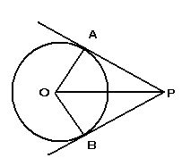
∆ABP is an equilateral triangle.

14. If the product of zeroes of a polynomial ax²-6x-6 is 4, find
the value of a.
15. Evaluate the following: Tan7⁰tan23⁰ tan60⁰ tan67⁰ tan83⁰+ cot54⁰cot36⁰+
sin20⁰sec70⁰-2
SECTION: C
16.

17. Solve for x
18. Use Euclid’s division lemma to show that the cube of any
positive integer is of the form 9x or 9x+1 or 9x+8
19. If the sum of first 7 terms of an A,P is 49 and that of 17 terms is 289. Find the sum of first n terms.
20. Prove that 2+√11 is an Irrational.
21.Prove that the ratio of the corresponding altitudes of two
similar triangles is equal to the ratio of their corresponding
sides. (OR)
In an equilateral triangle prove that three times the square on one side is equal to four times the square of its altitude.
22. Draw a ∆ABC with side BC=6cm, AB=5cm and ABC=60⁰ Construct a ∆ AB’C’ similar to ∆ABC such that sides of ∆AB’C’ are ¾ of the corresponding sides of ∆ABC
23 The area of an equilateral ∆ABC is 17320.5cm². With each vertex of the ∆ as centre, a circle is drawn with radius equal to half the length of the circle of the side of the ∆. Find the area of the ∆ not covered by circles. (Use ∏=3.14 and √3=1.73205)
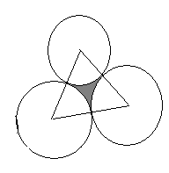

(OR)

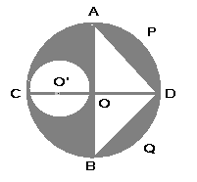
In fig, O is the centre of a circle with radius 14cm. AOB and COD are two perpendicular diameters of the circle. O’ is the centre of the circle of diameter CO. Find the area if the shaded region.

24. Using distance formula, show that (3, 3) is the Centre of the circle passing through the points (6, 2), (0,4) and (4,6). Find its radius also.
25. For area of ∆ABC with vertices A(4,-6),B(3,-2) and C (5, 2) verify that median of the triangle divides it in to two triangles of equal areas.
SECTION: D
26. A metallic right circular cone 20cm high and whose vertical angle is 60⁰ is cut into two parts at the middle of its height by a plane parallel to its base. If the frustum so obtained be drawn into a wire of diameter 1/16 cm, find the length of the wire. (OR)
A bucket of height 8cm and made up of copper sheets in the form of frustum of a right circular cone with radii of its lower and upper ends as 3cm and 9cm respectively. Calculate
(i) the height of the cone of which the bucket is a part,
(ii) the volume of water which can be filled in the bucket,
(iii) the area of copper sheet required to make the bucket (leave the answer in terms of ∏.
27. From the top and foot of a tower 40m high, the angles of elevation of the top of a light house is found to be 30⁰ and 60⁰ respectively. Find the height of the lighthouse. Also find the distance of the top of the lighthouse from the foot of the tower.
28. Find the missing frequencies f₁ & f₂ in the following table if the mean of the distribution is 53.
Age | 0-20 | 20-40 | 40-60 | 60-80 | 80-100 | Total
No. of persons | 15 | f₁ | 21 | f₂ | 17 | 100

29. If a line is drawn parallel to one side of a triangle, the other two sides are divided in the same ratio. Prove it. Use this result to prove the following: In f fig, if ABCD is a trapezium in which AB║DC║EF, then
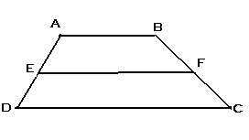

(OR)
Prove that the lengths of the two tangents drawn from an external point to a circle are equal. Using this result, do the following. In the fig, a circle is inscribed in a quadrilateral ABCD in which B=90⁰. If AD=23cm, AB=29cm and DS=5cm, find the radius of the circle.
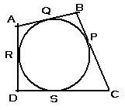

30. Solve the following pair of linear equations graphically: 3x+y-12=0, x-3y+6=0. Shade the region bounded by these lines and the x-axis. Also find the ratio of areas of triangles formed by given lines with X-axis and the Y-axis.

Paper Submitted by:
V.KALAVATHI
Email kalavathieswaran@yahoo.in
Phone No. 2482466

