MATHEMATICS
CLASS X
Time allowed: 3 hours Maximum Marks: 100

General Instructions:

- All questions are compulsory.
- The question paper consists of 25 questions divided into three sections —A, B and C. Section A contains 10 questions of 3 marks each. Section B is of 10 questions of 4 marks each and Section C is of 5 questions of 6 marks each.
- There is no overall choice. However, an internal choice has been provided in two questions of three marks each, two questions of four marks each and two questions of six marks each.
- In question on construction, the drawing should be neat and exactly as per the given measurements.
- Use of calculators is not permitted.

SECTION-A

Question numbers 1 to 10 carry 3 marks each.

- If is the HCF of and , then show that .

- Simplify:

- If the difference between the 21st and 10th terms of an AP is 55, find the difference between the 45th and 40th terms.

- Solve:

OR

- A bicycle can be bought for Rs.1808 cash or for Rs.600 cash down payment together with three equal monthly instalments. If the rate of interest charged is 8% per annum, find the amount of each instalment.

- A loan of Rs.26,000 is to be paid back in two equal annual instalments. If the interest is compounded annually at 8% per annum, how much is each instalment?

- In the given figure,. Prove that, .

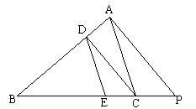

- Two chords of lengths 6 cm and 8 cm lie on the same side of the centre of a circle. If the distance between the chords is 1 cm , find the length of the radius of the circle.

- Solve for x:

- The length of the hypotenuse of a right angled triangle is 10 cm and the sum of the lengths of the other two sides is 14 cm. Find the lengths of these sides.

OR
The sum of two natural numbers is 11 and the sum of their reciprocals is . Find the numbers.

SECTION-B

Question numbers 11 to 20 carry 4 marks each.

- If the first term and last term of an AP are a and l respectively and its sum is S, prove that the common difference of the AP is equal to .

- Construct a quadrilateral ABCD with AB = 5cm, BC = 6.2 cm, CD = 7cm, DA = 4.8 cm and diagonal AC = 8 cm. Construct a quadrilateral with sides ^{th} of the sides of ABCD.

- The marks obtained by 80 students are given below. Find the mean number of marks using the assumed-mean method.

Marks | 31-40 | 41-50 | 51-60 | 61-70 | 71-80 | 81-90 | 91-100
No. of Students | 4 | 5 | 15 | 20 | 18 | 10 | 8

- Determine the vertices of the triangle formed by the straight lines representing the equations:

- Prove that:
OR
Prove that:
- The surface area of a sphere is . Find its volume.
- If the point P(0,2) is equidistant from the points (3,k) and (k,5) then find the value of k.

- The centroid of a triangle is at (4,-5). If two of its vertices are (2,5) and (3,-1), find its third vertex.

OR

If the points A(1,0) , B(a,3) , C(2,b) and D(-2,4) are the vertices of a parallelogram, find the values of a and b.

- Two coins are tossed simultaneously. Find the probability of getting:
- two heads
- one head and one tail
- at least one head
- no head

  - Mohanlal spent his salary on different items as shown in the adjoining pie-chart. If the amount spent on clothing is Rs.900, answer the following:
- What is the total salary of Mohanlal?
- What is the amount spent on entertainment?
- What is the difference in the amount spent on food and education?
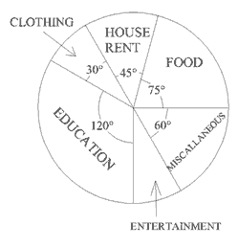
SECTION –C

Question numbers 21 to 25 carry 6 marks each.

- Prove that the angle subtended by an arc at the centre of the circle is double the angle subtended by it at any point on the remaining part of the circle.

Using the above, prove that in the given figure angles BAC and OBC are complementary. O is the centre of the circle and A is a point on the major arc BC .
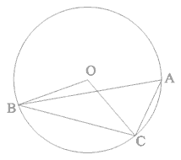

- If two circles touch each other internally or externally, prove that the point of contact lies on the line joining their centres.

Use the above in the following:
A circle is drawn through the centre O of another circle and touching it at A.The chord AB of the larger circle intersects the smaller circle at C. Prove that AC = BC.

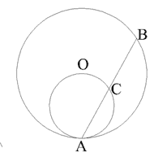
- The angles of elevation of a tower from two points at a distance a and b from the tower on the ground are α and β respectively. Prove that the height of the tower is.

OR

From the top of a cliff of height 100 m, the angles of depression of the top and bottom of a tower are 30⁰ and 45⁰ respectively. Find the height of the tower. (Use =1.732)

- A metallic rod of diameter 1 cm and length 8 cm is drawn into a wire of length 50 cm of uniform thickness. Find the thickness of the wire. Also find the curved surface area of the wire. (Use π = 3.14)
OR

The diameters of the top and bottom of a bucket are 10 cm and 20 cm respectively and its height is 12 cm. Find its capacity and the curved surface area. (Use π = 3.14).

- The annual income of Ajit Singh exclusive of HRA is Rs,2,40,000. He contributes Rs.2,500 per month in his provident fund and pays an annual LIC premium of Rs.8,000. He also donates Rs.12,000 to the Prime Minister’s Relief Fund. He pays an advance tax of Rs.1,000 per month for the previous 11 months. Find the income-tax to be paid by him in the last month.

(a)Rates for income tax are as follows:
Net Annual Income | Tax Rates
- Upto Rs.50,000  - Rs.50,000 to Rs.60,000  - Rs.60,000 to Rs.1,50,000  - Rs.1,50,000 to Rs.8,50,000  - Rs.8,50,000 and above | NIL  10% of the amount exceeding Rs.50,000.  Rs.1000 + 20% of the amount exceeding Rs.60,000.  Rs.19,000 + 30% of the amount exceeding Rs.1,50,000.  Rs,2,29,000 + 30% of the amount exceeding Rs.8,50,00. + Surcharge of 10% of the income tax.
(b) Educational Cess: 2% of the income-tax.

