Guess Paper – 2009
Class – XI
Subject – Physics
(Motion in Straight Line)

1.Two trains A and B of length 600m each are moving on two parallel tracks with a uniform speed of 60km/hr. in same direction with A ahead of B. B accelerates with 1m/s² to overtake A. If after 50sec. the guard of B just brushes past the driver of A, what was the original distance between them?

2. A bomb is dropped from aeroplane when it is at the height of 9000m. Aeroplane is moving with velocity 400 km/hr. Will bomb hit the target at height 9000m from aeroplane?

3. Two balls are thrown simultaneously one vertically upwards with speed of 20m/s from the ground and other vertically downwards from height of 40m with same speed and in same line of motion. At which point will they collide.

4. A train moves from point A to B with speed of 50km/hr and returns back from B to A with speed of 40 km/hr. calculate average speed and average velocity.

5. When two A and B move towards each other, the distance between them decreases by 10 m/s. if both car in same direction with the same speed, the distance between them increase by6 m/s .What are the speeds of the two cars.

6. Two train 100m and 50m in length are running in opposite direction with velocities 40 km/h and 20 km/h .The time they will completely cross each other.

7. A car travels along a straight line with a speed of 20 km/h for first half time and second half time with speed of 10 km/h. The means speed of the car is.

8. A train of 300 m length is going towards east direction with a speed of 10 m/s. A parrot fly a speed of 20 m/s towards west direction parallel to the road .The time taken by the parrot to cross the man is.

9.
A ball is thrown vertically upwards. The velocity time curve will be- |  | ( 1 mark )
(A) 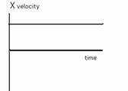(B) 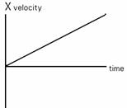(C) 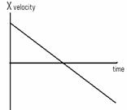
(D) 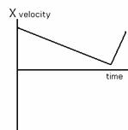

10. A man is going up with speed of 50 m/s. after 10 second a second man going same direction with a speed of 70 m/s .Assuming that they travel at constant speeds, how far distance covered by first man when second man catch first.
11. Two parallel rail track run north-south. Train A moves due north with a speed of 50 km/h and train B moves due south with a speed of 80 km/h. What is the velocity of B with respect to A in ms⁻¹.
12Delhi is at a distance of 150 km from ambala. A sets out from ambala at speed of 20 km/h B sets out at the same time from Delhi at a speed 10 km/h . When they will meet each other after.

Head office:-M-65,DIKSHA,GAUTAM NAGAR,NEW DELHI-110049
BRANCH OFFICE:-C-93,POCKET-6,KENDRIYA VIHAR PHASE 2,NOIDA SECTOR 82.
PHONE NO:-9871581508,011-41642844
FAX NO:-011-41642844,dikshaworld@gmail.com,dikshaworld@rediffmail.com

