Sample Paper – 2009
Class – X

Subject –Mathematics

Roll. No. Code. No. 041/02
Time: 3 hrs Maximum Marks: 80

General Instructions:
( i ) All questions are compulsory.
( ii ) The question paper consists of 30 questions divided into four sections – A, B, C and D. Section A
contains 10 questions of 1 mark each, Section B is of 5 questions of 2 marks each, Section
C is of 10 questions of 3 marks each and section D is of 5 questions of 6 marks each.
( iii ) There is no overall choice. However, an internal choice has been provided in one question of
two marks each, three questions of three marks each and two questions of six marks each.
( iv ) In question on construction, the drawing should be neat and exactly as per the given
measurements
( v ) Use of calculator is not permitted. .

SECTION A

- State fundamental theorem of Arithmetic.
- If one of the root of polynomial is 3 - , find the other root.
- For what value of k, the following pair of linear equations has infinite many solutions.
10x + 5y – ( k – 5 ) = 0; 20x + 10y – k = 0.
- Find the discriminant of the quadratic equation 2x² – 3x + 5 = 0, and hence find the nature of its roots.
- Determine k so that 4k+8 , 2k²+3k+6 , 3k²+4k+4 are the three consecutive terms of an A.P.
- The areas of two similar triangles ABC and DEF are 64m² and 169m² respectively. If BC = 4 cm, find EF.
- The diameter of a circular pond is 17.5 m. It is surrounded by a path of width 3.5 m. find the area of the park.
- The curved surface area of a cylinder is 1760 cm² and its base radius is 14 cm, find the height of the cylinder.
- If median of 20 observations is 50 and mode is also 50, find the mean.
- Two unbiased coins are tossed. Find the probability of getting : doublet ii. One head.

SECTION – B

- Without using trigonometric table evaluate the following
Sec 39◦ + 2 tan 17◦ tan 38◦ tan 60◦ tan 52◦ tan 73◦ - 3(sin² 31 + sin² 59)
Cosec 51◦ √3

- 17 cards numbered 2, 3,4…….. 17 are put a box and mixed thoroughly. Mohan draws a card from the box, find the probability the number on the card is :
- Divisible by 3 or 2. ii. Prime number iii. A number which is perfect square

- Find the value of k for which the points with coordinates (3, 2), (4, k) and (5, 3) are collinear.
- In ∆ABC, AD BC and AD² = BD × DC, Prove that ABC is a right triangle.
- The sum of the third and the seventh terms of an A.P. is 6 and their product is 8. Find the sum of first 16 terms of the A.P.
SECTION – C

- If 2 and 3 are the zeros of the quadratic polynomial 3x² – 2kx + 2m = 0. Find the values of k and m.
- Show that every +ve odd intger is of the form 6q+1 or 6q+3 or 6q+5 where q is some integer.
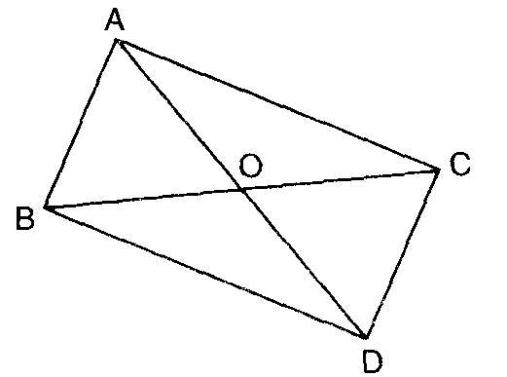
- If $\text{tan}A=\frac{1}{2}\text{,tan}B=\frac{1}{3}\text{and}\text{tan}(A+B)=\frac{\text{tan}A+\text{tan}B}{1−\text{tan}A\text{.}\text{tan}B}$, Find A + B.
- If two zeroes of the polynomial x⁴+3x³-20x²-6x+36 are and - , find the other zeroes of the polynomial.
- In figure, ABC and DBC are two triangles on the same base BC.If AD intersect BC at 0. Prove that: .
- Prove that the lengths of two tangents drawn from an external point to a circle are equal.
Use the above theorem to prove the following: A circle is touching the side BC of ∆ ABC
at P and touching AB and AC produced at Q and R respectively. Prove that: AQ = (Perimeter of ∆ ABC)
- Solve the following pairs of equations: (a – b) x + (a + b) y = a² – 2ab – b²
(a + b) x + y) = a² + b²
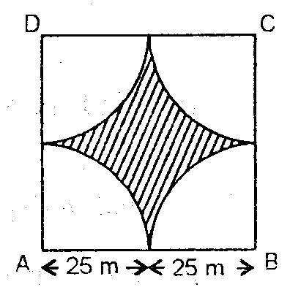
- If the points P( x, y ) is equidistant from the points A( 5, 1) and B( -1, 5 ). Prove that 3x = 2y.
- Four cows are tethered at four corners of a square plot of
side 50 inches, so that they just cannot reach one another.
What area will he left ungrazed ?

- ABCD is a quadrilateral formed by the points A( -1, -1), B( -1, 4 ), C( 5, 4 ) and D( 5, -1 ). P,Q,R and S are the mid-points of AB, BC, CD and DA respectively. Name the type of quadrialateral PQRS.

SECTION – D

- Two pillars of equal height stand on either side of a roadway which is 150 m wide. from a point on the roadway between the pillars the elevations of the top of the pillars are 60 ⁰ and 30⁰. Find the height of the pillars and the position of the point.
- Prove that in a triangle, if square of one side is equal to the sum of the squares of the other two sides, then the angle opposite to the first side is a right angle. Using the converse of above, determine the length of an altitude of an equilateral triangle of side 2 cm
- A tent in the form of a right circular cylinder up to a height of 4 m and base diameter 4.2 m is surmounted by a cone of equal base and height 2.8 m. Find the capacity of the tent and the cost of the canvas required at the rate of Rs.100 per m².

- A boat covers 32 km upstream and 36 km downstream in 7 hours. Also, it covers 40 km upstream and 48 km downstream in 9 hours. Find the speed of the boat in still water and that of the stream.

- The following table gives monthly wages in rupees of workers in a certain commercial organization. The frequency of class 49 – 52 is missing. It is known that the mean of the frequency distribution is 47.2. find the missing frequency.
Monthly wages | 40 – 43 | 43 – 46 | 46 – 49 | 49 – 52 | 52 – 55
No. of workers | 31 | 58 | 60 | ? | 27

Mohan Singh
Saraf Public School
Khatima : U.S.Nagar( Uttarakhand )
Contact : +919258777432, +919897623422
E-Mail : mr_mohansinghua@rediff.com

