Sample Paper – 2009
Class – XII
Subject – Physics

Time Allotted: 3hrs. Max. Marks : 70

General Instructions:
- All questions are compulsory.
- There are 30 questions in total. Questions 1 to 8 carry one mark each, questions 9 to 18 carry two marks each, questions 19 to 27 carry three marks each and questions 28 to 30 carry five marks each.
- There is no overall choice. However, an internal choice has been provided in one question of two marks, one question of three marks and all three questions of five marks each. You have to attempt only one of the given choices in such questions.
- Use of calculators is not permitted.
- You may use the following physical constants wherever necessary :
c = 3 x 10⁸ms⁻¹
h = 6.6 x 10⁻³⁴Js
e = 1.6 x 10⁻¹⁹ C
µ_{o} = 4π x 10⁻⁷A⁻¹ m T
Boltzmann constant k = 1.38 x 10²³ JK⁻¹
Avogadro’s number N_{A} = 6.023 x 10²³/mole
Mass of neutron m_{n} = 1.6 x 10⁻²⁷ kg

- Two point charges q₁ and q₂ are placed close to each other. What is the nature of the force between them when: (i) q₁q₂ < 0 and (ii) q₁q₂ >0? 1

- An electron an a proton, having equal momenta, enter a uniform magnetic field at right angles to the field lines. What will be the ratio of the radii of curvature of their trajectories? 1

- A parallel beam of monochromatic light falls normally on a single narrow slit. How does the angular width of the principal maximum in the resulting diffraction pattern depend on the width of the slit? 1

- Name the device which shows the variation of current (I) with voltage (V) as shown:

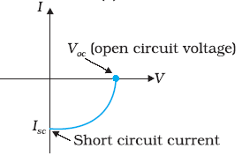
Also mention any one application of the device. 1

- What is the mathematical relation between speed of electromagnetic waves, permittivity and permeability in vacuum? 1

- Hertz observed, during the experiment to produce e.m.waves, an ‘enhancement’ in the sparks across the detector loop when the emitter plate was illuminated by U.V radiations. What was it due to? 1

- Define ‘trans-conductance’ of a transistor. 1

- When current in a coil changes with time, how is the back emf induced in the coil related to it? 1

- A message signal of frequency 10 kHz and peak voltage of 10 volts is used to modulate a carrier of frequency 1 MHz and peak voltage of 20 volts. Determine:
(a) modulation index, (b) the side bands produced. 2

- Derive an expression for the potential at the point on the axial line of an electric dipole. 2

- A household circuit has a fuse of 5A rating. Calculate the number of bulbs of rating 60W-220V each which can be connected in this circuit. 2

- The deviations from Ohm’s law can be, when the relation between V and I (i) depends on the sign of V or (ii) is not unique. Give an example for each and draw the respective graphs. 2

- On the same axes, draw the plots showing the variation of intensity of magnetization with the applied magnetic field for dia, para and ferro magnetic substances and label them as D, P and F respectively. How does diamagnetism vary with temperature? 2

- Draw the logic symbol and truth table of NOR gate. How can a combination of such gate be used to make AND gate? 2

- A screen is placed 80cm from an object. The image of the object on the screen is formed by a convex lens at two different locations, separated by 10cm. Calculate the focal length of the lens used. 2
(OR)

A microscope is focused on a dot at the bottom of a beaker. Some oil is poured into the
beaker to a height of ‘α ’ cm and it is found necessary to raise microscope through a vertical
distance of ‘β’ cm to bring the dot again into focus. Express refractive index of oil in terms of
‘α’ and ‘β’. 2

- A rectangular coil of N turns and area A is rotated in a uniform magnetic field of intensity B with an angular velocity ω. Obtain an expression for the maximum induced emf in the coil. What would be flux linked with the coil at the instant when the induced emf is maximum? 2
- Electromagnetic waves with wave length
(i) λ₁ are used to kill germs in water purifiers.
(ii) λ₂ are used in aircraft navigation.
(iii) λ₃ are referred to as ‘heat waves.
Identify the waves and arrange them in ascending order of their magnitudes. 2
- A bar magnet is dropped so that it falls vertically through the coil C. The graph obtained for voltage produced across the coil Vs time is shown in the figure below.
              - Explain the graph.
              - Why is the negative peak longer than the positive peak?

Magnet

p.d

Time
C

2

Page 2 of 4

- (a) Light, from a sodium lamp, is passed through two Polaroid sheets P₁ and P₂ kept one after the other. Keeping P₁ fixed, P₂ is rotated so that its ‘pass-axis’ can be at different angles, θ, with respect to the pass-axis of P₁.
An experimentalist records the following data for the intensity of light coming out of P₂ as a function of the angle θ.

Sl. No. | 1 | 2 | 3 | 4 | 5
θ (Angle between the pass-axis of the two polaroids) | 0º | 30º | 45º | 60º | 90º
I (Intensity of light coming out of P₂) | I | $\frac{\sqrt{3}}{2}$I | ½ I | ¼ I | 0
One of these observations is not in agreement with the expected theoretical variation of I with θ. Identify this observation and write the correct expression.
(b) Define Brewster angle and obtain the relation connecting this angle and refractive index. 3

- (i) Show mathematically, an amplitude modulated signal contains the frequencies ω_{c}, ω_{c}+ω_{m}
and ω_{c} - ω_{m}, where the symbols have their usual meanings.
(ii) Draw the block diagram to illustrate the process of amplitude modulation. 3

- Define ‘power of a lens’. Plot the graph showing the variation of power of a lens with the wavelength of the incident light. Prove that the equivalent power of the combination of two thin lenses in contact is the sum of their individual powers. 3

- A resistor of 200 Ω and a capacitor of 15.0 μF are connected in series to a 220 V, 50 Hz ac source. (a) Calculate the current in the circuit; (b) Calculate the voltage (rms) across the
resistor and the capacitor. Is the algebraic sum of these voltages more than the source voltage? If yes, resolve the paradox. 3
- What are ‘matter waves’? With the help of a labeled diagram, describe an experiment to demonstrate the existence of matter waves. 3

- Two cells of the same emf E, but different internal resistance r_{l} and r₂ are connected to an external resistance R as shown. in the figure. The voltmeter V reads zero. Obtain an expression for R in terms of r_{l} and r₂. Calculate the voltage across the cell of internal resistance r₂. (Assume that the voltmeter V is of infinite resistance).
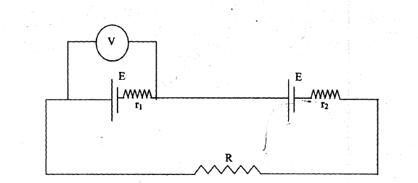 3

- State the postulates of Bohr Atom model. Verify the second postulate using de-Broglie’s concept of matter waves. 3

- How long can an electric lamp of 100W be kept glowing by fusion of 2.0 kg of deuterium? Take the fusion reaction as

₁H² + ₁H² → ₂He⁴ + n + 3.27 MeV 3
(OR)
Calculate the binding energy per nucleon of ₂₀Ca⁴⁰ nucleus. Given: m (₂₀Ca⁴⁰) = 39.962589u
Mass of a neutron = 1.008665u and mass of a proton = 1.007825u. 1u = 931MeV 3

- Explain the terms: ‘Saturation state’ and ‘cut-off state’ of a transistor. Draw the circuit diagram, showing the use of transistor as a switch. 3

- (i) State Gauss’ theorem. On the basis of this, prove that, for a point outside a charged
spherical shell, it behaves as a point charge.
(ii) The electric field components in figure are E_{x} = αx^{1/2}, E_{y} = E_{z} = 0, in which α = 800 N/C
m^{1/2}. Calculate (a) the flux through the cube, and (b) the charge within the cube. Assume
that a = 0.1 m.
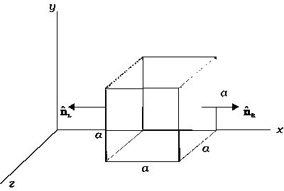
5
(OR)

- Explain the principle on which Van de Graff generator operates. Draw a labeled schematic sketch and write briefly its working.
- A Van de Graff generator is capable of building up a potential difference of 15 x 10⁶ V. The dielectric strength of the gas surrounding the electrode is 5 x 10⁷ V/m. What is the minimum radius of the shell spherical shell required?
5
- A straight thick long wire of uniform cross section of radius ‘a’ is carrying a steady current I. Use Ampere’s circuital law to obtain a relation showing the variation of the magnetic field inside and outside the wire with distance r, (r ≤ a) and (r > a) of the field point from the centre of its cross section. Plot the graph showing the nature of this variation.
Calculate the ratio of magnetic field at a point a/2 above the surface of the wire to that at a point a/2 below its surface. What is the maximum value of the field of this wire? 5

(OR)

- Draw the labeled diagram of a moving coil galvanometer. Prove that in a radial magnetic field, the deflection of the coil is directly proportional to the current flowing in the coil.
- Which one of the two – an ammeter or a milli-ammeter, has greater resistance, when made from identical galvanometers? Explain. 5

- (a) How is a ‘wavefront’ defined? Using Huygen’s construction draw a figure showing the
propagation of a plane wavefront refracting at a plane surface separating two media.
Hence verify Snell’s law of refraction.
(b) Can two wavefronts cross each other? Explain. 5

(OR)

(a)With the help of a labeled diagram, show the image formation by a compound
microscope. Derive an expression for its magnifying power.
(b) How does the resolving power of a compound microscope get affected on
(i) decreasing the diameter of its objective?
(ii) increasing the focal length of its objective? 5

Paper Submitted by:
M Rajeev
Email rajphy@eim.ae
Phone No. +97506336049

