Guess Paper – 2009
Class – X
Subject – MATHEMATICS

Time: 3 hrs Marks: 80

General Instructions:
- All questions are compulsory.
- The question paper consists of 30 questions divided into four sections – A, B, C and D. Section A contains 10 questions of 1 mark each, Section B is of 5 questions of 2 marks each, Section C is of 10 questions of 3 marks each and section D is of 5 questions of 6 marks each.
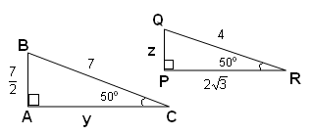
- In question on construction, the drawing should be neat and exactly as per the given measurements.

SECTION – A

- Express sin A in terms of Cot A
- In adjoining figure ∆ABC ~ ∆PQR, find y and z.
- Express 7429 as a product of its prime factors
- Find the number of integral zeros of x² – 6x + 12.
- Find the nature of the roots of the quadratic equation $\sqrt{3}$x² - $4$x +$\sqrt{5}$ = 0.
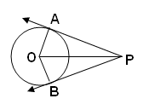
- Find the 10th term from end of the A.P. 4, 9, 14, …, 254.
- The radii of two circles are 3 cm. and 4 cm. Find the radius of a circle whose area is equal to the sum of the areas of two circles.
- In adjoining figure, ∠POB = 55º, find ∠APB.
- If the probability of winning a game is P and that of losing is 2P², find the value of P.
- The point of intersection of the Ogives (more than and less than type) is at a distance of 36cm from X-axis and 25cm from Y-axis. What is the Median?
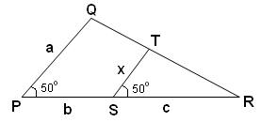
SECTION – B

- For what value of k will the following pair of linear equation has no solution:
ax + 3y = a – 3; 12x + ay = a.
12. In adjoining figure, prove that:$x=\frac{\text{ac}}{b+c}$.
- The coordinates of A and B are (-3, 3) and (12, -7) respectively. P is a point which divides AB in the ratio AP : AB = 2:5, find the coordinates of P.
- Evaluate : $\frac{\text{cos 45}°}{\text{sec}\text{30}\text{°+}\text{cos}\text{ec}\text{30}°}$
- A box contains cards bearing numbers 6 to 70. If one card is drawn at random from the box. Find the probability that it bears:
- a one digit number, and
- a number divisible by 5.

SECTION – C

- Physical teacher of a school decided to have maximum number of mixed sections for a team, each section has to accommodate equal number of boys player and equal number of girls player. What is the maximum number of such section, if there are 240 boys player and 228 girls player?

- Find all the zeros of the polynomial$2x^{4}−7x^{3}−\text{13}x^{2}+\text{63}x−\text{45}$, if the two of the zeros are 3 & -3.
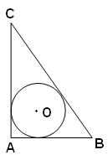
- Solve for x and y: $\frac{\text{10}}{x+y}+\frac{2}{x−y}=4$; $\frac{\text{15}}{x+y}−\frac{5}{x−y}=−2$
OR
The sum of the digits of a two digit number is 9. Also nine times this number is twice the number obtained by reversing the order of the digits. Find the number.
- Find the sum of A.P.:$\frac{1}{\text{15}}$,$\frac{1}{\text{12}}$,$\frac{1}{\text{10}}$, ………. to 11 terms.
- In ΔABC, AB = 5cm, BC = 13cm, A = 90º, find the radius of the in-circle.
- What type of triangle is formed by joining the points (5, -2) (6, 4) and (7, -2)?
- Find the value of k, if P (1, k), Q (4, -3) and R (-9, 7) are the vertices of a triangle whose area is 15 square units.
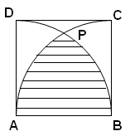
- Prove that: $\frac{1}{\text{sec}A+\text{tan}A}−\frac{1}{\text{cos}A}=\frac{1}{\text{cos}A}+\frac{1}{\text{sec}A−\text{tan}A}$
OR
If P, Q and R are the interior angle, of ΔPQR, then prove that: $\text{cos}\left(\frac{Q+R}{2}\right)\text{sin}\frac{P}{2}+\text{sin}\left(\frac{Q+R}{2}\right)\text{cos}\frac{P}{2}=1$
- Construct a pair of tangents to a circle of radius 5 cm from an external point P, which are inclined to each other at an angle of 60º.
- In adjoining figure, ABCD is a square of side 14 cm; find the area of shaded region.

SECTION - D

- The numerator of a fraction is one less than its denominator; if three is added to each of the numerator and denominator, the fraction increases by$\frac{3}{\text{28}}$, find the fraction.
OR
Two pipes running together can fill a tank in $\text{11}\frac{1}{9}$minutes. If one pipe takes 5 minute more than the other to fill the tank, find the time in which each pipe would fill the tank.

- The angle of elevation of the top of building from the foot of the tower is 30º and angle of elevation of the top of the tower from foot of the building is 60º. If the tower is 50 m high, find the height of the building.
OR
As observed from the top of a 75 m high light house from sea level, the angles of depression of the two ships are 30º and 45º. If one ship is exactly behind the other in the same side of the light house find the distance of the two ships.

- A metallic right circular cone 20 cm high and whose vertical angle is 60º is cut in to two parts at the middle of its height by a plane parallel to its base. If the frustum so obtained be drawn into wire of diameter $\frac{1}{\text{16}}$cm, find the length of the wire
- Find the mean, the mode and the median for the following data:
Class Interval | 10 - 20 | 20 - 30 | 30 - 40 | 40 - 50 | 50 - 60 | 60 - 70 | 70 - 80
Frequency | 4 | 8 | 10 | 12 | 10 | 4 | 2

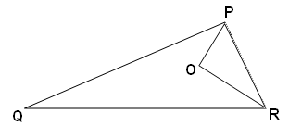
- If In a triangle the square of one side is equal to the sum of the squares of the other two sides, then prove that the angle opposite to the first side is a right angle.
Use the above theorem to prove the following:
In figure O is a point inside ΔPQR such that ∠POR = 90º, OP = 6 cm, OR = 8 cm. If PQ = 24 cm, QR = 26 cm, then
prove that PQR is a right angled triangle.

BISWAS TEST SERIES - 2009
Paper Submitted by:
DILIP BISWAS
Email dilipbiswas2006@gmail.com
Phone No. 09214927974

