Guess Paper – 2009
Class – XII
Subject – Mathematics
Time: 3 hr Full mark - 100
General instruction :- (a) Question no 1 to 10 are 1 mark each
(b) Question no 11 to 22 are 4 mark each
(c) Question no 23 to 29 are 6 mark each

1. Is function f :N→N,defined by f(x) =3x onto? Give reasons.

2. Find the value of sin⁻¹(x / x+1) + sec⁻¹(x_1/x).

3. If the points (λ,7), (1,-5) and (-4,5) are collinear. Find the value of x.

4. Find the cofactor of (1, 2) ^{th} entry in the given matrix
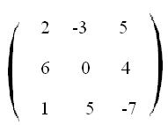

5. If a matrix is both is symmetric and skew symmetric, then show that it is a null matrix.

6. Evaluate:
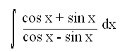
7. Evaluate:
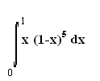

8. Find a vector of magnitude 9 units, which is perpendicular to both the vectors
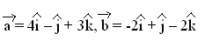
9. Find λ , when the projection of 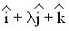on 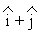is √2 units.

10. If a, b, and c are unit vectors such that,then find the value of .

11. Let f: X→R be a relation defined as f(x) = 4x²+12x+15. Show that f: N→ Range of f is inversible. Find the inverse of f.
or
Let f: X→Y is a given function. Define a relation R in X given by R= {(a, b) ∈ X, X f (a) =f (b)}. Discuss whether R is an equivalence relation.

12. Write the simplest form: tan⁻¹ (3a²-x³/a³-3ax²)
or
Solve: tan⁻¹ 1/4+2tan⁻¹1/5+tan⁻¹1/6+tan⁻¹1/x = π/4.

13. Using determinant, Prove that
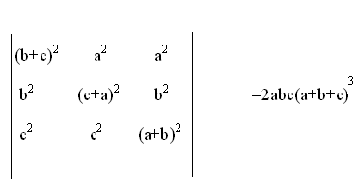

14. Let f(x)=
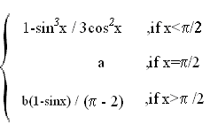

If f(x) is continuous function at x =π/2, find a and b.

15. If y = x log(x/a + bx). Prove that d²y / dx² = 1/x(a / a+bx)²

16. Find the equation of the tangents to the curve y = √3x-2 which is parallel to the line 4x-2y+5 =0.
or
Find the intervals in which the function f(x) = x³+1/ x³ increasing or decreasing.

17. Evaluate i) ∫ cot³ dx
ii) ∫ dx/sin(x-α) sin(x-β)
18. If ≠ 0, then show that, where k is a scalar.

19. Find the shortest distance between the lines
x-1 = y-2 = z-3 and x-2 = y-4 = z-5
2 3 4 3 4 5
Also, find the equation of the line.

20. A and B throw a pair of die turn by turn. The first to throw 10 is awarded a prize. If B starts the game. What is the probability that A is getting prize.

21. Form the differential equation for the family circles passing through origin and with centre on y-axis.

22.Solve: cos²x dy/dx + = tan x or (x + y)² dy/dx -1 =0.

23. A manufacturer has three machine operators A,B and C. The first operator A produces 1% defective items, where as the other two operators B and C produce 5% and 7% defective items respectively. A is on the job for 50% of the item, B is on the job for 30% of the time and C is on the job for the remaining time .If a defective item is produced, what is the probability that it was produced by A?

24. Find the distance of the point (2,3,4) from the plane
3x + 2y + 2z + 5 =0 measured parallel to the line
x+3/3 = y-2/6 = z/2

25. Using integration find the area of triangle PQR where the co-ordinates of P,Q & R are (2,1) (3,4) and (5,2) respectively.

26.Evaluate : ∫ cos xdx/(1-sin³x) (2+sin x)

27. At 8a.m ship A is 65 Km due east of another ship B. Ship A is then sailing due to east at 10 Km/hr. It they continue sailing on their respective paths, when will they be nearest to one another and how near?

28 .Using elementary row transformations, find the inverse of
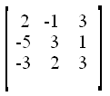

29. Two godowns A and B have a grain storage capacity of 100 quintals and 50 quintals respectively. They supply 3 ration shops D, E and F, whose requirements are 60,50 and 40 quintals respectively. The cost of transportation per quintal from the shop are given below.
Transportation costs per quintal (in Rs)
TO\FROM | A | B
D | 6.00 | 4.00
E | 3.00 | 2.00
F | 2.50 | 3.00

How should the supplies be transported in order that the transportation cost is minimum?
S K. JENA
PGT MATHS
J.N.V.CUTTACK.
sanjaykjena2003@yahoo.co.in
cell.no.:-09937628145

