Sample Paper – 2009
Class – X

Subject –Mathematics

Time: 3 hrs Maximum Marks: 80

General Instructions:
- All questions are compulsory.
- The question paper consists of 30 questions divided into four sections – A, B, C and D. Section A
contains 10 questions of 1 mark each, Section B is of 5 questions of 2 marks each, Section
C is of 10 questions of 3 marks each and section D is of 5 questions of 6 marks each.
- There is no overall choice. However, an internal choice has been provided in one question of
two marks each, three questions of three marks each and two questions of six marks each.
- In question on construction, the drawing should be neat and exactly as per the given measurements
- Use of calculator is not permitted. .

SECTION A

- Explain why 7 x 11 x 13 + 13 is a composite number.
- Find the roots of equation a²b²x² + ( b² – a² )x – 1 = 0.
- Triangles.
- One zero of the quadratic polynomial 2x² – 8x – k = 0 is 5 / 2. Find the other zero and the value of k.
- Three coins are tossed once. Write the elements of the outcomes. Find the probability of getting :
- At least 2 heads ii. At most 2 heads.
- The graphs of y = p(x) are given in the figure below, a polynomial p(x). Find the number of zeroes.
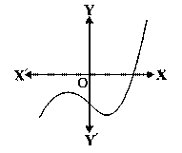
- Three cubes whose edges measure 3cm, 4cm and 5cm respectively to form a single cube. Also, find the surface area of the new cube.
- Find the sum of first 20 terms of an A.P., in which 3rd term is 7th term is two more than thrice of its 3rd term.
- Mohan went to a bank to withdraw Rs 2000. She asked the cashier to give her Rs 50 and Rs100 notes only. Mohan got 25 notes in all. Find how many notes of Rs 50 and Rs 100 she received.
- The perimeter of a sector of a circle of radius 5.2 cm is 16.4cm. Find the area of sector.

SECTION – B

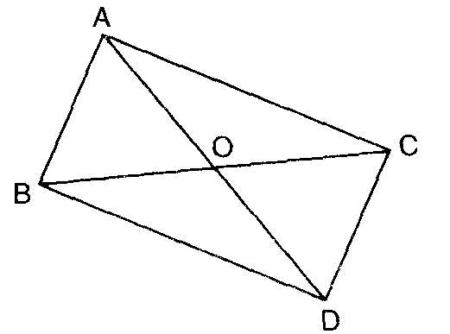
- Prove: (1 + cot θ + tan θ )(sin θ – cos θ) = sin² θ cos² θ .
sec³ θ – cosec³ θ
- In figure, ABC and DBC are two triangles on the same base BC. If
AD intersect BC at 0. Prove that: .

- A man repays a loan of Rs 3250 by paying Rs 20 in the first month and then increases the payment by Rs 15 every month. How long will it take him to clear the loan.
- If the point ( x, y ) is equidistant from the points ( a+b, b-a ) and ( a-b, a+b ). Prove that bx = ay.
- A jar contains 76 marbles some of which are red, green and orange. The probability of selecting a red marble at random from the jar is ¼, and the probability of selecting an orange marble is ½ . how many green marbles doses the jar contains ?
Section - C

- Mohan and Lalit have certain number of pens. Mohan says to Lalit, “if you give me 10 of your pens, I will have twice the number of pens left with you.”Lalit replies, “if you give me 10 of your oranges, I will have the same number of pens as left with you.”Find the number of oranges With Mohan and Lalit.
- In what ratio does the line 3x + y -9 =0 divides the segment joining the points ( 1, 3) and ( 2, 7).
- Find the zeros of the Polynomial f(x) = x³ -12x² + 39x – 28, if it is given zeros are in A.P.
- An athletic track 14m wide consists of two straight sections 120m long joining semi-circular ends whose inner radius is 35 m. Calculate the area of the track.
- Draw a ABC with side BC= 7cm, B= 45, A = 105. Construct a triangle whose sides are 4/3 times corresponding sides of ABC.
- The radius of the incircle of a triangle is 4 cm and the segments into which one side is divided by the point of contact are 6cm and 8 cm. determine the other two sides of the triangle.
- 08 men and 12 boys can finish a piece of work in 10 days while 06 men and 08 boys can finish it in 14 days. Frame the above information as a system of linear equations in two variables to find the time taken by one man and that by one boy alone to finish the work
- Prove that the coordinates of the centroid of the triangle whose vertices are (x₁, y₁), (x₂,y₂) and ( x₃, y₃ ) are . Using the above find the third vertices of a triangle whose two vertices are (1, 3) and (4, -5) and its centriod is (7, 2).
- Prove that one of every three consecutive +ve integers is divisible by 3.
- If .

.SECTION – D

- A hollow cone is cut by a plane parallel to the base and the upper portion is removed. If the curved surface of the remainder is 8/9 of the curved surface of the whole cone find the ratio of the line segment into which the cone’s altitude is divided by the plane.
- Prove that the square of the longest side is equal to the sum of square of other two sides.
Using the above, Prove that PR² = 4PS² – 3PQ², if PQR is a right triangle right angle at Q and S is a point on QR such that QS = SR.
- Two stations due south of a leaning tower which leans towards the north are at distances a and b from its foot. If, be the elevations of the top of the tower from these stations, prove that its inclination to the horizontal is given by .
- One – fourth of dogs were seen in the garden. Twice the square root of the dog had gone for hunting and remaining 15 dogs were seen on the road. Find the total number of dogs.

- The median of the following data is 35. Find the values of x and y, if the total frequency is 100.
C.I | 0 – 10 | 10-20 | 20-30 | 30-40 | 40-50 | 50-60 | 60-70 | Total
Frequency | 10 | 20 | X | 40 | Y | 25 | 15 | 170
Using the above table draw: i. Less than ogive ii. More than ogive

Mohan Singh
Saraf Public School
Khatima : U.S.Nagar( Uttarakhand )
Contact : +919258777432, +919897623422
E-Mail : mr_mohansinghua@rediff.com

