Sample Paper – 2009
Class – IX
Subject – English

Time : 3 hours English – 9 Marks : 100

This paper consists of four sections.
Section A – Reading 20 marks
Section B – Writing 30 marks
Section C – Grammar 20 marks
Section D – Literature 30 marks
Instructions:
- Attempt all questions.
- Do not write anything in the question paper.
- All the answers must be correctly numbered as in the question paper and written in the answer sheet provided to you.
- Attempt all questions in each section before going on to the next section.
- Read each question carefully and follow the instructions.
- Strictly adhere to the word limit given with each question. Marks will be deducted for exceeding the word limit.

SECTION A – READING

1. Read the following passage carefully: [10]

HENRY CAVENDISH

1 Henry Cavendish, the eldest son of Lord Charles Cavendish, was born at Nice in 1731.
From a school at Hackney, he entered Cambridge in 1749. He devoted his whole life to scientific investigation and became a first-rate physicist and chemist. An uncle of his left him a large amount of money and this enabled Cavendish to carryon his work without any interruption.
2 Cavendish was one of the pioneers in the study of gases. In 1766 he discovered 'inflammable air', now called 'hydrogen'. Later he showed that water was produced when this gas was burnt. In 1785, he discovered that nitric acid was produced by the combination of the two constituent gases of the atmosphere, oxygen and nitrogen. The discovery has since become immensely important in industry, especially in the manufacture of fertilizers. In the course of this experiment he made the remarkable observation that a very small fraction, about I' 120th of the air, was different from the rest of it. Thus Cavendish had observed but not recognized the gas that was rediscovered more than a hundred years later and was given the name Argon.
3 In addition to the above discoveries, Cavendish made notable discoveries in electrostatics.
The accuracy and completeness of his discoveries, even from the modern point of view, were remarkable. Cavendish died in 1810. The Cavendish Physical Laboratory at Cambridge was named in his honour and contains much of his apparatus.
4 Cavendish was a silent and solitary man and hated to meet strangers. His female domestic servants had orders to keep out of his sight. It is said that he ordered his dinner daily by a note placed on the dinner table.
1.1. On the basis of your reading the passage, complete the following table with suitable words and phrases chosen from it. Write your answers in your answer sheet against the correct blank number. (6marks)

Year | Event/discovery
1731 | (a) ...............
1749 | joins Cambridge
(b) ............... | discovers 'inflammable air'
 | (now called 'hydrogen')
 | later shows that
 | (c) ...............
 | ...............
(d) ............... | discovers nitric acid
1.2. On the basis of your reading the passage, answer the following questions as briefly as possible. Write your answers in your answer sheet against the correct blank number.
(4 marks)
(a) The most important factor that enabled Cavendish to carry out his research was __________.
(b) Nitric acid consists of __________ .
(c) The utility of nitric acid is more in the fields of __________ .
(d) Cavendish hated meeting strangers and was a solitary man. This fact is clear from __________.

2. Read the following passage carefully and answer the questions that follow: [10]

FACING OLD AGE WITH ZEST

1. The phenomenon of ageing has been with us. Anything that is born must disappear. We cannot avoid old age, but how to face it and add zest to life in the remaining years of our living on this earth?
2. Ageing should bring control over three human passions- lust, anger and greed. Controlling these forces changes the mode of our living and our thinking.
3. There are two factors which are responsible for our well being. First, keeping ourselves fully occupied both mentally and physically, with something we like. The second is directing ourselves towards spirituality. Spiritual learning makes us calmer and gives inner peace.
4. Meditation, reading books and keeping company with spiritually-enlightened people keep us mentally occupied and bring tranquility. A life full of contentment at this stage particularly would make the remaining years of our life happier.
5. We understood the meaning of renunciation, wrongly perhaps. Running away from the world and its material attractions is not the path being professed. The stage of life that we are at, is one in which we must not ignore the spark that guides us to the correct path. We are not the external body alone, but the soul within also. According to our scriptures, God resides in every soul.
6. There are three weapons, which God has given us for our happiness – awareness, wisdom and goodness.
Awareness refers to knowing one’s real self. It means to be aware of our real personality. Wisdom is our second weapon. Most of us lead this life without being aware of our aim, goal and priorities and each one’s inherent capacities. A person of wisdom will succeed by disciplining his life, fixing the priorities and reorganizing his reactions, emotions and thoughts. Wisdom lies in knowing our goal in life. Goodness is in fact the core of all philosophies. It is the sheet anchor of the teaching of various religions. What are the Ten Commandments? What is compassion taught by Buddha? What is Ahimsa taught by Saint Mahavir? The Gita repeats, again and again, that unless we enhance our content of nobility and purity, the goal of self realisation will remain beyond reach.
7. Goodness and humility go hand-in-hand and complement each other. One has to replace selfishness with selflessness and bring one’s ego under control
8. To practice compassion you have to have all the qualities of goodness – truth, love, purity and humility.
9. The Dalai Lama has repeatedly brought out in his discourses that love and anger cannot be generated exactly at the same time in the same person. Once you become accustomed to one class of attitudes, the other side automatically will diminish.
10. He said: “Ignorance, anger, attachment and pride are your ultimate enemies. They are not outside but within you and must be fought with the weapons of wisdom and concentration. Have a good heart, a good mind and warm feelings?” This will lead us to live a beautiful life.

2.1 On the basis of your reading the passage complete the notes. Write your answers in your answer sheet against the correct blank number. [04]

a) To add zest to old age one should control three human passions:
i) ________________ ii) ________________ and lust.
b) One should keep oneself occupied i) ________________________ and mentally.
c) One should be spiritually inclined through i) ______________ ii) ___________ and reading books.
d) Three weapons God has given us for happiness are
i) ________________ ii) ________________ and awareness.
e) One should follow: i) _________________________________

2.2 On the basis of your reading, complete the following sentences briefly. Write your answers in your answer sheet against the correct blank number. [4x1/2 = 2]

Wisdom lies in _________________________
We cannot achieve self-realisation unless ________________________
Truth, love, purity and humility are essential to practise _________________
According to Dalai Lama our four ultimate enemies are _________________

2.3 Find words/phrases in the passage that have the same meaning as the following. Write your answers in your answer sheets against the correct blank number. [04]

- enjoyment (para 1)
- giving up (para 5)
- asserted; stated (para5)
- precedence (para 7)

SECTION B – WRITING

3. Read the following telephone conversation which took place between Kamal and Sumit. Sumit’s father is not at home and he is to hurry to school. Sumit, therefore, leaves a message for his father. Write the message in not more than 50 words. [05]

Kamal: Hello Sumit. Is uncle at home?
Sumit: I’m sorry, he’s out at the moment. What can I do for you?
Kamal: Well, my daddy was to come to see uncle today at home at 6pm. But guests are due and he won't be able to do so
Sumit: Yes…….
Kamal: He will come to see uncle day after tomorrow at about 6:30 pm. Kindly tell uncle about it
Sumit: Don’t worry. I am in a bit of hurry. I will leave a message for papa. Bye
Kamal: Bye.

4. Anupam Singh is on his way to Hisar to join his university after the summer vacation. At Rohtak, just before he is to catch another bus, he remembers that he has forgotten his notes and newly bought watch, both placed in his almirah. He decides to write a post card at home to give his notes and watch to Anil, his junior, who is to come to Hisar the next day. Write the postcard to his mother, in not more than 50 words. [05]

4. The cartoon, below makes fun of the kind of fashions followed by today's youth. Using ideas from this cartoon together with your own ideas, write a short speech on "Changing Fashions" to be given at the morning assembly in your school in not more than 150 words. [05]

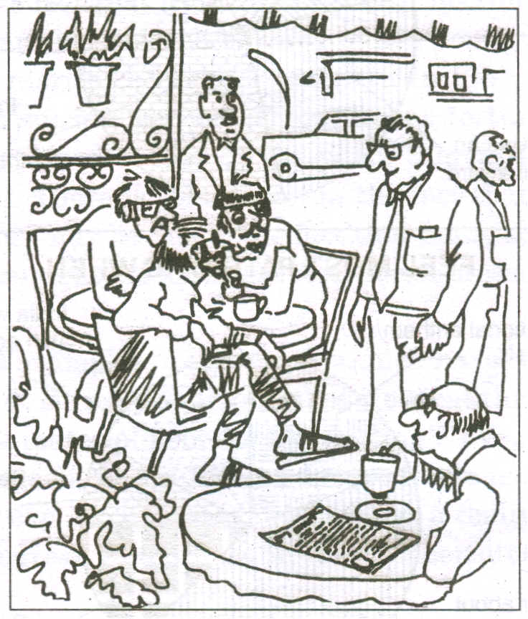

5. Neelam Verma of Class X B is the Secretary of Holy Angel Public School Geography Forum. Her teacher-in-charge asks her to put up a notice on the School Notice Board to invite the students of Geography to participate in an Inter-School Geography Quiz Contest to be held after a fortnight. The first prize carries Rs. 1000 and a Trophy. Imagining yourself as Neelam Verma, write that Notice in not more than 50 words making it catch. Put the notice in a box. [07]
6. You are Abhishek, living in Ambala. The elder brother of your friend Anand who is living at 1, Wallace Garden, Chennai-4, is getting married. You promised him that you would attend his marriage. But you have your mid-term examinations on the day of the marriage. You decide to send him a telegram expressing your inability to attend the marriage and congratulating him. Copy the format given below in your answer sheet and write the telegram in not more than 25 words. [08]

SECTION C - GRAMMAR
7. Below you can see a cartoon. Complete the following paragraph reporting what happened in the cartoon. Write the answers in your answer sheet against the correct blank number. [05]

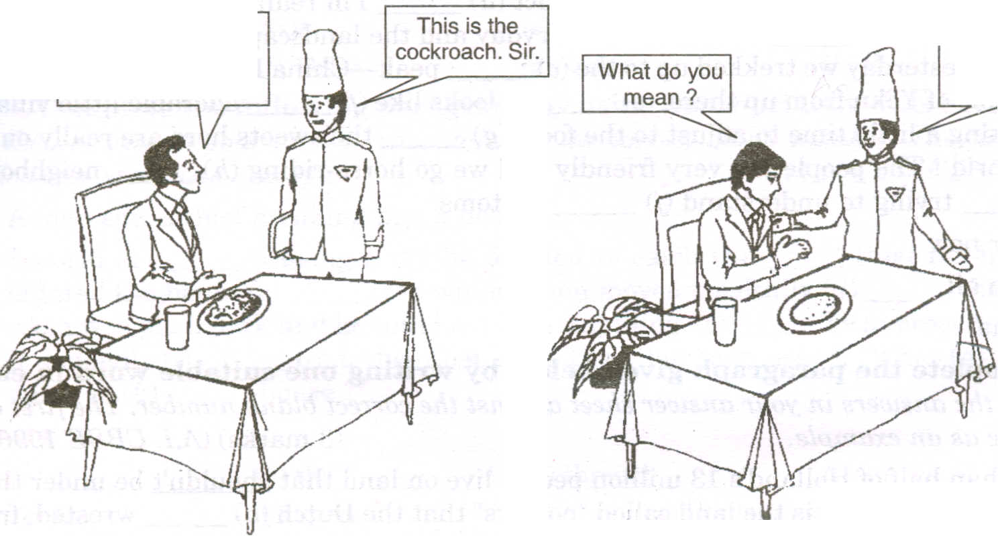
Waiter, what is this blackish thing
in the plate?
Do you expect an elephant in Ten Rupees?

. INDIAN POST AND TELEGRAPH
NAME AND | NAME
ADDRESS OF | ADDRESS
THE ADDRESSEE | TELEGRAPH OFFICE
 | TEL. NO. (If any)
MESSAGE
SENDER'S NAME
NOT TO BE TELEGRAPHED
SENDER'S ADDRESS:

1:1
The customer asked the waiter what (a) and the waiter told respectfully
that (b) . When the customer asked (c) , the waiter asked if he (the customer) (d) __.

8. Look at the words and phrases given below. Rearrange them to form meaningful sentences. [4x ½ =2]

Example: is / explain/ crude oil/ how / refined Explain how crude oil is refined

- crude oil/ of/ first/ heated/ all/ is
- on/ finest/ the/ vapours/ first/ petrol/ become/ cooling
- condescended/ gas/ later/ off/ coming/ paraffin/ into/ is
- come/ are/ to/ oils/ last/ lubricating
9. In the paragraph given below, one word has been omitted in each line. Write the missing word along with the word that comes before and the word that comes after it in your answer sheet against the correct blank number. Make sure that the word that forms your answer is underlined. [04]

The television has always very controversial. e.g. always been very
While the positive aspects the electronic a) ______________
media innumerable, their negative b) ______________
impact children cannot be denied. c) ______________
For new piece of information that d) ______________
a child learns the Discovery or National e) ______________
Geographic channel, are also f) ______________
unrealistic stunt shows parents dislike. g) ______________
Computers and TV have students to lose interest h) ______________
in studies.

10. The following passage has not been edited. There is one error in each of the lines. Write the incorrect word and correction in your answer sheets as given below against the correct blank number. Remember to underline the word that you have supplied. [6X1/2 = 3]

Children love picnics and outings of their parents e.g. of……..with
though they are equally happier doing things with a) ______________
them around the house. A parent may make b) ______________
his child feels special by following some simple c) ______________
rituals. Bedtime stories, the game of cards or d) ______________
simply talking and laugh together before going to e) ______________
bed – some give children a wonderful sense f) ______________
of well-being.

11. Below you can see a set of instructions for making Carroty halwa. Complete the following paragraph. [04]
Ingredients:-
½ kg carrots, ½ litre milk, 100 gm of khoa, 1 cup of water, 100g sugar, 3 tablespoonful of oil and 5-6 cardamoms.
Method:-
Wash, scrape and grate the carrots. Cook carrots alongwith he milk in a vessel. Add fat and fry when the milk dries up. Add sugar and crushed cardamoms. Fry till the oil comes out. Mix khoa well and remove it from the fire.

The carrots are washed, scarped and grated. They (a) _____________ vessel. Fat(b) _____________ when the milk dries up. Sugar and crushed cardamoms are added to it and then it (c) _____________ out. Khoa (d) ___________ fire.

12. Complete the following newspaper items: [1 x 2 =2]
- OLD COINS FOUND
According to Archeological Survey of India, some (a) ……………………………………………………..
while digging an ancient mound near Mungeh.

- SPECIAL TASK FORCE TO BEGIN PROBE KIDNAP
Special Task Force sleuths arrived here today where (b) …………………………………………. of the son of a former Union Minister.

SECTION D- LITERATURE
13. Read the following extract and answer the questions that follow:
“She springs like a beam on the brow of the tide
She falls like a tear from the eyes of a bride
Lightly O lightly we glide and we sing
We bear her along like a pearl on the string”
- Who are ‘we’? What are they doing? [01]
- Which words in the extract show that she is not a burden for the persons carrying her? [01]
- Name and explain the poetic device used in the last line. [01]
14. Read the following extract and answer the questions that follow:
“I cannot remember my mother
But when in the early autumn morning
the smell of shiuli flowers floats in the air
the scent of the morning service in the temple
comes to me as the scent of my mother.”
- When does the poet remember his mother? [01]
- When are shiuli flowers found? How are they used? [01]
- How does the poet recollect his mother? [01]
15. What choice did the poet have to make in the poem “The Road not Taken”? Does he regret his choice? Why/ Why not? [03]
16. Why was Ramanujan worried about getting his daughter married? Give four reasons.
Or
How does the postman console and guide Ramanujam and his family during each of the instances? [03]
17. After reaching school, Arun in ‘The Woman on Platform No.8’ decides to share his joy in meeting the woman with his cousin Ravi. Imagine you are Arun and write the letter in about 150 words. [05]
18. Read the following extract and answer the questions that follow: [04]
“I see no fault in that, so long as she does not shirk her wedded duty, or bring reproach upon the noble name she bears”
- Who speaks these lines and to whom? [01]
- What is the ‘fault’ that is referred to? [01]
- Who is being talked about? Does the speaker defend or accuse her? How? [01]
19. What resolutions did John Perkins make in the absence of his wife, Katy? [03]
20. What message does ‘The Bishop’s Candlesticks’ give? Write answer in 50-75 words. [03]

Atmiya Vidya Mandir
International Residential School for Boys

Paper Submitted by:
Paras H. Pancholi
Email punchparas@gmail.com
Phone No. 9824675329

