Guess Paper – 2009
Class – XII
Subject – Mathematics
Time-3hr M.M-100

General Instruction: a) Q.no 1-10 are of 1 mark each
b) Q.no 11-22 are of 4 mark each
c) Q.no 23-29 are of 6 mark each
1. Solve for x:
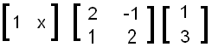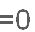
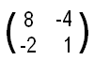
2. Find the inverse of matrix, A=
if exist, using elementary row transformation .
3. If A is A square matrix, such that A² =A, then find
( I + A)² – 3A.
4. Is Function f: NN, defined by f(x) = 3x onto?
Give Reasons.
5. Find the approximate value of √0.0037, using differential?

6. Using properties of definite integral
Evaluate:
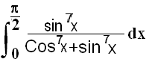

7. Find the integrating factor for solving the differential equation (1+y²) dx = (tan⁻¹y-x) dy ?
8. If Ia I=3, I bI =4 and a . b=9, find Ia bI ?
9.Evaluate P(A B), if 2 P(A)=P(B)=5/13 ,and P(A/B)=2/5 ?
10.Mean of a binomial distribution is 5 and variance is 10/3. Find the distribution?
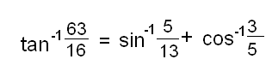
11.Differentiate (x) ^{1/x} with respect to x ^{logx}
^{12. Prove that :}

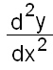
13. If x=a(cosθ+θsinθ), y=a(sinθ-θcosθ),

Find :

14.Verify lagrange’s Mean Value Theorem for the function
f(x)=(x-3)(x-6)(x-9) in [3,5]
OR,
Find the interval for which the function
f(x)= x⁴ – 2x²

15.Discuss the continuity of the function
f(x)= 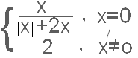

16.Evaluate 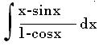 or 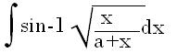
17.Evaluate 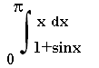 or 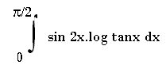
18.find the unit vector perpendicular to the plane ABC, where the position vectors of A, B & C are 2i – j + k, 3i+j+2k & -2j+3k respectively?
19 Evaluate
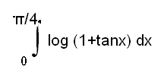

Or
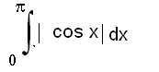

20. Solve the differential equation :
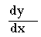
=(4x+y+1)²
Or
X = y(logy-logx+1)

21. Two cards are drawn successively with replacement from a well-shuffled pack of 52 cards .find the probability distribution of the number of aces .find its mean and standard deviation.
22. In shuffling a pack of 52 playing cards, four are accidentally dropped .find chance that missing cards should be one from each suit.
23. Let ‘*’ be a binary operation defined on the set of integers as a*b=a+b+1 for a, b € I
i) Show that -1 works as an identify element.
ii) Find the value of x such that 3*(x*4) =11
24. given that sum of edge of a cube and radius of a cube is equal to л/3 times of the diameter of sphere if the sum of their surface is minimum
25. Using integration, find the area of the region bounded by triangles whose sides are: 4 x-y+5=0, x+y=0, x-4y+5=0

OR
Prove that the curve y²=4x and x²=4y divide the area of the square bounded by x=0,x=4,y=0,y=4 into three equal parts
26.The sum of numbers a,b,c is 2.if twice b is added to a and c ,the sum is 1 .by adding b and c to five times the first number , we get 6.find a,b,c using matrices
27.A small manufacturing firm produces two types of gadgets A and B which are first processed in the foundary shop, then send to another machine shop for finishing. The number of man hours of labour required in each shop for production of each unit of A and B and the number of man hours for the firm available per week are as follows :
 | Foundary shop | Machine shop
Gadget A | 10 | 5
Gadget B | 06 | 4
Firm capacity per week | 1000 | 600

The profit on sale of is Rs 30 per unit and on B is Rs 50 per unit . Formulate the linear programming model for determining how many units of each gadget should be produced per week to maximize the firm’s profit .

28. Find the equation of the line passing through the point (3,1,2 ) and perpendicular to the plane r .(2i-ĵ+ĸ ) = 4 . Find also the point of intersection of line and plane.

29. find the equation of the plane through the points
(2,2,-1)and (3,4,2) and parallel to the line whose direction ratios are 7,0,6 .

Paper Submitted by:
sanjay kumar jena
MR. S K. JENA.PGT MATHS
J.N.V.CUTTACK.
Email sanjaykjena2003@yahoo.co.in
Phone No. 06712879703

