Sample Paper – 2009
Class – X

Subject –Mathematics
Time: 3 hrs Max. Marks: 80

General Instructions:
(i)All questions are compulsory.
(ii)The question paper consists of 30 questions divided into four sections – A, B, C and D. Section A contains 10 questions of 1 mark each, Section B is of 5 questions of 2 marks each, Section C is of 10 questions of 3 marks each and section D is of 5 questions of 6 marks each.
(iii)There is no overall choice. However, an internal choice has been provided in one question of two marks each, three questions of three marks each and two questions of six mark each.
(iv)In question on construction, the drawing should be neat and exactly as per the given measurements
(v) Use of calculator is not permitted. .

SECTION – A

- State fundamental theorem of Arithmetic.
- Find the discriminant of the quadratic equation 2x² – 3x + 5 = 0, and hence find the nature of its roots.
- The diameter of a circular pond is 17.5 m. It is surrounded by a path of width 3.5 m. find the area of the park.
- Two unbiased coins are tossed. Find the probability of getting :i). Doublet ii). One head.
- For what value of k, the following pair of linear equations has infinite many solutions. 10x + 5y – (k – 5) = 0; 20x + 10y – k = 0.
- The curved surface area of a cylinder is 1760 cm² and its base radius is 14 cm, find the height of the cylinder.
- If one of the root of polynomial is 3 - , find the other root.
- Determine k so that 4k+8, 2k²+3k+6, 3k²+4k+4 are the three consecutive terms of an A.P.
- The areas of two similar triangles ABC and DEF are 64m² and 169m² respectively. If BC = 4 cm, find EF.
- If median of 20 observations is 50 and mode is also 50, find the mean.

SECTION – B

Without using trigonometric table evaluate the following
Sec 39◦ + 2 tan 17◦ tan 38◦ tan 60◦ tan 52◦ tan 73◦ - 3(sin² 31 + sin² 59)
Cosec 51◦ √3
OR
Prove the following identity: $\frac{\text{cot}A+\text{cos}\text{ecA}−1}{\text{cot}A−\text{cos}\text{ecA}+1}=\frac{1+\text{cos}A}{\text{sin}A}$
- 17 cards numbered 2, 3, 4…….. 17 are put a box and mixed thoroughly. Mohan draws a card from the box, find the probability the number on the card is :
- Divisible by 3 or 2. ii. Prime number iii. A number which is perfect square
- Find the value of k for which the points with coordinates (3, 2), (4, k) and (5, 3) are collinear.
- In ∆ABC, AD BC and AD² = BD × DC, Prove that ABC is a right triangle.
- The sum of the third and the seventh terms of an A.P. is 6 and their product is 8. Find the sum of first 16 terms of the A.P.

SECTION – C
- If 2 and 3 are the zeros of the quadratic polynomial 3x² – 2kx + 2m = 0. Find the values of k and m.
- Prove that 3 - is an irrational number. .
OR
If $\text{tan}A=\frac{1}{2}\text{,tan}B=\frac{1}{3}\text{and}\text{tan}(A+B)=\frac{\text{tan}A+\text{tan}B}{1−\text{tan}A\text{.}\text{tan}B}$, Find A + B.
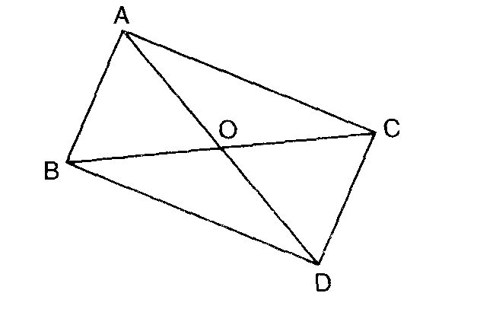
- If two zeroes of the polynomial x⁴+3x³-20x²-6x+36 are and - , find the other zeroes of the polynomial.
- In figure, ABC and DBC are two triangles on the same base BC. If AD intersect BC at 0. Prove that:.
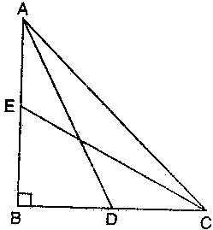
OR
In given figure AD and CE are medians of a triangle ABC right angled at A. prove that $4({\text{AD}}^{2}+{\text{CE}}^{2})=5{\text{AC}}^{2}$

- Prove that the lengths of two tangents drawn from an external point to a circle are equal.
Use the above theorem to prove the following: A circle is touching the side BC of ∆ ABC at P and touching AB and AC produced at Q and R respectively. Prove that: AQ = (Perimeter of ∆ ABC)
- Solve the following pairs of equations: (a – b) x + (a + b) y = a² – 2ab – b²
(a + b)( x + y) = a² + b²
- If the points P(x, y) is equidistant from the points A (5, 1) and B (-1, 5). Prove that 3x = 2y.
OR
If A (-2,-2) and B (2,-4) are points of the line segment AB, find the co-ordinates of P lying on AB if AP=3/7AB.
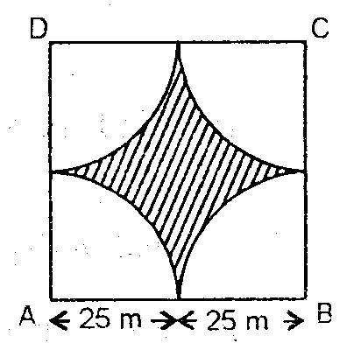
- Four cows are tethered at four corners of a square plot of
Side 50 inches, so that they just cannot reach one another.
What area will he left ungrazed?

- ABCD is a quadrilateral formed by the points A( -1, -1), B( -1, 4 ),C( 5, 4 )and D( 5, -1 ). P, Q, R and S are the mid-points of AB, BC, CD and DA respectively. Name the type of quadrilateral PQRS.
SECTION – D

- Two pillars of equal height stand on either side of a roadway which is 150 m wide. From a point on the roadway between the pillars the elevations of the top of the pillars are 60 ⁰ and 30⁰. Find the height of the pillars and the position of the point.
OR
From a window (60 meters high above the ground) of a house in a street the angle of elevation and depression of the top and the foot of the another house on opposite side of street are 60º and 45º respectively. Show that the height of the opposite house is 60(1+√3) meters.
- Prove that in a triangle, if square of one side is equal to the sum of the squares of the other two sides, then the angle opposite to the first side is a right angle.
Using the converse of above, determine the length of an altitude of an equilateral triangle of side 2 cm
- A tent in the form of a right circular cylinder up to a height of 4 m and base diameter 4.2 m is surmounted by a cone of equal base and height 2.8 m. Find the capacity of the tent and the cost of the canvas required at the rate
Of Rs.100 per m².
- A boat covers 32 km upstream and 36 km downstream in 7 hours. Also, it covers 40 km upstream and 48 km downstream in 9 hours. Find the speed of the boat in still water and that of the stream.
OR
Roohi travels 300km to her home partly by train and partly by bus. She takes 4 hours if she travels 60km by train and rest by bus. If she travels 100km by train and rest by bus she takes 10 minutes longer. Find the speed of the train and bus separately.

- The mean of the following frequency table 50. But the frequencies F1 and F2 in class 20 – 40 and 60 – 80 are missing. Find the missing frequencies.
Class | 0 – 20 | 20 – 40 | 40 – 60 | 60 – 80 | 80 – 100 | Total
Frequency | 17 | F1 | 32 | F2 | 19 | 120

Paper Submitted by:
Anil kumar
Email :- urdaksh@gmail.com
Phone No. 9818824279

206/27 A, SADAR BAZAR, DELHI CANTT-10 PH.65959896, 9818824279

