TIME:3HR M.MARKS: 100
CLASS: X
MATHEMATICS

General Instructions
(i) All questions are compulsary.
(ii) This question paper consists of 25 questions divided into three sections. Section A
(Q.1to 10), Section B (Q. 11 to 20) and Section C (Q 21 to 25).
(iii) As far as possible answer questions in serial order. When you are not sure of
answering the question, you may leave it for the tine being and proceed further
without wasting your time.
(iv) When you wish to re-answer any question, please cancel the first one.
(v) Use of a calculator is not permitted.
(vi) Keep some time for revision.
(vii) Please, write down the serial number of the question before attempting it.
(viii) Use of calculator is not allowed. However, you can use Mathematical Tables.

SECTION A
(Question numbers 1 to 10 carry three marks each).

1. Find the value of k for which the system of equations have a unique solution:
x −ky = 2, 3x+ 2y = −5

2. Find the GCD (HCF) of the polynomial 2x⁴ − 2y⁴, 3x³ + 6x²y − 3xy² − 6y³

3. Simplify :

4. Solve using quadratic formula, for x : a(x² + 1) = x(a² + 1)

- Which term of A.P. 3, 15, 27, 39 ------- is 132 more than 54th term.

- Find the sum of the following A.P. 1 + 3+ 5+ 7 -------------199

7. A cooler is sold for Rs.4000 cash or for Rs.1600 cash down payment and two installments
of Rs.1300 paid monthly. Find the rate of interest.

8. A loan of Rs.12,000 is obtained by Shiela to repair her house. The amount is to be paid
back in equal 2 annual instalments. How much is each instalment, if the interest is
compounded annually on balance at 5% p. a.

- Show that the diagonals of a trapezium divide each other proportionally.

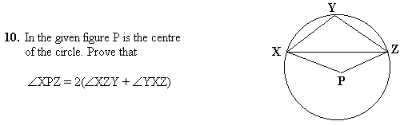

SECTION B
Question numbers 11 to 20 carry four marks each.

- Solve graphically the equation x − y =10, 2x −3y = − 10.

12. Simplify:

13. What point on the X- axis is equidistant from the points (7,6) and (− 3,4)

14. Prove that

15. An agricultural field is in the form of a rectangle of length 20m and width 14m. A 10m
deep well of diameter 7m is dug in a corner of the field and the earth taken out of the
well is spread evenly over the remaining part of the field. Find the rise in its level.

- Draw a pie chart representing the following data showing the number of
Students who like different subjects:
Subject No. of Students
Physics 45
Chemistry 20
English 60

