Guess Paper – 2009
Class – XII
Subject – Physics
(Alternating Current)

Q 1 What is meant by impedance? Using a phasor diagram or otherwise derive the expression for the impedance of an a.c. circuit containing L, C and R in series. Find the expression for resonant frequency.
Marks (5)
Q 2 What is choke coil? Why is it preferred to resistance in a.c. circuit? If the frequency of emf is increased, then what will be the effect on the currents flowing through the circuits given below?
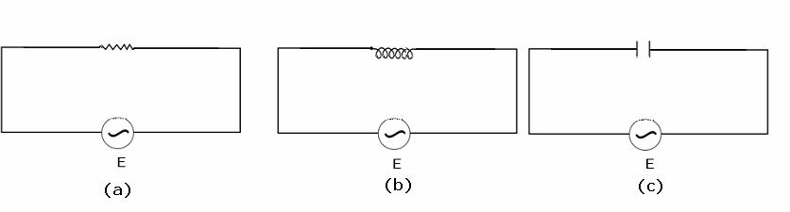
Marks (5)
Q 3 An a.c. circuit containing 800 mH and a 60 μF capacitor is in series with 15 ohm resistance.They are connected to 230 volt, 50 hz a.c. supply.Obtain the average power transferred to each element and the total power absorbed.
Marks (5)
Q 4 An a.c. circuit having an inductor and a resistor in series draws a power of 560 W from an a.c. source marked 210 V,60hz.If the power factor of the circuit is 0.8 ,calculate
(a) the impedance of the circuit.
(b) the inductance of the inductor used.
Marks (5)
Q 5 A 100 mH inductor , a 25 μF capacitor and a 15 ohm resistor are connected in series to a 120 volt,50 hz a.c. source. Calculate the
(a) impedance of the circuit at resonance.
(b) current at resonance.
(c) resonant frequency.
Marks (5)
Q 6 When a series combination of inductance and resistance are connected with a 10V ,50 hz a.c. source, a current of 1 A flows in the circuit.The voltage leads the current by a phase angle of 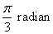.Calculate the value of resistance and inductance.

Paper Submitted by:
MANISH JHA
Email dikshaworld@gmail.com
Phone No. 011-41642844

