SAMPLE PAPER - 2009
Class - X
SUBJECT – Mathematics

TIME: 3 HOURS MAX MARKS: 80
SECTION - A

- If the H C F of 309 and 657 is 9, find their L C M.
- If α and β are the zeros of the polynomial 3x² – 5x + 7, find the value of .
- The system of equations 3x – 4y + 7= 0, kx + 3y – 5 = 0 is inconsistent. Find the value of k.
- Find the coordinate of the point at which the line 3x + 2y = 12 intersects the x-axis.
- Find the 10th term of the A.P. ,........
- If 3 sin² θ = 2, find the value of θ.
- Find the distance between the points (a cos 35⁰, 0) and (0, a cos 65⁰)
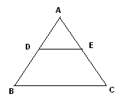
- In Δ ABC, DE // BC, so that AD = 2.4 cm, DB = 3.2 cm, and AC = 9.6 cm, then find EC?

- Find the perimeter of a sector of a circle of radius 14 cm and central angle 60⁰.
- In a throw of a pair of dice, what is the probability of getting a sum more than 7.

SECTION – B

- Find the 12th term from the end of the A.P. 3, 8, 13, .............., 253
- If 3 cos θ – 4 sin θ = 2 cos θ + sin θ, find tan θ.
OR
If tan 2x = cos 60⁰ + sin 45⁰ cos 45⁰, find the value of x.
- The diagonal BD of a parallelogram ABCD intersects the segment AE at the point F, where E is any point on the side BC. Prove that: DF × EF = FB × FA
14. Find the value of k, if the point P (0, 2) is equidistant from (3, k) and (k, 5).
- From a pack of 52 playing cards jacks, queens, kings and aces of red colour are removed. The remaining cards are shuffled and one card is taken at random. Find the probability that the card drawn is (i) a face card (ii) neither queen nor king.

SECTION – C

- In a morning walk three persons step off together, their steps measure 80 cm, 85 cm and 90 cm respectively. What is the minimum distance each should walk so that they can cover the distance in complete steps?
- Solve:
OR
If ‘– 5’ is a root of the quadratic equation 2x² + px – 15 = 0 and the quadratic equation p(x² + x) + k = 0 has equal roots, find the value of k.
- If α and β are the zeros of the polynomial f(x) = 3x² – 6x + 4, find a quadratic polynomial whose zeros are (α + β) and (α – β).
- Prove that: (sin θ + sec θ)² + ( cos θ + cosec θ)² = (1 + sec θ cosec θ)²
OR
If x = r Sin A cos C, y = r sin A sin C and z = r cos A, prove that r² = x² + y² + z².
- The sum of the third and the seventh terms of an A.P. are 6 and their product is 8. Find the sum of first 16 terms of the A.P.
- The vertices of a Δ ABC are (1, 2), (3, 1) and (2, 5). Point D divides AB in the ratio 2 : 1 and P is the mid-point of CD. Find the coordinates of the point P.
OR
The line joining the points (2, 1) and (5, – 8) is trisected at the points P and Q. If the
point P lies on the line 2x – y + k = 0, find the value of k.
- The area of a triangle is 5. Two of its vertices are (2, 1) and (3, – 2). The third vertex lies on y = x + 3. Find the third vertex.
Page 2 of 4
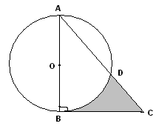
- Let ABC be a right triangle in which AB = 7 cm and B = 90⁰ and BC = 5 cm. BD is the perpendicular from B on AC. The circle through B, C, D is drawn. Construct tangents from A to this circle.
- In the adjoining figure ABC is a right angled triangle,
B = 90⁰, AB = 6 cm and BC = 6√3 cm. AB as diameter circle is drawn which intersects the circle at D. Then find the area of shaded region.

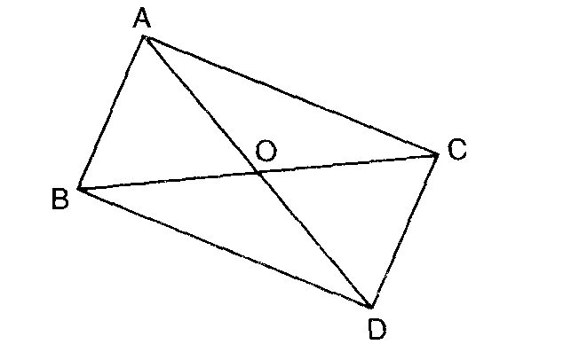
- In figure, ABC and DBC are two triangles on the same base BC. If AD intersect BC at 0.
Prove that:

SECTION – D
- Determine graphically the vertices of the triangle, the equations of whose sides are given below:
2x – y + 1 = 0; x – 5y + 14 = 0; x – 2y + 8 =0
- State and prove the Pythagoras theorem.
Using the above theorem prove the following:
In an isosceles triangle ABC with AB = AC, BD is perpendicular from B to the AC.
Prove that: BD² – CD² = 2 CD. AD
- A boy is standing on the ground and flying a kite with a string of 150 m, at an angle of elevation of 30⁰. Another boy is standing on the top of a 25 m tall building and is flying his kite at an elevation of 45⁰. Both the boys are opposite sides of both the kites. Find the length of the string in metres, correct to two decimal places that the second boy must have so that the two kites meet.
OR
Two pillars of equal height stand on either side of a roadway which is 150 m wide.
From a point on the roadway between the pillars the elevations of the top of the
pillars are 60⁰ and 30⁰. Find the height of the pillars and the position of the point.
- A right triangle, whose sides are 15 cm and 20 cm, is made to revolve about its hypotenuse. Find the volume and surface area of the double cone so formed. (Use π = 3.14)
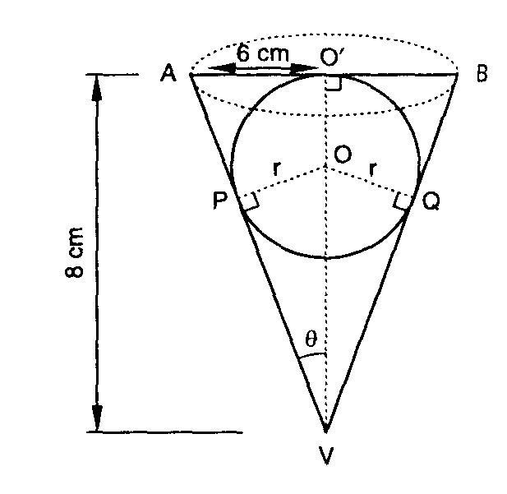
OR
A conical vessel of radius 6 cm and height 8 cm is completely filled with water. A sphere is lowered into the water and its size is such that when it touches the sides, it is just immersed as shown in the figure. What fraction of water overflows?

- Compute the missing frequencies $f_{1}$ and $f_{2}$ in the following data if the mean is $\text{166}\frac{9}{\text{26}}$ and the sum of the observations is
Classes | Frequency
140 – 150 | 5
150 – 160 | $$f_{1}$$
160 - 170 | 20
170 – 180 | $$f_{2}$$
180 – 190 | 6
190 – 200 | 2
Total | 52

Paper Submitted by:
HaraGopal
Email :- haragopal_r@yahoo.co.in
Phone No. +919885911608

