SAMPLE PAPER - 2009
Class - X
SUBJECT – Mathematics

MARKS: 80M TIME: 2 ½ Hrs

I. Answer the following. 10 x 1M = 10M

- What is the probability of getting a vowel from the word “MATHEMATICS”?
- If a, b are 2 positive even numbers then their LCM is _________.
- Find the center of the circle whose vertices of diameter is given by (3, 2) and (5, 6).
- If x=2 is a root of a quadratic equation 2x²+k-6=0 then k value is ______.
- If a, b, c are the 3 consecutive terms of an AP then express ‘b’ in terms of a, c.
- A bi-quadratic polynomial contains a maximum of ______ roots.
- In a right triangle ABC, right angled at B, if angle A =90 then _____ side=0.
- What is the area of circle whose radius is √Π cm?
- Which is the middle term of an AP whose total no. of terms is “2n”?
- What is the area of the largest triangle that can be inscribed in a semi-circle?
(Prepared by Siva Shankar)

II. Answer the following. 5 x 2M = 10M

- Find the HCF of the numbers 4052 and 12576 using Euclid’s Division Algorithm?
- On dividing x³-3x²-x+2 by a polynomial g(x), the quotient and the remainder were x-2 and -2x+4. Find g(x).
(OR)
Prove that the area of semi-circle on the hypotenuse of a right triangle is equal to the sum of the areas of semi-circles on the other 2 altitudes.
(Prepared by Harsha & Charan)
- Which term of the AP -121, -117, -113 . . . is the first positive term?

- If a dice is thrown twice, then what is the probability of getting
a). Same number on two dice
b). At least 5 as the sum on two dice
c). At most 10 as the sum on two dice
d). 1 as the sum on two dice

- Prove that “The lengths of tangents drawn from an external point to a circle are equal”.
III. Answer the following. 10 x 3 M =30M

- Aftab tells his daughter “Seven years ago, I was seven times as old as you were then. Also three years from now I shall be 3 times as old as you will be”. Solve this graphically.
- Speed of a boat in still water is 15km/hr. It can go 30km upstream and return downstream to the original point in 4hrs and 30 minutes. Find the speed of stream.

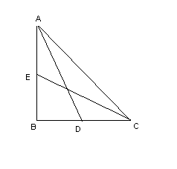
- In a ∆ABC whose two vertices are A(6, 3) and B(-5,1) and the centroid ‘G’ is given by (5,2), then the find the area of triangle ABC.

- If angle B and angle Q are the acute angles such that sin B = sin Q then prove that angle B = angle Q.

- In ∆ABC, angle B = 90 AD and CE are the medians drawn to BC and AB respectively. If AC = 5cm and AD = (3√5/2) cm, then find the length of CE.
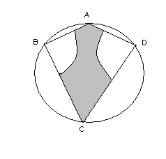
- ABCD is a kite that inscribed in the circle. And AC is the diameter of the circle. If AD=3cm and BC = 4cm. And B, D is as the centers with 2cm radius two sectors are drawn. Then find the area of shaded region.

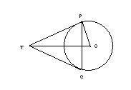
- If a sphere of radius 3cm is melted and recast into 27 equal spheres, then what is the ratio between surface area of bigger sphere and that of smaller one?

- PQ is a chord of length 8cm to a circle of radius 5cm. the tangents at P & Q meet at the point T. Find the length of TP.

- Draw a circle with 3cm radius. Take a point P on the circle; draw a tangent PQ at ‘P’ whose length is 5cm. From the point Q draw another tangent to the circle.

Class Interval | 45-55 | 55-65 | 65-75 | 75-85 | 85-95
Frequency | 3 | 10 | 11 | 8 | 3
Find the mode of given data.

IV. Answer the following 5 X 6M = 30M

- A copper wire, 3mm in diameter is wound about a cylinder whose length is 12cm and diameter 10cm so as to cover the curved surface area of the cylinder. Find the length and mass of wire. Assuming the density of copper to be 8.88 gm/cm^{3.}

Age in yrs | No. of Policy holders
Below 20 | 2
Below 25 | 6
Below 30 | 24
Below 35 | 45
Below 40 | 78
Below 45 | 89
Below 50 | 92
Below 55 | 98
Below 60 | 100
Find the median of given data.

- a). State and prove Pythagoras theorem. 4M
b). Prove that mid-point theorem using converse of BPT. 2M

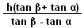
- If the angle of elevation of a cloud from a point ‘h’ meters above a lake is ‘α’ and the angle of depression of its reflection in the lake is ‘β’. Then prove that the height of cloud is

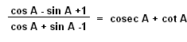
- a). Prove that using the identity

cosec²A = 1+cot²A 4M.
b). If tan A and tan B are the roots of x2-Ax+B and cot A and cot B are the roots
of x2-Cx+D, then find the value of ‘C x D’ in terms of A &B. 2M

(Prepared by Vineeth)
haragopal_r@yahoo.co.in

Make your failure as the ‘Stepping Stone’ to your way,
Then only your success will be a ‘Milestone’ in the history.

Good Luck

