Guess Paper – 2009
Class – XII
Subject –Informatics Practices

M.M:70 Time : 3 hrs
Note : Question paper has 3 section of 30, 20 and 20 marks.
All the question are compulsory

SECTION A
Q 1 Answer the following question :
a) Define – (i) Freeware ii) Shareware iii) OpenSource iv) Tomcat 2
b) What is the purpose of Data Mining? 2
c) Define the following terms. 2
i) Data Dictionary ii) Data Warehousing
d) What does object modeling technique mean? Why do we use UML? 2
e) Explain Localization & Internationalization. 2
Q 2 Answer the following question :
a) Explain the following terms:
i) Startup Form ii) Load Statement iii) Show Method iv) Event 2
b) How is a standard module different from a form module? Explain with example. 2
c) Explain the term Data Provider and Data Control. 2
d) Write one difference and one common characteristic between a control and a
variable in Visual basic? 2
e) What do understand by OLE? 2
Q 3 Answer the following question :
a) What is the need of normalization? Define second normal form. 2
b) State the difference between –
i) Constraints and Triggers. ii) Before and After trigger 2
c) Define database Transaction. What is the role of SavePoint in database transaction?
d) What is Network Protocol? Discuss the functioning of TCP/IP Protocol? 2
e) What is Distributed database? Name the keyword used to : 2
(i) Force every value in a column to be different. (ii) To make a new Table.
(iii) assign a value as no data (iv) In a column value comes automatically.
SECTION B
Q 4 Read the following case study and answer the question that follow :
Bharti School has computerized its school Admission system for classes 6th to 8th. The following is the data entry screen used.
1 When the form load, the textboxes for attributes Marks, Total marks and result should be disabled. 1
2 When the user clicks clear button, all the values stored in text boxes and check boxes should be cleared. 2
3 Check that the Marks in test (txtmarks) entered are in the range 0 to 75. 2
4 Marks in Attributes marks textbox automatically shows the marks when
User click on any Attributes 3
5 When the command button with caption “find results” is clicked total marks
and result are calculated, based on the criteria given below and displayed in appropriate text boxes. 2

* The criteria for calculation of attributes marks is as given below :
Neighbourhood Child | 5 marks
Responsible Parents | 10 marks
Parents are alumni | 5 marks
Sibling of our student | 5 marks
- Total Marks is calculated as Attributes marks + Marks in Test.
- If Total marks are above 80, display result as Selected otherwise display result Not selected
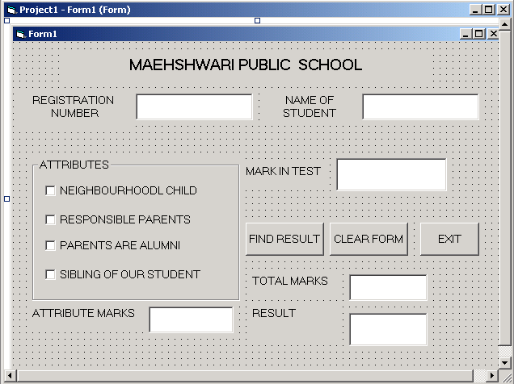
Q 5 a) Find the error from the following code segment and rewrite the corrected code underlining the correction made(VB):
x=50 ; y=10
For I = 1 to 100 then
if x mod 6 = 0
print x+y
End
x = x**x+y*2
y + 1 = y
Loop
b) Find the output of the following code segment:
Dim st as string, I as integer
st = "Happy New Year"
For i = 1 To Len(st)
If i Mod 4 = 1 Then
ss = Mid(st, i, 1)
ss = ss + "SS"
Print ss;
End If
Next
c) Change the following code using FOR loop without affecting the output.
I = 6
x = 1
Do while I >=1
x = x - 2
If x = 0 then
Print “Zero”
End if
Print I
I = I -2
Loop
d) Write a procedure that calculates and displays the volume of a cuboid. The procedure takes three parameters for length, width and height of the cuboid respectively. The last two parameters are optional. If the last two parameters are not passed then the volume of a cube having sides equal to the first parameter is to be calculated. (Volume of Cuboid = L * B * H) 2
e) Write a procedure in VB that takes in year of birth of a person as an argument. It display a message box indicating how many years are left for the person to reach the retirement age of 60. If the user is older than 65, wish him/her for a long life. 2
SECTION C
Q 6 a) Write the output produced by the following part of code in PL/SQL: 2
DECLARE
P NUMBER;
Q NUMBER;
BEGIN
P := 5;
FOR Q IN 1..4
LOOP
P := P + Q;
DBMS_OUTPUT.PUT_LINE(P);
END LOOP;
END;
b) DECLARE 2
P Number;
Q Number;
Begin
P := -2;
Q := 5;
for I in 5.. 7 loop
Q = Q + 2;
P := Q;
if P > Q then
dbms_output.put_line(P);
end if;
dbms_output.put_line(I);
end loop;
end ;
c) Find Error in the following code, underline errors and rewrite the correct code.
DECLARE
NUMBER Total ;
BEGIN;
Total := 30;
LOOP
Total := total***3;
DBMS_OUTPUT.PUT_LINE(total);
EXIT WHEN total>2000;
ENDLOOP;
END;
d) Write a PL/SQL Function Power that take Two Number as arguments and Return the value of the First Number to the raised to the Power of the Second, But if First Number is greater than Second than return Factorial of First Number.
Q 7
COLUMN | DATATYPE | SIZE | CONSTRAINT
Room_No | Number | 4 | Primary key
Room_Type | Varchar2 | 20 | Allowed values :  Suite, Deluxe, Economy
Current_Status | Varchar2 | 20 | Allowed values:  Vaccant, Occupied
Customer_name | Varchar2 | 20
a) Write an SQL statement to add new field ‘PAYMENT’ as Number type with size of 8 digit including last two digit for decimals and it should be more than zero. 1
b) Write an SQL command to display the Name and room number of all customer whose name start with ‘R’ and type of uses Economy room. 1
c) Write the SQL command to display the detail of the customer with highly paid in each room_type 2
d) Write a PL/SQL code to display the records of all customer of particular status. Also display the total payment by all customer if status is ‘occupied’ and if status is ‘vacant’ then print appropriate message. 2
e) Write a stored procedure Disp_Out to display the details of the customer of particular room number. Room number is accepted as parameter. 2
f) Create Trigger that make customer name as NULL and room type as Economy if current status is Vaccant. 2

Paper Submitted by:
Ravi Goyal
Email :- aashishgoyal23@yahoo.com

