Sample Paper – 2009
Class – XII
Subject – Mathematics

INDEFINITE INTEGRALS
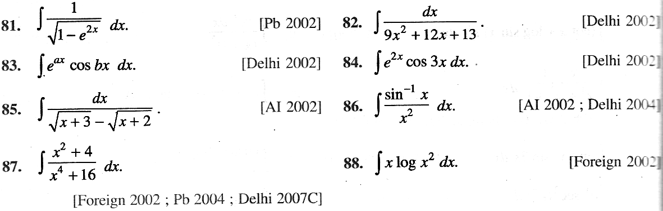
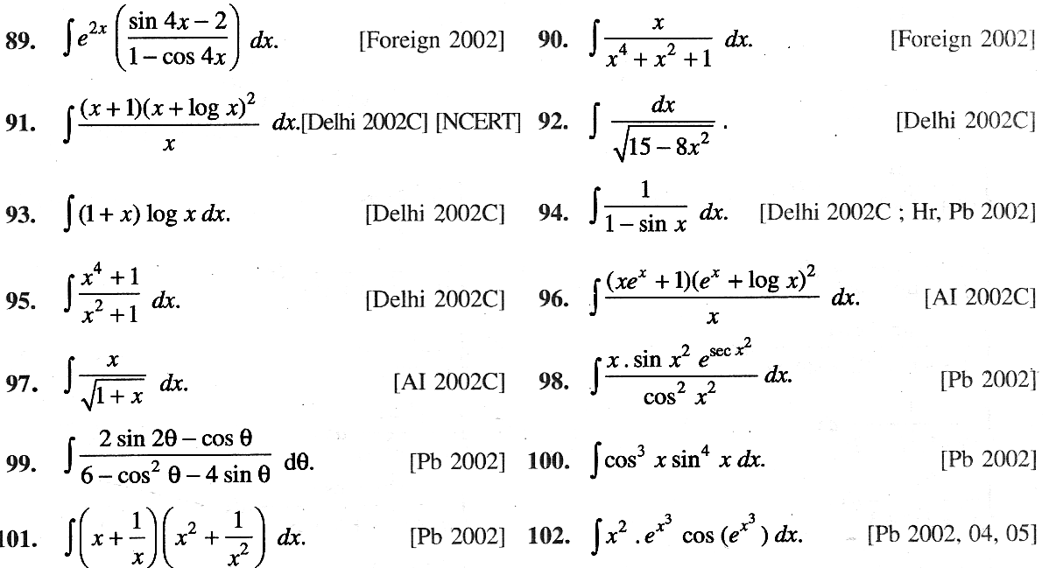
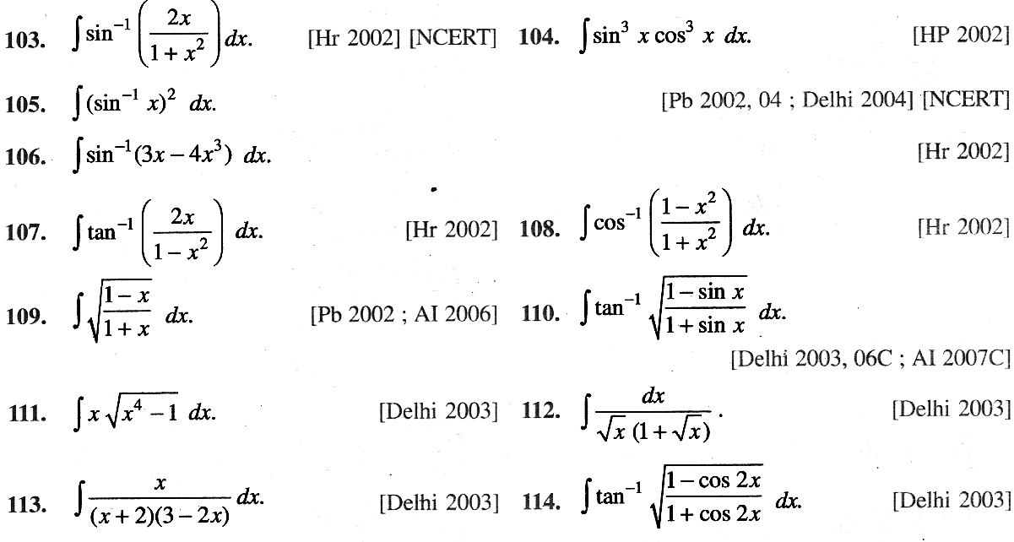
Page (3/4)

DEEPAK TUITION CENTER
A – 98, NEW MOTI NAGAR, NEW DELHI – 110 015 Ph: 25176448

