Sample Paper – 2009
Class – X
Subject – MATHEMATICS

Roll. No. Code. No. 041/02
Time: 3 hrs Maximum Marks: 80

General Instructions:
( i ) All questions are compulsory.
( ii ) The question paper consists of 30 questions divided into four sections – A, B, C and D. Section A
contains 10 questions of 1 mark each, Section B is of 5 questions of 2 marks each, Section
C is of 10 questions of 3 marks each and section D is of 5 questions of 6 marks each.
( iii ) There is no overall choice. However, an internal choice has been provided in one question of
two marks each, three questions of three marks each and two questions of six marks each.
( iv ) In question on construction, the drawing should be neat and exactly as per the given
measurements
( v ) Use of calculator is not permitted. .

SECTION A

- If the HCF of 210 and 55 is expressible in the form 210 x 5 + 55y, find y.
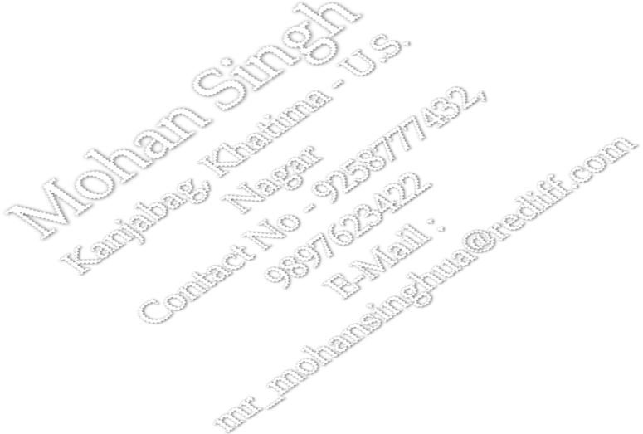
- If a and b are the zeros of the quadratic polynomial f(x) = 2x² + 5x + k satisfying the relation
a² +b² + ab = 21/4, then find the value of k for this to be possible.
- For what value of k, the following pair of linear equations has no solutions.
kx - y = 2; 6x – 2y = 3.
- Divide 16 into two parts such that twice the square of the larger part exceed the square of the smaller part by 164.
- If sin A = 4/5, find the value of : 4 Tan A – 5 Cos A / Sec A + 4 Cot A
- The perimeters of two similar triangles ABC and PQR are 36 cm and 24 cm respectively. If PQ = 10cm, find AB.
- Find the area of the sector of a circle with radius 4 cm and angle 30. Also find the area of major sector.
- The dimensions of a metallic cuboid are: 100cm x 80cm x 64cm. It is melted and recast into a cube. Find the surface area of a cube.
- Three measure of Central Tendency is given by :
- Determine the general term of an A.P, whose 7th term is – 1 and 16th term is 17.

SECTION – B

- Prove that 1 - 1 = 1 - 1 .
Secθ - tanθ cosθ cosθ secθ + tanθ
- Three unbiased coins are tossed. Find the probability of getting :
i. 2 heads ii. At least two heads iii. At most two heads iv. One heads or two heads.
13. If the points A ( 6, 1 ), B ( 8, 2 ), C ( 9, 4 ) and D ( p, 3 )are the vertices of a parallelogram taken in
order, find the value of p.
- ABC is a triangle right angled at A and AD⊥BC. Show that AC² = BC.CD.
- Which term of the A.P 1, 10, 19, 28, 37 …is 153 more than its 25th term?

SECTION – C

- Prove is an irrational number.
- A sum of Rs 700 is to be used to give seven cash prizes to students of a school for their overall academic performance. If each prize is Rs 20 less than its preceding prize, find the value of each of the prizes.
- Prove : cot A + cosec A – 1 = 1 + cos A
cot A – cosec A + 1 sin A
- If Solve by the method of cross – multiplication : ( a – b ) x + ( a + b ) y = a ² – 2 ab – b²
( a + b )( x + y ) = a + b.
- Draw a triangle ABC in which BC=6cm , AB=5cm and ∠ABC=60 then construct a triangle similar to the given triangle whose each corresponding side is 3/4th of that of triangle ABC.
- In fig. a circle touches all the four sides of a quadrilateral ABCD whose sides are AB = 6cm, BC = 7cm and CD = 4cm. Find AD.
D R C

S Q

A P B
- Solve the system of linear equations graphically:
x + y = 4; 3x – 2y = - 3
Shade the region bounded by the lines representing the above equations and x - axis. Determine
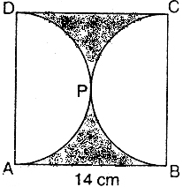
the ratio in which the points (6,a)divides the join of A (-3, -1) & B (-8, 9). Also find the value of “a”.
- In given figure, ABCD is a square whose each side is 14 cm. APD and BPC are semicircles.
Find the area of the shaded region.

- The line joining the points ( 2, 1 ) and ( 5, -8 ) is trisected at the points P and Q. If point P lies on the line 2x – y + k = 0. Find the value of k.
- L and M are the mid points of AB and BC respectively of $Δ\text{ABC}$, right angled at B prove
That $4{\text{LC}}^{2}={\text{AB}}^{2}+4{\text{BC}}^{2}$

SECTION – D

- A bird is sitting on the top of a tree, which is 80m high. The angle of elevation of the bird from a point on the ground is 45º. The bird flies away from the point of observation horizontally and remains at a constant height. After 2 seconds, angle of elevation of the bird from the point of observation becomes 30º. Find the speed of the bird.
- In a right triangle, the square of hypotenuse is equal to the sum of squares of other two sides.
A ladder 13m long, placed against a wall reached a window 12m above the ground. Due to some
fault, the foot of the ladder slipped 7m. How high above the ground is the other end of the ladder now?
- A boat can go 20km downstream and 30 km upstream in 3 hrs. It can go 20km downstream and 10 km upstream in 1$\frac{2}{3}$hrs. Find the speed of boat in still water and speed of stream.
- A building is in the form of a cylinder surmounted by a hemispherical vaulted dome ,the building contains 17.7 m³ of air and its internal diameter is equal to the height of the cylindrical part find the height of the building
(use $π=\frac{\text{22}}{7}$)
- The lengths of 40 leaves of a plant are measured correct to the nearest mm, and the data obtained is represented in the following table.
Length ( in mm ) | Number of leaves
118 - 126 | 3
127 - 135 | 5
136 - 144 | 9
145 - 153 | 12
154 - 162 | 5
163 - 171 | 4
172 - 180 | 2
Find the median length of the leaves. Draw a less than type ogive and more than type ogive for the given data.
Hence obtain the median weight from the graph and verify the result by using formula.

Mohan Singh
Saraf Public School
Khatima : U.S.Nagar( Uttarakhand )
Contact : +919258777432, +919897623422
E-Mail : mr_mohansinghua@rediff.com

