Guess Paper – 2010
Class – X
Subject – Maths

SECTION – A
- Why is 7x11x13+7 a composite integer.
- If Find zeros of Polynomials.
- Find a quadratic polynomial, whose roots are
- Find the first three terms of the series if the sum of n terms is 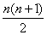
- Fill in the blank:
- The length of minute hand of a clock is 21 cm. Find the area swept by the clock in 2 minutes.
- Three coins are tossed together. Find the probability of getting exactly two heads.
- The mean of six observation 10 , 5, x, 3, 9,15 is 9. Find x.
- Two cubes each of 12 cm edge are joined end to end. Find the surface area of the resulting cuboid.
- Triangles ABC and PQR are similar triangles. Area of Triangles ABC and Triangle PQR are 16 sq cm and 81 sq cm. If QR= 8 cm find BC. .SECTION – B
- If one root of the quadratic equation is 2, find the value of .Also find the other root .
- Prove that 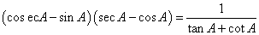 OR Prove that 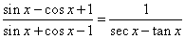
- Find a relation between x and y such that the point (x , y) is equidistant from the points (7, 1) and (3, 5).
- ABC is a right triangle right-angled at B. Let D and E be any points on AB and BC respectively. Prove that
- A bag contains 5 red, 8 white and 7 black balls. A ball is drawn at random from the bag. Find the probability that the drawn ball is
(i) red or white.
(ii) not black.
(iii) neither white nor black.

Using quadratic formula solve the equation for
- .SECTION C
- Find all the Zeroes of if two of its Zeros
are
- Find the sum of the first 40 positive integers divisible by 7.
- Use Euclid’s Division Lemma to show that the square of any positive integer is either of the form 3m or 3m+1 for some integer m.
- For what value of n are the nth terms of two A.P.’s 63,65,67 ….. and 3,10,17………..equal? OR If the mth terms of an A.P. is equal to n times its nth term , find the (m+n )th term of the A.P.
- Draw a right triangle in which the sides containing the right angle 5 cm and 6 cm. Construct a similar triangle whose sides are 5 times the sides of the above triangles. 3
- The Perpendicual AD on the base BC of a ΔABC intersects BC at D. So that DB= 3CD. Prove that 2 AB² = 2 AC² + BC²
- Sum of the areas of two squares is 468 m². If the difference of their perimeter is 24 m, find the sides of two squares.
Evaluate sec² (90–θ) – cot²θ ₊ 2 cos² 60º tan² 28º tan²62º
- 2 (sin² 25 + Sin²65) 3(Sec²43º – cot ² 47 withouts using trigonometric table.
- Prove is an irrational number. SECTION D
- Four equal circles, each of radius 7cm touch each other as shown in figure. Find the area included between them.
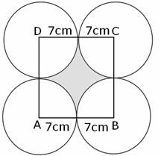
Q 27. Prove that in a right triangle, the square of the hypotenuse is equal to the sum of the squares of the other two sides
Use the above theorem in the figure to prove that
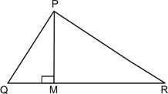

Q.28 If a line is drawn parallel to one side of a triangle intersecting the other two sides, then the other sides are divided in the same ratio. Prove this theorem Using above theorem, prove that in the figure if is a trapezium in which then
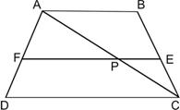

Q29. There are 50 students in a class. The marks obtained by them are represented in the following table.

marks | Number of leaves
0 - 10 | 8
10 - 20 | 6
20 - 30 | 9
30 - 40 | 12
40 - 50 | 5
50 - 60 | 6
60 - 70 | 4

Find the medain Draw the less than type ogive and more than type ogive for the given data.

Q.30. The angle of elevation of the top of a tower from a point P on the ground is 30^{0.} On moving a distance of 20 m towards the foot of the tower to a point Q the angle of elevation increases by 30⁰. Find the height of the tower and distance of the tower from the point P.

Paper Submitted by: Mukesh Kumar Grover
Email : mkgroverkch@sify.com
Prepared by Cambridge Study Circle

CAMBRIDGE STUDY CIRCLE
11/55 SUBHASH NAGAR, NEW DELHI-10027
Ph:9899000936 Email:mkgroverkch@sify.com

.

