Sample Paper – 2010
Class – XII
Subject – Informatic Practices

(Section A)

Q1. Answer the following Questions
- “Visual Basic is not an Object Oriented Language” Justify this statement. 2
- How is a standard module different from a form module? Explain with example. 2
- Why do we need Control structures ? mention the classification of Control structures With Syntaxes ? 2
- Write difference between Fix() and Int() functions. 2
- Write characteristics of MDI Child Form. 2
- What do you mean by Arranging Child Windows. Write syntax and values for the same. 2
- Explain IIF() function with the help of an example. 2
- What is ADO data control? To whom you can connect this? 2
- What do you understand by the term Record Source of an ADO data control? 2
- Distinguish between call by Val and call by Reference in visual basic. 2
- Mention the limitations of Simple loop ? how to make simple loop as finite loop ? 2
- Explain the following terms:
i) Startup Form ii) Load Statement iii) Show Method iv) Event 4
- Which controls function as a Data – Bound controls ? 4

(Section B)
Q 2.
a). Write a VB Procedure that takes “maxrows” and “maxcols” as argument to generate a output given below. using nested loop. 3.
The output will be like this:
0 2 3 4 5
2 0 6 8 10
3 6 0 12 15
4 8 12 0 20
5 10 15 20 0

b). Write a sub procedure in VB which take two integers as argument and print it’s the reminder and quotient without using mod and division operator. 2.

c). Write a procedure in VB to generate the series given below: 2
1, 3, 6, 10, 11, 13, 16, 20, …………………………….50

d). A program accepts 5 strings in an array arrname(4). Further the program finds the longest string in the array and prints it. Write the VB program to achieve this. 3

Q3.
a). Convert the do while loop into for next loop without affecting its output. 2
i = -10
do while i <5
If i mod 2 = 0 then
Num = num + i
End if
Print num
i = i - 3
loop

b). Convert the do loop until into for next loop without affecting its output. 2
Dim count, ans
Ans=5
Count = 25
DO
Ans = ans + Count
Count = count – 3
Print Ans*Count;
Loop Until count <= 8
Print ans;
c). Find the output of the following code segment: 2
dim st as string, s as integer, t as integer
st =MID (“Year of Luck 2009”,14,4)
s =Val(MID(st,1,1))* Val(MID(st,4,1))
t = Val(MID(st,1,1))+ Val(MID(st,4,1))
print s*t;
d). Re-write the following using If Else Structure: 2
Private Sub Command1_Click( )
n = InputBox("Enter The Month", "Number", 0)
m = InputBox("Enter The year", "Number", 0)
If n = 1 Or n = 3 Or n = 5 Or n = 7 Or n = 8 Or n = 10 Or n = 12 Then
Print "31 days"
ElseIf n = 4 Or n = 6 Or n = 9 Or n = 11 Then
Print "30 days"
ElseIf n = 2 Then
If m mod 4=0 then
Print "29 days"
Else
Print "29 days"
End if
Else
Print "Not a valid month no"
End If
End Sub
2. Re-write the following using If Else Structure: 2
Private Sub Command2_Click( )
n = InputBox("enter", "Number", 0)
Select Case n
Case 90 To 100
grade = "A"
Case 75 To 89
grade = "B"
Case 60 To 74
grade = "C"
Case 45 To 59
grade = "D"
Case 33 To 44
grade = "E"
Case 0 To 32
grade = "F"
Case Else
MsgBox "Out of Range"
End Select
Print grade
End Sub
Q 4. A School Data has two categories: Students and Staff. Design the VB Application to perform the task given below. The interface for the application as given below:
Object Type | Object Name | Description
Form | FrmDataEntry | Main Form
Frame | Fmrstudent | Student frame
Frame | Fmrstaff | Staff Framea
Text Box | Txtstfaname | To enter staff name
Text Box | Txtstfsal | To enter staff salary
Text Box | Txtteadob | To enter staff date of birth
Text Box | Txtstuname | To enter student name
Text Box | Txtstufname | To enter student father’s name
Text Box | Txtstudob | To enter student date of birth
Text Box | Txtstuscno | To enter student scholar number
Combo Box | Cmbstfpost | To select staff post
Combo Box | Cmbstuclass | To select student class
Option Button | Optteaching | To select staff type
Option Button | Optoffice | To select staff type
Option Button | optStudent | To Select Frame type
Option Button | Optstaff | To Select Frame type
Command Button | Cmdsavestu | To calculate fine
Command Button | Cmdsave staff | To clear the entered values

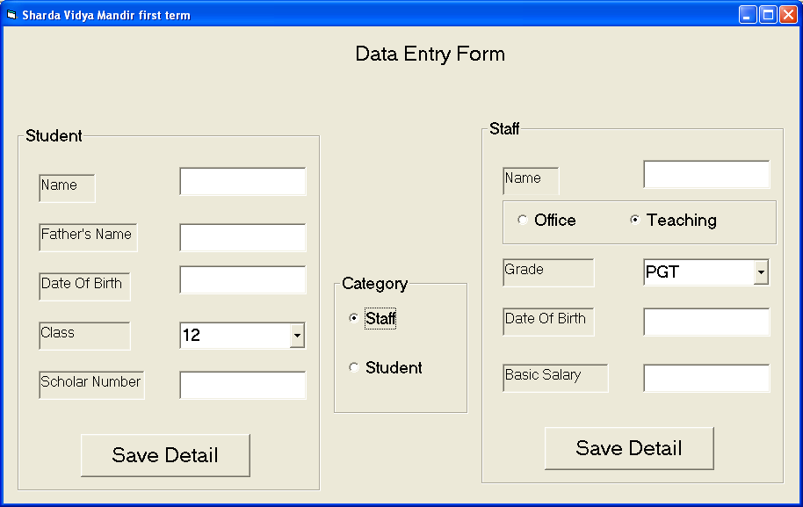
1. Write a VB procedure to check the first three character of scholar number should be SVM. 2.
2. When the user select optstaff then the objects of frame student should be disable and when the user select optstudent the objects of staff should be disable. 2.
3. In the combo box cmbstuclass and cmbstfpost the user is not allow to add the extra class or post apart from the list. 2
4. Write a VB Procedure to check weather the date of birth is valid or not be valid. 2
5. Write a VB procedure to change the list of the combo box cmbstfpost according to the selection of option button
If optoffice is selected then list of combo box cmbstfpost should display Manager, Clerk, Accountant.
If optteaching is selected then list of combo box cmbstfpost should display PRT, TGT, PGT. 2

Q5.

1. Find the output of the below VB program 4.
Sub one(a As Integer, b As Integer)
Print a, b
a = a + b
b = a - b
a = a - b
b = a + b
If b < 10 Then
Call two(a, b)
End If
Print a, b
End Sub

Sub two(ByVal a As Integer, b As Integer)
Print a, b
a = a + b
b = a - b
a = a - b
b = a + b
End Sub

Private Sub Command1_Click()
Dim x As Integer, y As Integer
x = 3
y = 4
Call one(x, y)
Print x, y
End Sub

2. Find the output of the below VB program 4.
Sub showe(a As Integer, c As String)
Print a, c
a = a + 1
End Sub

Private Sub Command1_Click()
Dim i As Integer
i = 1
Do While i < 9
If i < 3 Then
Call showe(i, "@")
ElseIf i < 7 Then
Call showe(i, "#")
Else
Call showe(i, "*")
End If
Loop
End Sub

3. Find the output of the below VB program 2.

Private Sub Command 1_click()
Dim sum As Integer
Const a As Integer = 10
sum = 0
For i = 4 To 1 Step -1
sum = sum + i
Do Until sum > 50
sum = sum + a
Loop
Print sum
Next
End Sub

Paper Submitted by: Sanjay Nair
Email : sanjay_eishan@yahoo.com

