Sample Paper – 2010
Class – X
Subject – Maths

MATHEMATICS

General instructions:-
- All Questions are compulsory.
- The question paper consists of 30 questions divided into 4 sections A, B, C, and D. Section A comprises of 10 questions of 01 marks each, section B comprises of 5 questions of 02 marks each, section C comprises of 10 questions of 03 marks each, and section D comprises of 5 question of 06 marks
- All questions in section A are to be answered in one word, one sentence or as per the exact requirement of the question.
- There is no overall choice. However internal choice has been provided in one question of 02 marks each, three questions of 03 marks each and one question of 06 marks each. You have to attempt only one of the alternatives in all such questions.
- Uses of calculators are not permitted. However you may ask for mathematical tables.

Section A
- Find n such that the AP 66, 59, 52, 45… ….. a_{n} where a_{n} is negative integer.
- Given that tan A =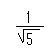, what is the value of 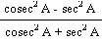 .
- A cylinder, a cone and a hemisphere are of equal base and have the same height. What is the ratio in their volumes?
- What is the condition for a quadratic equation which has two real roots?
- Find the number of roots of the following graph.
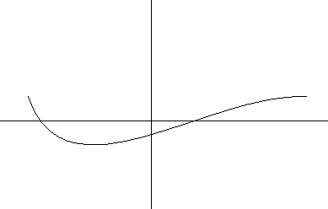
- Find the median from the following figure.
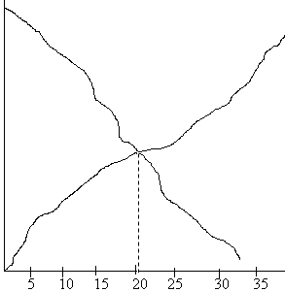
- Find the area of a sector of a circle with radius 6 cm if angle of the sector is 60⁰.
- Define an A.P
- In fig 1. What are the angles of depression from the positions O₁ and O₂?
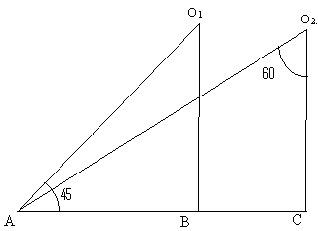
Fig. 1
- The opposite vertices of a parallelogram are P (1, b) and R (a, 0) and mid point of a diagonal is M (1, 1). Find a and b.

Section B
- The diameter of a circular pond is 17.5m. It is surrounded by a path of width 3.5m. Find the area of the path. ()
- solve for x:
- A quadrilateral ABCD is drawn to circumscribe a circle as shown in the figure below. Prove that AB + CD = AD + BC
OR
Prove that the tangents drawn at the ends of a diameter of a circle are parallel
- solve for x and y:
x + y = a + b
ax – by = a² – b²
- From your pocket money, you save Rs. 1 on day 1, Rs. 2 on day 2, Rs. 3 on day 3, and so on. How much money will you save in the month of October 2008?

Section C
- Find all the zeroes of 2x⁴ – 3x³ – 3x² +6x -2, if you know that two of its zeros are and - .
- prove that:
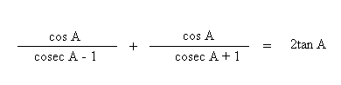
OR
Prove that
cos⁴ A – cos² A = sin⁴ A – sin² A
- Prove that 5 - is irrational.
- Find the relation between x and y such that the point P(x, y) is equidistant from the points A (2, 5) and B (-3, 7).
OR
Find the ratio in which the line segment joining the points A (3,-6) and B (5, 3) is divided by x axis. Also find the coordinates of the point of intersection.
- Draw a pair of tangents to a circle of radius 5 cm which are inclined to each other at an angle of 60⁰.
- Find the area of the shaded region.
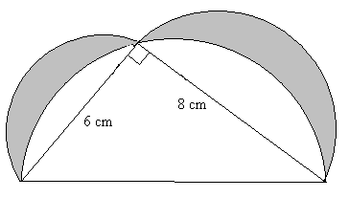

- A square field and an equilateral triangular park have equal perimeters. If the cost of ploughing the field at rate of Rs. 5/m² is Rs. 720, find the cost of maintaining he park at the rate of Rs. 10/m²
OR
An iron solid sphere of radius 3cm is melted and recast into small spherical balls of radius 1cm each. Assuming that there is no wastage in the process, find the number of small spherical balls made from the given sphere. ( )
- solve graphically:
2x + 5y = 19
3x – y = 3
Also find the area of the triangle formed between the lines and the x – axis.
- If the radii of the circular ends of a conical bucket, which in 45 cm high, are 28 cm and 7 cm. find the capacity of the bucket. ( ).
- A bag contains 5 red balls, 8 white balls, 4 green balls and 7 balls. If one ball is drawn at random, find the probability that it is :
    - black
    - red
    - not green
Section D
- The mean of the following data is 35.37. find the missing frequencies

Class | Frequencies
5 – 15  15 – 25  25 – 35  35 – 45  45 – 55  55 - 65 | 6  f₁  21  f₂  14  5
Total | 80

- From the top and foot of a 40m high tower, the angle of elevation of the top of a light house is 30⁰ and 60⁰ respectively. Find the height of the light house. Also find the distance of the top of the light house from the foot of the tower.
OR
There are two pillars, one each on either bank of a river, just opposite each other. One pole is 60m high. From the top of this pole, the angles of depression of the top and the foot of the other pole is 30⁰ and 60⁰ respectively. Find the width of the river and the height of the other pole.
- State and prove Pythagoras theorem. Using the above theorem to prove that AB² + CD² = BD² + AC²
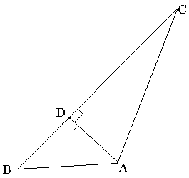
- A solid is composed of a cylinder with hemispherical ends. If the whole length of the solid is 100cm and the diameter of the hemispherical ends is 28cm. find the cost of polishing the surface of the solid at the rate of 5 paise per sq. cm.
- A motor boat whose speed is 18 km/hr in still water takes 1 hour more to go 24 km upstream than to return downstream to the same point. Find the speed of the stream.

Paper Submitted by: Tom T George
Email : georgetomt@gmail.com

