Guess Paper – 2010
Class – XII
Subject – Informatics Practices

Section – A (Theory) 35 Marks
Q-1 Answer the following questions: 15
- What is Open Source Software? Differentiate between Open source software and Free Software. 2
- Write short Notes on- i) PHP ii) Python 2
- What type of data is stored and maintained in inventory control system? Name any two reports produced by it. 2
- What is the significance of phase ‘System Review and Maintenance’ in SDLC? 2
- What is the significance of Object modeling? What tool can be used for object modeling? 2
- What do you mean by Data Warehousing? 2
- Define Data mining. 1
- Explain the concept of client server architecture? 2
Q-2 Answer the following in Respect of VB programming language. 20
- What do you mean by implicit and explicit variable declaration? Give examples. 2
- How is an event procedure different from other procedure? 2
- What is looping? Name the loops supported by VB. 2
- Why should you write initializing code in Activate event rather in Load event of a form? 2
- What are parameters? What are actual parameters and formal parameters? 2
- Explain the difference between the SDI and MDI. 2
- How the library function is different from the user defined function. Explain with help of example. 3
- Write the difference between private scope of variable and public scope of a variable. 2
- What is module? Explain the various types of module in VB. Also write the extension of each and extension VB project and VB form. 3
Section – B (VB Practical) 35 marks
Q-4
a) Find the errors from the following code segment and rewrite the corrected code underlining the correction made: 2 x=50 ; y=10
for i= 1 to 100 then
if x mod 6 = 0
print x+y
end
x=x**x+y*2
y+1= y
loop

b) Find the output of the following code: 2
x=20
do while (x>=10)
if x>9 then
r=0
else
r=2
end if
x=x-4
print x
loop
c) Change the following code using Do until loop without affecting the output. 2
For I = 2 To 50 Step 4
b = I : c = b - 1
d = b + c
If d < 0 Then
d = 0
End If
Print b; c
Next
Print d
d) Write a function funCountvowel that takes a string argument and return the number of vowels in the passed string. 3
e) Rewrite the code using IF statement without affecting the output of the code: 2
select case marks
case is>=75
category=”A”
case 50 to 74
category=”B”
case 33 to 49
category=”C”
case else
category=”D”
end select
f) Write a visual basic function that takes Marks in Written test and Marks in Internal Assessment as arguments, find the total marks secured ( sum of Written test and Internal Assessment) and returns whether the students is eligible for ‘Scholarship’. To be eligible for Scholarship, a student must secure at least 95 total marks. 4
Q- 4 A School library has two categories of members: Students and Faculty Members. Students are issued books for a week whereas faculty members are issued books for 3 days. A fine of Rs. 6 and Rs. 10 per extra day is charged from students and faculty members respectively, if the book is returned after the due date. The interface for the application as given below:
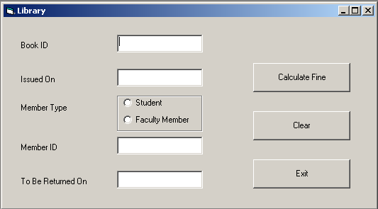
Object Type | Object Name | Description
Form | FrmLibrary | Main Form
Text Box | textbook ID | To enter book ID
Text Box | txtIssuedOn | To enter issue date
Text Box | txtMemberID | To enter member ID
Text Box | txtReturnOn | To enter return date of book
Option Button | optStudent | To Select Member type
Option Button | optFaculty | To Select Member type
Command Button | cmdCalcFine | To calculate fine
Command Button | cmdClear | To clear the entered values
Command Button | cmdExit | To close the application

- Book ID and Member ID should be non-blank alphanumeric characters. 1
- Text box TxtIssuedOn should be set to system date when the form loads and user should not allow changing it. 1
- Ideal return date should be calculated according to the logic explained above and should be stored in the text box txtReturnOn. 3
- When the user clicks the CmdCalcFine button, the fine amount should be displayed in a message box. 3
- Write the code for CmdClear command button to clear all the text boxes and set the default member type to student. Also write the code for CmdExit to close the application. 2

Q-5 Read the following case study and answer the questions that follows;
HMT has computerized its billing its billing. The following is the Data Entry Screen in visual Basic used by them.
The form details of the below form are given in the following table:
Object Type | Object Name | Description
Form | Frminvoice | The Main form Object
Text Box | TxtProd  TxtDesc  Txtqty  Txtunitprice  Txtsubtotal  Txtdeliver  txtTotal | To enter product ID of a Product  To enter product name  To enter the number of items bought by the customer  To enter the unit price of product sold  To display the Quantity multiplied by t unit Price.  To display Delivery and handling charges on the basis of category of city where product is sent  To display Total Charges to be paid by the customer as sum of Sub total, Tax, Delivery and Handling charges.
Option button | OptA, OptB, OptC | To enter the information whether the city where product has to be delivered is A category, B category, or C category
Command Button | Cmdcalculate  Cmdclear  cmdExit | To calculate sub Total, Tax, Delivery, and handling charges and Total.  To Clear all the values in the Text Boxes, option button in the form  To close the Application
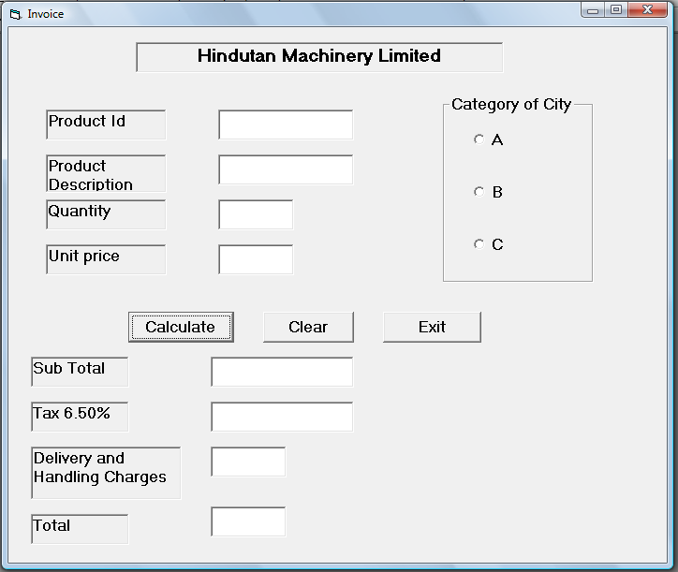
Write code to implement the following:
- When the user clicks clear button, all the values stored in the textboxes and option button should be cleared. 2
- Check that in the Textbox for Quantity, the data entered is numeric only. 2
- Close the application when Exit button is clicked after displaying the message “Thank You” 2
- When the command button with caption “Calculate” (cmdcalculate) is clicked, subtotal, Tax (6.50% of sub Total), Delivery and Handling Charges and Total Amount are computed and display. 4
The criterion for calculation of Delivery and Handling charges is as given below:
Category of City Charges (in Rs.)
A 2,000/-
B 3,000/-
C 3,500/-
- Sub Total is calculated by multiplying Quantity with Unit Price.
- Tax is calculated as 6.50% of Sub Total.
Paper Submitted By : Naveen Gupta (CBSE Examiner)
Email: gupta.naveen1@gmail.com
M- 9212073711, 9313108588
Navechetna study circle
A path to success
Computers for any class till engeering Level.
Specialist in Class XI and XII Syllabus for
CS, IP (latest Syllabus Also),MWT
for the CBSE.
Provide coaching for B-Tech, BE, BCA,MCA Or any other computer subject.
Working with Reputed Public School

