Sample Paper – 2010
Class – XII
Subject – Informatics Practice

Practice Set 1
Q 1 | Apollo Medical Facility generates its medicine bills using the following interface: | 6
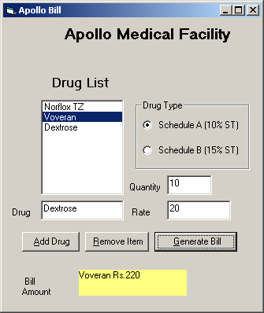
When ever the command button cmdDrug is clicked a new entry is made in the list box lstDrug as per the contents of the text box txtDrug.
When ever the command button cmdRem is clicked the selected item is deleted from the list box.
When ever the command button cmdBill is clicked the amount is visible on the label lblBill along with the selected medicine from the list box. The calculation is as under:
A 10% tax is added on the total amount i.e the product of quantity txtQty and rate txtRate when ever option optA is selected and a tax of 15% is added similarly when option optB is selected.
Write codes for click events of all the three command buttons to achieve the above goals.
Q.2 | Differentiate between OSS and FLOSS | 1
Q.3 | Write a short note on PHP | 2
Q.4 | What are the major steps involved in SDLC? | 2
Q.5 | A school has many students. Each school has its school_code and school_name. Every student has a scholar_no, class and name. Each student has his performance recorded. Performance has pid, subject, marks. Depict the scenario as E-R diagram. | 2
Q.6 | What is Data mining? Name two techniques used in Data Mining. | 2
Q.7 | Write a VB program to obtain the greatest among 3 numbers. | 2
Q.8 | What is the output of the following program:  Dim a, n, sum as Integer  a = 1  Do While (a <= 3)  n = 5  While (n >= 1)  sum = sum+n Mod 2  n = n - 1  Wend  a = a + 1  Loop  Print sum | 2
Q.9 | Write a VB program to obtain the reverse of a number. | 2
Q.10 | What is Normalization? Which problem is resolved in 3rd Normal form? | 2
Q.11 | Write an SQL query to display the average salary of employees in each department from the EMP table. | 2
ractice Set 2

 | 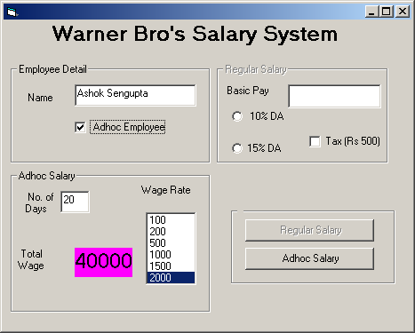  Ms Warner Bro’s have developed software to disburse salary to their employees. They have an interface as shown above. |  |  | 8
 | Text box | txtName | Name of the Employee
 | Text box | txtBasic | Basic pay of regular employees
 | Text box | txtDays | No. of days of work by adhoc employees
 | Check Box | chkAdhoc | Check box for Adhoc Employees
 | Check Box | chkTax | Check box for tax of Rs 500
 | Option Button | Opt10 | 10% of basic as DA
 | Option Button | Opt20 | 15% of basic as DA
 | Label | lblWage | Label to display the wage
 | List Box | lstWage | Wage Rate of Adhoc Employees
 | Command Btn | cmdReg | Calculates salary for Regular Employee
 | Command Btn | cmdAdh | Calculates salary for Adhoc Employees
 | Frame | frmReg | Contains controls for regular employees
- When the check box chkAdhoc is checked the controls in the frame for regular employees should be disabled and the command button cmdReg should be disabled. The action should reverse when the check box is unchecked.
- When the command button cmdReg is clicked, the salary should be displayed in a message box with the neme of the employee. The Salary is calculated as:
Basic pay plus DA( depending upon the selected option, 10 or 15 percent of Basic) minus the tax if applicable as per the checked or unchecked check box chkTax.
- When the command button cmdAdh is clicked, the wages are calculated as the number of days multiplied by the wage rate as selected from the list box lstWage. The name and wage are to be displayed in a message box.
- When the list box lstWage is clicked, the wage should be displayed in the label lbiWage as the product of no. of days and the wage rate selected from the list box.

Q.2 | Underline the errors in the following VB programs and re-write the corrected code:
 | - num=10  For i=1 to num step -1  If i % 2 = 0 then  Display i  Exit If  Next i | - i=1  sum=0  While (i =< 10)  sum+i=sum  i+3=i  Exit while  Print sum | 4
Q.3 | What will be the value of m after the execution of the second call statement in the following:  Private Sub Command1_Click()  Call Sum(10)  Call Sum(25)  End Sub  Private Sub Sum(ByVal n As Integer)  Static m As Integer  For i = 1 To 5  m = m + 10  Next  Print m  End Sub |  | 2
Q.4 | What is the difference between Entry Controlled and Exit Controlled loops? Give examples to support your answer. |  | 2
Q.5 | Explain the concept of Dynamic arrays with suitable examples. |  | 2
Q.6 | Write a VB program to find the product of individual digits of a number. |  | 2
Q.7 | Write a VB program to bind the sum of the series: 1-2+3-4+5-…up to n |  | 2
Q.8 | What is the difference between call by value and call by reference in a VB procedure? |  | 2
Q.9 | Write a VB procedure to test whether a number passed as a parameter to the procedure is Even or Odd. |  | 2
Q.10 | Write a VB function that calculates the factorial of a number passed as a parameter to the function and prints the result in the calling procedure. |  | 2
Q.11 | What are access keys? What will happen if two command buttons are assigned the same access keys? |  | 2
Q.12 | What is implicit variable declaration? How can you enforce explicit variable declaration? |  | 2
Q.13 | What is the difference between unloading and hiding of a form? |  | 2
Q.14 | What is a Recordset? What is the significance of Dynamic Recordset? |  | 2
Q.15 | Write a VB program to print the following pyramid:  1 2 3 4 5  1 2 3 4  1 2 3  1 2  1 |  | 2
Q.16 | Write a VB program to find the minimum number in a five element integer array. |  | 2

Q.17 | Write short notes on any two of the following:  a) Data Warehouse b) UML c) Client-Server Computing  d) Changeover Procedure | 4
Q.18 | Given the following tables:  TABLE: SUPPLIER  Write the SQL queries to perform the following tasks:  - To display the Supplier details where quantity is more than 200.  - To display the Supplier name and product name of those suppliers who are not dealing with Britannia.  - To display the average price for each suppler in the given relation. | 6
  #SNO | PNAME | SNAME | QTY | PRICE
  S1 | Bread | Britannia | 150 | 8
  S2 | Cake | Britannia | 250 | 20
  S3 | Coffee | Nescafe | 170 | 45
  S4 | Chocolate | Amul | 380 | 10
  S5 | Sauce | Kissan | 470 | 36
  S6 | Maggi | Nestle | 340 | 10
  S7 | Biscuit | Marie | 560 | 21
  S8 | Jam | Kissan | 220 | 40

Practice Set 3

Q.1 | 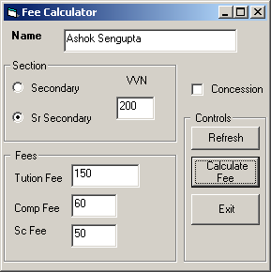  KV Jalahalli has been using this interface to calculate the fee for students studying in the school. The interface has the following components:  Write VB codes under suitable events to achieve the following:  - When the option button optSec is selected then the VVN in the text box txtVvn becomes 160 where as when the option button optSrsc is selected the VVN becomes 200. (2)  - When the check box chkCon is selected the tuition fee in txtTut becomes 0 and the text box is disabled. (2)  - When the command button cmdFee is clicked the fees is calculated as the sum of all the fees and the same is displayed in a message box with the name of the child. (3)  - When the command button cmdRef is clicked the text boxes with numeric values should have 0 in them, the text box for name should be blank, the option button optSec should be selected and the checkbox chkCon should be de-selected. (2)  - When the command button cmdExit is clicked the program should end. (1) | 10
  Control | Name
  Text box | txtName
  Textbox | txtVvn
  Textbox | txtTut
  Textbox | txtComp
  Textbox | txtSc
  Check Box | chkCon
  Control | Name
  Option Buttion | optSec
  Option Button | OptSrSec
  Command Button | cmdRef
  Command Button | cmdFee
  Command Button | cmdExit
Q. 2 | Explain the difference between the following function with suitable examples:  - Int() and Fix().  - Date() and Date$() | 2
Q. 3 | What is the difference between SDI and MDI applications? | 2
Q. 4 | Why it is not suggested to have menus in the MDI child forms? | 2
Q. 5 | What is a module in VB? What is the significance of Sub Main() procedure? | 2
Q. 6 | Write a VB function that accepts parameters P, r and t and calculates the simple interest from these values. The simple interest is then added to the Principal amount in the calling event procedure to get the total amount. | 4
Q. 7 | Write a VB program that reverses an input string without using the strReverse() function. | 4
Q. 8 | Write the output of the following functions.  str1 = "MAGALOMANIAC MORGAN"  - Print Right(Mid(str1, 3, 9), 6)  - Print InStr(4, Mid(str1, 6, 14), "A") | 2

Q. 9 | Compare and contrast DAO with ADO. |  | 2
Q.10 | What are data bound controls? Give four examples. |  | 2
Q.11 | Write a Connection String in VB that connects to Oracle database using ADO and OLEDB. Give a message if the connection is successful. |  | 4
Q.12 | How is optimistic lock different from a pessimistic lock in ADO programming? |  | 2
Q.13 | What is a Recordset? Name the Recordsets available with VB. |  | 2
Q.14 | Find the value of sum in the following programs. Write the intermediate values also:
 | a) sum = 0  For i = 10 To 1 Step -1  If i Mod 2 <> 0 Then  sum = sum + i  Print sum;  Else  sum = sum + 2  Print sum;  End If  Next | b) sum = 10  i = 1  Do Until (i >= 10)  sum = sum - i Mod 2  i = i + 1  Loop  Print sum | 4
Q.15 | Write the VB code to lock a text box with the Recordset studentRset and Recordset field STUDNAME. |  | 2
Q.16 | Write a VB program to generate a Fibonacci series.  OR  Write a VB program to obtain the GCD of two numbers. |  | 4

Practice Set 4

Q.1 | Sapna Book House is using the following interface for the billing of book sale:  The controls used in the interface are as under:  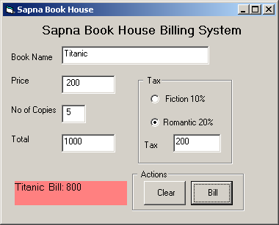  Write VB codes to add functionalities as mentioned below:  - The text box txtPrice should only accept numeric values. (2)  - When focus gets shifted from text box txtCps (no. of copies) the text box txtTotal should display the total cost of the book ordered as the product of price and number of copies. (2)  - When the option button opt10 is clicked the text box txtTax should display the tax calculated as 10% of the total cost obtained from text box txtTotal. When the option button opt20 is clicked the text box txtTax should display 20% tax calculated, the same way. (2)  - When Command button cmdBill is clicked the label lblBill should display the bill calculated from tax subtracted from the total cost along with the name of the book as displayed in the interface. (2)  - When the command button cmdClear is clicked the text box containing numeric values should display 0, the text box for book name should be cleared, the option button opt10 should be selected and the label lblBill should also be cleared. (2) | 10
  Text Box | txtBname
  Text Box | txtPrice
  Text Box | txtCps
  Text Box | txtTotal
  Text Box | txtTax
  Option btn | Opt10
  Option btn | Opt20
  Label | lblBill
  Command btn | cmdClear
  Command Btn | cmdBill
Q.2 | What is an Entity-relationship model? Explain weak entity with an example. | 2
Q.3 | Convert the following If-Else structure in to Select Case structure:  Private Sub NumberFun()  Dim num as Integer  num = InputBox(“Enter a number”)  If num = 2 Or num = 3 Or num = 5 Then  Print “Lucky numbers”  ElseIf num>=8 and num<=10 Then  Print “My favourit numbers”  ElseIf num=1 Or num=6 Or num=7 Then  Print “I don’t like them”  Else  Print “Enter a valid number between 1 to 10”  End if  End Sub | 2

Q.4 | Re-write the following program using For Next construct:  Num=6  Temp=Num  DO WHILE Num>=1  Temp=Temp-1  IF Temp MOD 2 = 0 THEN  PRINT Temp," is Even"  ELSE  PRINT Temp," is Odd"  END IF  Num=Num-2  LOOP |  | 2
Q.5 | What is the difference between the Msgbox() and the InputBox() functions in VB. Give examples to support your answer. |  | 2
Q.6 | Write a VB procedure PrintLargest() that accepts three numbers as parameters and prints the largest of the three numbers. |  | 4
Q.7 | Write a VB function Average() that accepts two numbers as parameters and returns the average of the two numbers to the calling event procedure. |  | 4
Q.8 | Write the output of the following VB statements:  Msg = “SAINT SANTA SANCTURY”  - Print Mid(Left(Msg, 11) , Len(Msg)\5 , 2)  - Print Right(StrReverse(Msg), 5) |  | 2
Q.9 | Write four properties of MDI child forms.  Or  What is the significance of Windowlist property of an MDI application? How this feature is incorporated in an MDI application? |  | 2
Q.10 | Compare and contrast OLEDB with ODBC. |  | 2
Q.11 | Write short notes on the following:  - Referential Integrity.  - Schema Objects. |  | 4
Q.12 | What is Normalization? Explain the third normal form with an example. |  | 4
Q.13 | Table: Guide | Table:Student | 10
  SUBJECT# | ADVISOR
  PHYS | VINOD
  COMP | ALOK
  CHEM | RAJAN
  MATH | MANJU
  HIST | SMITA
  ID# | NAME | FEES | SUBJECT | MARK | DIV
  1 | KARAN | 400 | PHYS | 68 | 1
  2 | DIVAKAR | 450 | COMP | 68 | 1
  3 | DIVYA | 200 | CHEM | 62 | 2
  4 | ARUN | 350 | PHYS | 63 | 1
  5 | SABINA | 500 | MATH | 70 | 3
  6 | JOHN | 400 | CHEM | 55 | 2
  7 | ROBERT | 250 | PHYS | 64 | 1
  8 | RUBINA | 450 | MATH | 68 | 3
  9 | VIKAS | 600 | COMP | 62 | 1
  10 | MOHAN | 300 | MATH | 57 | 2

Write SQL queries to do the following:
- Display the name, stipend and subject of all the students whose marks is greater than 60.
- Display the details of all the students in the ascending order of their fees paid.
- Display the student names whose advisor is VINOD.
- Display the student names and subjects who are paying fees of Rs400 or Rs300 or Rs500.
- Display the average fees paid by students in each subject.

Practice Set 6

Q.1 | 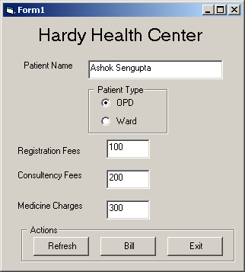  Hardy’s Health Center prepares its medical bills through the given interface. The controls used are as under:  Write VB codes to add functionality as mentioned below:  - The text box txtName should only accept alphabets. (3)  - When the option button optOpd is clicked and selected the textbox txtReg (for registration fees) should be enabled and display 100. (1)  - When text box txtWard is clicked and selected the text box txtReg should be disabled and display 0. (1)  - A discount of 10 percent is credited in the medicine charges if the patient is a Ward patient. The total bill is displayed with name of the patient in a message box calculated as the sum of Registration fees, Consultancy fees and Medicine charges when command button cmdBill is clicked. (2)  - When the command button cmdRef is clicked the text box txtname is cleared, all the other text boxes should have 0 in them and option button optOpd is selected. (2)  - The program quits when the command button cmdExit is Clicked. (1) | 10
  Textbox | txtName
  Textbox | txtReg
  Textbox | txtCon
  Textbox | txtMed
  Option | optOpd
  Option | optWard
  Command | cmdRef
  Command | cmdBill
  Command | Cmd Exit
Q.2 | Explain the ACID properties of transaction. | 4
Q.3 | Indian Railway system consists of trains that have originating station and a destination station. Trains are identified by their train no and name. Stations too have its name and category. Trains have many coaches. Each coach has a number and category. Coaches have births that have birth numbers and location. Many passengers travel by a train. Each passenger has a ticket containing the information like ticket no, PNR no, date of journey, birth no, from and to locations. Depict this scenario in ER diagram. | 2
Q.3 | Enumerate four advantages of PL/SQL over SQL. | 2
Q.4 | What is Database fragmentation? | 2

Q.5 | Re-write the following using Select Case Construct:  Private Sub Command1_Click()  n = InputBox("enter", "Number", 0)  If n = 1 Or n = 3 Or n = 5 Or n = 7 Or n = 8 Or n = 10 Or n = 12 Then  Print "31 days"  ElseIf n = 4 Or n = 6 Or n = 9 Or n = 11 Then  Print "30 days"  ElseIf n = 2 Then  Print "28 or 29 days"  Else  Print "Not a valid month no"  End If  End Sub | 2
Q.6 | Find the value of sum after the execution of the following loop:  sum=0  i=1  Do  sum=sum+2^i  i=i+1  if sum> 32 Then  Exit Do  End if  Loop while i<10  Print sum | 2
Q.7 | The following program was intended to be written to print n even numbers. But the output sugests that the program prints even numbers up to n. Do the necessary modification in the program so that n even numbers are printed.  Private Sub Command1_Click()  Dim i As Integer  Dim n As Integer  n = InputBox("Enter a Number", "Limit", 0)  For i = 2 To n Step 2  Print i;  Next  End Sub | 2
Q.8 | Re-write the following program using For Next loop:  Private Sub Command3_Click()  Dim Res As Integer  Dim i As Integer  Res = 0  i = 20  Do While (i > 10)  Res = Res + i Mod 2  i = i - 1  Loop  Print Res  End Sub | 2
Q.9 | An integer array arr(5) contains 6 elements (3, 5, 6, 2, 8, 9). Write a VB program to find the largest element in the array.  OR  Find the sum of the series 2+8+16+32+64+…up to n terms | 4
Q.10 | Write a PL/SQL program that checks whether an input number is Even or Odd. | 4
Q.11 | What are anchored variables in PL/SQL? | 2
Q.12 | What are the characteristics of a Data Warehouse? | 2
Q.13 | How is a 3-tier computing model more effective than a 2-tier computing model? | 2
Q.14 | What is a popup menu? Which method invokes a popup menu? | 2
Q.15 | What is the difference between a call by value and call by reference in VB procedures? | 2
Q.16 | What do you understand by scope of a variable? What is the scope of a Static variable? | 2

Paper Submitted by: Ashok
Email : ashokjbp@gmail.com
Mob No. : 08023459250

