Guess Paper – 2010
Class – XII
Subject – Physics

Time allowed: 3 hours Max Marks 70

General Instruction
(i) All questions are compulsory.
(ii) Question numbers 1 to8 are very short answer type questions, carrying one mark each,
(iii) Question numbers 9-18 are short answer type question, carry two marks each.
(iv) Question numbers 19to27 are also short answer type question, carrying 3 mark each.
(v) Question number 28to30 are long answer type question carrying five marks each.
(vi) Use log tables for necessary calculations.
------------------------------------------------------------------------------------------------------------
Q1) Give a reason to show that microwaves are better carriers of signals for long range transmission than radio waves. (1)
Q2) How does the energy gap in an intrinsic semiconductor vary, when doped with a pentavalent impurity ? (1)
Q3) State the condition in which terminal voltage across a secondary cell is equal to its e.m.f. (1)
Q4) If electric field intensity is zero at a given point, will the electric potential be necessary zero at that point? (1)
Q5) If the number of turns of a solenoid is doubled, keeping the other factors constant, how does the self-inductance of the solenoid change ? (1)
Q6)Suggest a possible communication channel for the transmission of a message signal which has a band width of 5 MHz. (1)
Q7) The wavelength of radiation emitted is λ₀ when an electron jumps from the third to the second orbit of hydrogen atom.For the electron jump from the fourth to the second orbit of the hydrogen atom,What will be the wavelength of emitted radiation ? (1)
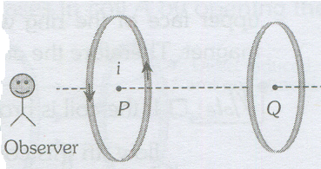
Q8) Two coils P and Q are lying a little distance apart coaxially.If an anticlockwise current I is suddenly set up in the coil P then, What will be the direction of current induced in coil Q? (1)

Q9) A point charge Q is placed outside a hollow spherical conductor of radius R,at a distance (r>R)from its centre C. Calculate the electric field at C due to the induced charges on the conductor. (2)
Q10) Draw the graph showing the variation of binding energy per nucleon with the mass number of different nuclei. State two inferences from this graph. (2)
Q11) In a single slit diffraction experiment, if the width of the slit is doubled, how does the (i) intensity of light and (ii) width of the central maximum change. Give reason for your answer. (2)
Q12) A prism having an apex angle 4⁰ and refraction index 1.5 is located in front of a vertical plane mirror as shown in figure.Through what total angle is the ray deviated after reflection from the mirror? (2)
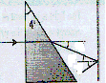

Q13) (i)Does the sinusoidal nature of the emf produced in the generator depend on the size or shape of the coil?
(ii)An alternating current emf device has a smaller resistance that that of the resistive load; to increase the transfer of energy from the device to the load, a transformer will be connected between the two. Should it be a step-up or step down transformer? (2)
Q14)Describe an expression for covering range of TV transmission tower. (2)
Q15)What is the difference between frequency modulation and amplitude modulation. Why is an FM signal less susceptible to noise than an AM signal? (2)
Q16)(i). Is it correct to say that the maximum kinetic energy of photoelectron is proportional to the frequency of incident radiation?
(ii). When the speed of a particle doubles, its momentum doubles, and its kinetic energy becomes four times greater. When the momentum of a photon doubles, does its energy become four times greater? Provide a reason for your answer. (2)

OR
(i)Is p = E/C valid for electrons?
(ii)If you double the kinetic energy of a non relativistic particle, how does its de-Broglie wavelength change? (2)
Q17) In a microwave oven, the food is kept in a plastic container and the microwave is directed towards the food. The food is cooked without melting or igniting the plastic container. Explain? (2)
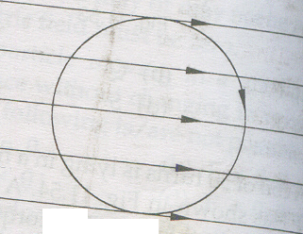
Q18) The wire loop of radius r carries a clockwise current placed in a uniform magnetic field directed to the right. Answer the followings. (2)
(i) what is the direction of the net force on the current loop?
(ii)what is the direction of the torque on the current loop?

Q19) Consider the potentiometer circuit arranged as shown in figure. The potentiometer wire is 10 m long. At what distance from the point A should the Jockey touch the wire to get zero deflection in the galvanometer? (3)
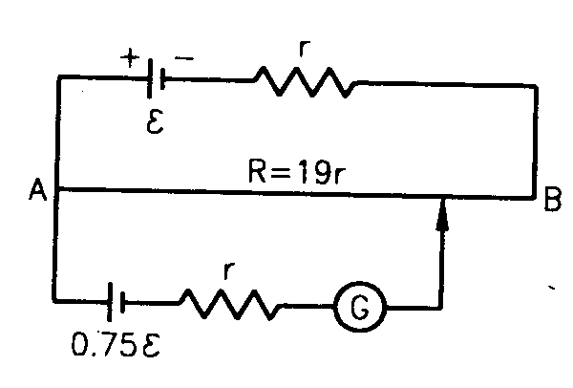

OR
Find the potential difference between the plats of the capacitor C in the circuit shown in figure. The internal resistances of the sources are negligible. (3)
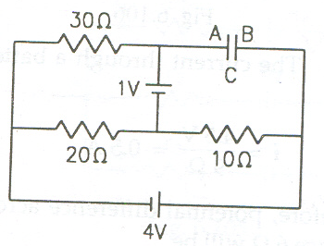

Q20) Derive expression for drift velocity of electrons in a good conductor in terms of
Relaxation time of electrons. (3)
Q21)State Huygen's postulates of wave theory. Illustrate with the help of diagrams the action of (i)convex lens and (ii)concave mirror on a plane wavefront incident on it. (3)
Q22) (a)State Brewster’slaw.
(b)An incident beam of light of intensity I₀ is made to fall on a Polaroid A. Another polariod B is so oriented with respect to A that there is no light emerging out of B. A third Polaroid C is now introduced mid-way between A and B and is so oriented that its axis bisects the angle between the axes of A and B. What is the intensity of light now between. (i) A and C (ii) C and B. Give reasons for your answers. (3)
Q23) Describe a compound microscope and find an expression for its magnifying power. (3)
Q24) Light is incident on the cathode of a photocell and the stopping voltage are measured for light of two wavelengths. From the data given below, determine the wave function of the metal of the cathode in eV and the value of the universal constant .(3)
Wavelength Å | Stopping voltage (volt)
4000 | 1.3
4500 | 0.9
Q25)Using basic law of radioactive decay to show that radioactive nuclei follow on exponential decay law. (3)
Q26)Draw the circuit diagram of a common emitter amplifier using an npn transistor. What is the phase difference between the input signal and out put voltage/state two reasons why a common emitter is preferred to a common base amplifier. (3)
Q27) Two signals, A and B, shown in the figure, are used, one by one, as the two inputs of three different gates G₁, G₂ and G₃. These outputs obtain from the three gates are as shown.

I

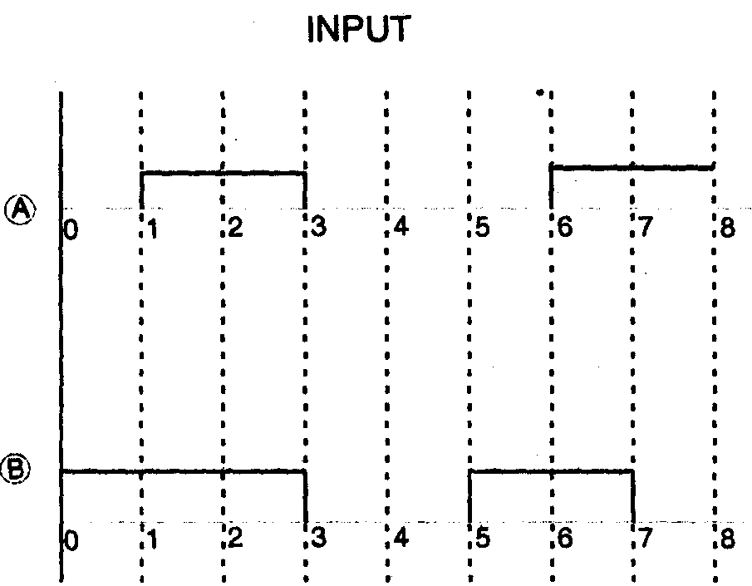
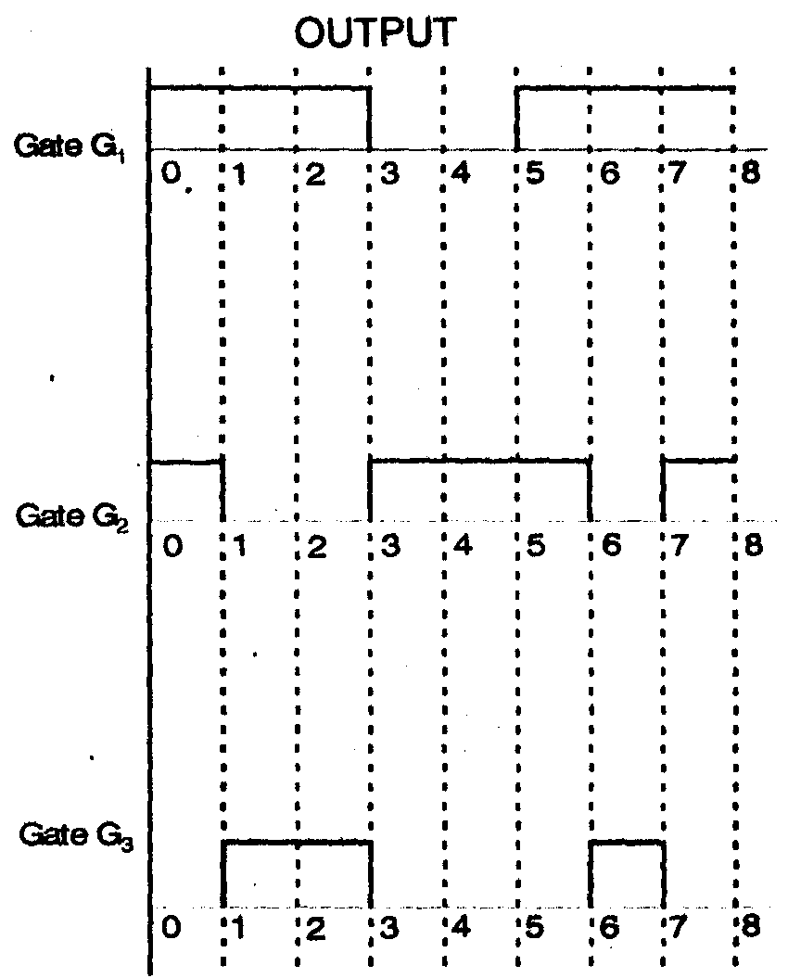

Identify the three gates. (3)
Q28)(i)Using Gauss theorem, derive an expression for the electric field intensity at any point outside a charged spherical shell.
(ii) Find the equivalent capacitance (between points A and B) and charge on the three capacitors shown in figure. (5)
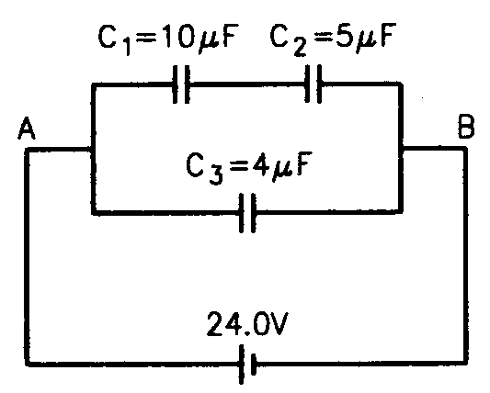

OR
(ii)Using Gauss theorem, derive an expression for the electric field intensity at any point due to a uniformly charged infinite plane sheet.
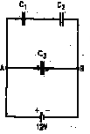
(ii) Find the equivalent capacitance between points A and B and the charges on each capacitor for the circuit shown in figure. Use C₁ = 4.00 μF, C₂ = 6.00 μF, C₃ = 3.00 μF and V = 12.0 V. (5)

Q29)(i)Draw a labeled diagram of a moving coil galvanometer. State the principle on which it works.
(ii)A conductor in the form of a right angle triangle ABC with AB =3 cm and BC= 4 cm carries a current of 10 A. There is a uniform magnetic field of 5T perpendicular to the plane of the conductor. What will be the force on the conductor? (5)
OR
(i)How will a dia, para and a ferromagnetic material behave when kept in a non uniform external magnetic field. Name two main characteristics of a material which help us to decide its suitability for making (1)a permanent magnet(ii)an electromagnet
(ii) Calculate the percentage change in the magnetic susceptibility of a paramagnetic substance when its temperature increases two thrice of its initial temperature T. (5)
Q30) with the help of a neat and labeled diagram explain the principle, construction and working of an a.c. generator. (5)
OR
Explain with the help of a neat and labeled diagram, the principle, construction and working of a transformer.

(5)

Paper Submitted by: Arun Joshi
Email : arunjoshi_67568@rediffmail.com
Ph No.: 09414827275

