Guess Paper – 2010
Class – XII
Subject – Chemistry
Time: 3 hrs. .
General instructions:

All questions are compulsory.
Marks for each question are indicated against it.
Questions number 1to 8 are very short –answer questions, carrying 1 mark each. Answer these in one word or about one sentence each.
Questions number 9 to18 are short –answer questions, carrying 2 marks each. Answer these in about 30 words each.
Questions number19 to27 are short –answer questions, carrying 3 marks each. Answer these in about 40 words each.
Questions number28 to30 are long-answer questions of 5 marks each. Answer these in about 70 words each.
7 Use log tables, if necessary. Use of calculators is not permitted

Questions:

Q1 Which is a better nucleophile, a bromide ion or an iodide ion? (1)
Q2 How is DDT prepared? Write the chemical equation for its preparation. (1)
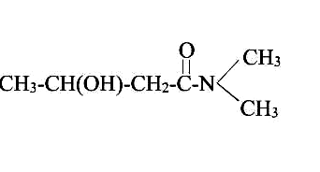
Q3 How will you distinguish between 1-Phenylethanol and 2-phenylethanol? (1)
Q4 Write IUPAC name of the following compound: (1)

Q5 When fruits and vegetables that have dried are placed in water; they slowly swell and return to the original form. Explain why? Would a temperature increase accelerate the process? Explain. (1)
Q6 Sodium chloride or calcium chloride is used to clear snow from the roads. Why? (1)
Q7 What are metal chelates? (1)
Q8 What are ambidentate ligands? (1)
Q9 (a) Write the mechanism of dehydration of alcohol. (2)
(b) Write Kolbe’s reaction. (1)
Q10 (a) Compound (A), C₄H₁₀O, is found to be soluble in sulphuric acid. (A) does not react with sodium or potassium permanganate. When (A) is heated with excess of HI, it is converted into a single alkyl halide. What is (A)? (1)
(b) Identify the product in the following reaction: (1)

EtOH

Q11 Give reasons:
- Acid catalyzed dehydration of t-butanol is faster than that of n-butanol. ` (1)
- When t-butanol and n-butanol are separately treated with a few drops of dilute KMnO₄, in one case only purple colour disappears and a brown ppt is formed. Which of the two alcohols give above reaction and what is brown ppt? (2)
Q12 How will you convert acetaldehyde into following compounds?
(i) Butane-2-one (ii) Butane-1,3-diol (2)
Q13 (a) Arrange the following in increasing order of their basic strength: (1)
Methylamine, dimethylamine, aniline and N-methylamine
(b) Write Hoffman-Bromamide reaction. (1)
Q14 Answer the following:
- Although — NH2 group is an ortho and para directing group, nitration of aniline gives along with ortho and para, meta derivatives also. (1)
- Aniline does not undergo Friedel crafts reaction. (1)
Q15 0.004 M solution of Na₂SO₄ is isotonic with 0.01 M solution of glucose at the temp. What is the apparent degree of dissociation of Na₂SO₄? (2)
Q16 Give a chemical test to distinguish between [Co(NH₃)₅Br]SO₄ and [Co(NH₃)₅ SO₄]Br. Name the type of isomerism exhibited by these compounds. (2)
Q17 (a) Which out of 0.1 M HCl and 0.1 M NaCl, do you expect have greater ∆m and why? (1)
(b) Which will have greater molar conductivity? Solution containing 1 mol KCl in 200 ml or 1 mol of KCl in 500 ml. (1)
Q18 How long would it take to deposit 100 g of Al from an electrolytic cell containing Al₂O₃ using a current of 125 ampere? (2)
Q19 An organic compound (A) C₇H₁₅Cl on treatment with alcoholic caustic potash gives a hydrocarbon (B) C₇H₁₄. (B) on treatment with ozone and subsequent hydrolysis gives acetone and butyraldehyde. What are (A) and (B). Explain reactions. (3)
Q20 Write the chemical equations, when 1-propanol reacts with (a) acidified KMnO₄ (b) SOCl₂(c) ethanoic acid. (3)
Q21 (a) An organic compound (A) having molecular formula C₃H₈O on treatment with Cu at 300⁰C gives (B). (B) does not reduce Tollen’s reagent but gives positive iodoform test. Write down the structures of A and B.(1)
(b) How will you convert?
(i) Methyl iodide to acetic acid (ii) Propionic acid to acetic acid (2)

Q22(a) Assign a reason for each of the following statements:
- Alkyl amines are stronger bases than aryl amines.
- In aqueous solutions secondary amines are more basic than tertiary amines. (2)
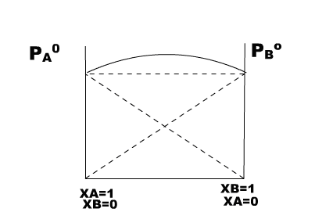
(b) Write one method used for the preparation of pure primary amines. (1)
Q23 Chloro acetic acid is a monoprotic acid and has Ka = 1.36 × 10–3. Calculate b. p. of 0.01 M aqueous soln ? (Kb = 0.51 k kg/mol) (3)
Q24 Answer the following questions: (3)
(a) What does the graph indicates?
(b) Give an example of such liquids, which results in the formation
of such graphs.
©Give reason for such behaviour.

Q25 (a) FeSO₄ solution mixed with NH₄(SO₄)₂solution in 1 : 1 molar ratio gives the test of Fe2+ ion butCuSO₄ solution mixed with aqueous ammonia in 1 : 4 molar ratio does not give the test of Cu²⁺ on. Explain why? (1)
(b) Explain crystal field theory on the basis of splitting in octahedral complexes. (2)
Q26 Write IUPAC names of the following coordination compounds:
- K₃[Cr(C₂O₄)₂] (ii) [Co(NH₃)₆]ClSO₄ (iii) [Co(en)₂(ONO)Cl]Cl (3)
Q27 Predict the direction in which the reaction will proceed if a cell is made by connecting silver electrode with mercury electrode.
E° = 0.80 V E° = 0.79 V

[Ag+] = 10–1 mol/l [Hg2+] = 10–3 mol/l
Also write cell representation. (3)
Q28 Explain why?
- Acetic acid is a stronger acid than ethyl alcohol.
- Trichloroacetic acid is a stronger acid than acetic acid.
- Formic acid shows reducing properties.
- Carboxylic acids with five or fewer carbon atoms are water soluble but, higher ones are insoluble.
- Acetic acid can be halogenated in the presence of phosphorous and chlorine but formic acid cannot be halogenated in the same way. (5)
OR
An organic compound (A) having molecular formula C₉H₁₀O forms an orange red precipitate (B) with , 2,4-DNP reagent. Compound (A) gives a yellow precipitate (C) when heated in the presence of iodine and NaOH along with a colourless compound (D). (A) does not reduce Tollen’s reagent or Fehling’s solution nor does it decolourises bromine water. On drastic oxidation of (A) with chromic acid, a carboxylic acid (E) of molecular formula (C₇H₆O₂) is formed. Deduce the structures of the organic compounds (A) to (E). (5)
Q29 Given below is the sketch of a plant for carrying out a process.

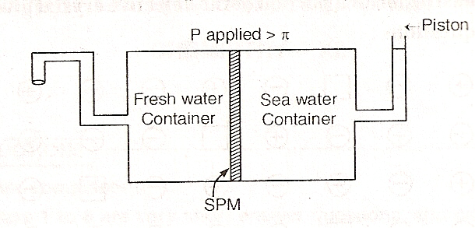

- Name the process occurring in the above plant.
- To which container does the net flow of solvent takes place?
- Name one SPM which can be used in this plant.
- Give one practical use of this plant.
- What will happen if the applied pressure is removed? (5)
OR
- What are azeotropes? What are their types? Give example in each case? (3)
- What is van’t Hoff factor? When it is used? (2)
Q30 (a) What are primary and secondary cells? Discuss construction and working of lead storage battery. (4)
(b) What is abnormal molecular mass? (1)
OR
- Tarnished siver contains Ag₂S. Can this tarnish be removed by immersing the tarnished silverware in an Al pan containing an inert electrolyte soln. such as NaCl?
Given that standard electrode potentials for half reactions are:
Ag₂S(s) + 2e⁻ 2Ag(s) + S²⁻(aq.) is -0.71 V
Al³⁺(aq.) + 3e⁻ Al(s) is -1.66 V. (2)
- What is Kholrausch’s law? What are its applications? (3)

Paper Submitted by:
Mohini Belani
Email mohinibelani@yahoo.co.in
Phone No. 07544-273314

