Sample Paper – 2010
Class – XI
Subject - INFORMATICS PRACTICES(065)

TIME : 1 Hrs Max Marks: 30

Section – A
Q1. | Find the output of the following:-
 | (a). |  |  | class MAIN{  void calculate( int a, int b)  { show( a+b);  System.out.print(“Calculating”); }  public MAIN( int x, int y)  {calculate( x,y);  System.out.print(“ In Initialize “ + x+” & “ +y +”Place”); }  void show( int x)  {System.out.print(I am Printing: ” + x);}  Public static void main(String args[])  {MAIN ob=new Mani(10,-90);}  } |  |  | 2
 | (b). |  |  | i. private void jButton1ActionPerformed(java.awt.event.ActionEvent evt)  { display(11, 19 );  }  void display(int i, int j ){  System.out.println(i>>j);  System.out.println(i<<j);  } |  | ii. private void jButton2ActionPerformed(java.awt.event.ActionEvent evt)  { manipulate(11 ); }  void manipulate(int i){  int n=i*5;  System.out.println(“i= ” + i%i++ );  i%=--n+1;  System.out.println(“n= ” + n );  } | 4
Q2. | Find Errors and Rewrite correct code the following program code:-
Q2. | (a) . |  |  |  | public class MAINPRO {  int a,b;  public void MAINPRO(int x, int y)  { x=100;  y=200; }  public static void main(String args[])  { MAINPRO(120, 50) obj = new MAINPRO(10);  a=20;  b=30; }  } |  | 2
Q2. | (c). |  |  |  | Write a Java Class ABC and define two class methods like “swapByVal()” for swapping two number by value , “swapByRef()” for swapping variable value by using reference parameter.  And also display swaped value on screen, these method call in main () method. |  | 2
Q2. | (d). |  |  |  | Write NetBean IDE code to display following output:  1! + 2! + 3! + 4! + ……… + N! |  | 3

Section – B
Q4. |  | Differentiate with example :
 |  | (a) |  | Testing & Debugging |  |  | 1½
 |  | (b) |  | Try & Catch and Throws. |  |  | 1½
Section – C
Q5. | Answer the following questions
 | (a) |  | What is Error? Explain different type of errors. |  |  |  | 2
 | (b) |  | Design an application having an interface like:  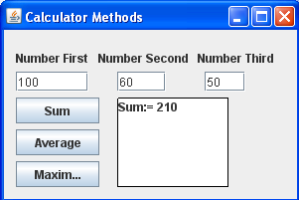  Implement functionality by writing methods with passing the argument of three textboxes in, clacSum(), calcAvg() & calcMax(). Invoke these methods from buttons event handlers. |  |  |  | 6
Q6. | Answer the following questions
 | I. |  | Write down Problem solving Methodology and Techniques |  |  |  | 2
 | II. |  | Difference between Primitive data type and User define data type. |  |  |  | 2
Q7.Answer the following questions [any two ]
 | a). |  | Write a program & design IDE form to define two method calcCI() & calcSI() to pass Principal Amount & Time as a argument and return Simple Interest & Compound Interest respectively as per following criteria :-  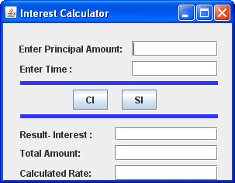 |  |  |  | 4
  Amount | Time | Rate
  1-5000 | 0-5 | 10%
  5000-10000 | 6-8 | 15%
  10000- 20000 | 9-12 | 20%
  20000-50000 | 13-20 | 25%
  >50000 | >20 | 30%
 | b). |  | Write Java method and integer number of series terms as a argument to print following series.  1, 2, 4, 8, 16, 32,……….. |  |  |  | 4
 | c). |  | Write a Java code to display following Code:-  0  0 2  0 2 4  0 2 4 6  0 2 4 6 8 |  |  |  | 4

Paper Submitted by:

Lakhan Singh Pal
Email :- lakhan_it2002@yhaoo.co.in
Phone No. 9549164900

