Sample Paper – 2010
Class – XII
Subject – Physics

General Instructions:
(a) All questions are compulsory
(b) There are 30 questions in total. Qns. 1 to 8 carry 1 mark each. Qns. 9 to 18 carry 2 marks each, Qns. 19 to 27 carry 3 mark each and Qns. 28 to 30 carry 5 marks each.
(c) There is no overall choice. However, an internal choice has been provided in one question of 2 marks, one question of 3 marks and all three questions of 5 marks each. You have to attempt only one of the given choices in such questions.
(d) Use of calculators is not permitted.
(e) You may use the following physical constants wherever necessary.
c = 3 x 10⁸ ms⁻¹
h = 6.6 x 10⁻³⁴ Js
e = 1.6 x 10⁻¹⁹C
µ_{o} = 4π x 10⁻⁷ TmA⁻¹
1/4πε_{o} = 9 x 10⁹ N m²C⁻²
Avogadro number N_{A} = 6.023 x 10²³ mol⁻¹
Mass of the neutron = 1.675 x 10⁻²⁷ kg
Boltzmann constant, k = 1.38 x 10²³ J K⁻¹

- In the diagram , the radii of the trajectories of proton and alpha particles having equal momenta moving perpendicular to the uniform magnetic field are shown. Which one corresponds to alpha particle? 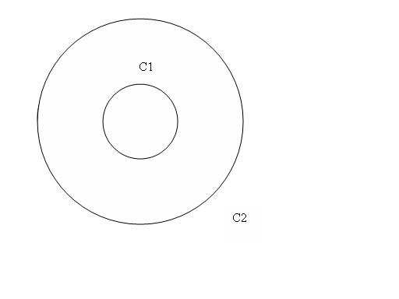

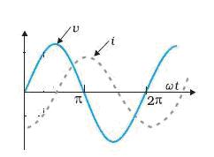
The fig. shows the variation of V and I vs ωt for a circuit element connected to A.C mains. Name the circuit element and the phase relation between current and voltage.

3.
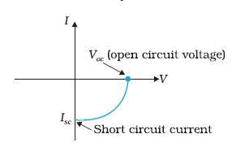
The above fig. is a V-I graph for a device. Identify the device. Mention any one material
from which it is prepared.
4.
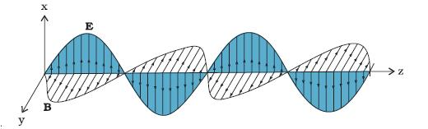

The above graph shows the variation of electric and magnetic fields of electromagnetic
wave in space. Identify the direction of propagation of em wave. What is the phase
relationship between electric and magnetic field for such wave.
5.
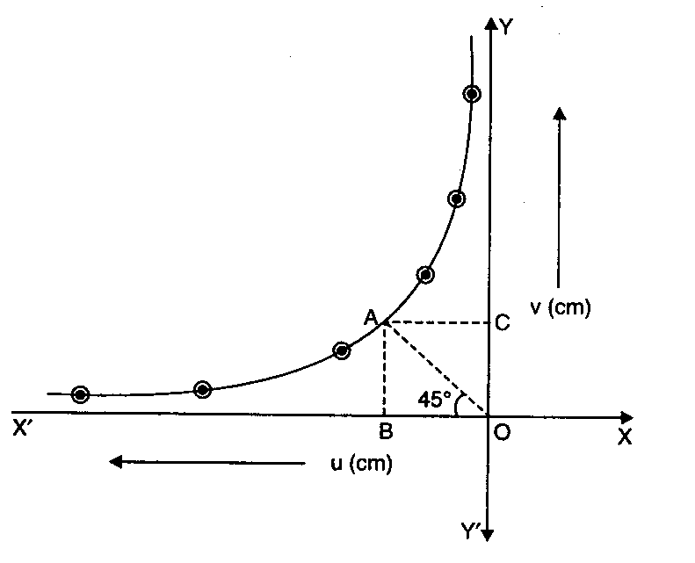
The above graph shows the variation of u-v graph for a spherical mirror/lens for a real image . Identify the lens/mirror. What is the significance of the point A on the graph.
6.
The fig. shows spectral series due to hydrogen atom. Identify the series . In which region does this series belong to?
7.

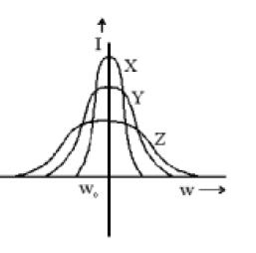
The above graph shows the variation of current amplitude vs angular frequency (ω) for a series LCR a.c. circuit obtained for different values of resistances X,Y,Z . Arrange the resistances in increasing order.

8.
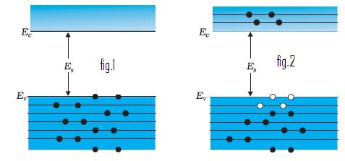
The above figures show the energy band diagram for an intrinsic semi conductor at temperatures at T = O K and T > O K. Which of the above fig corresponds to T= 0 K and why?

9. Keeping the voltage of the charging source constant, What would be the percentage change in the energy stored in a parallel plate capacitor , if the area of each plate is increased by 10%?

10.
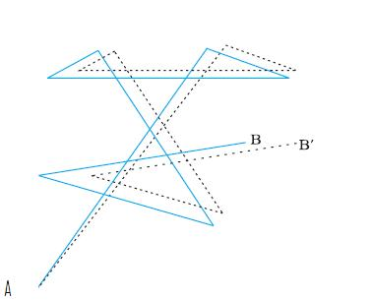

In the fig. there are two paths A to B and A to B’ , one path corresponds to the path followed by electron in the absence of electric field and one path corresponds to the path followed by electron in the presence of electric field in a conductor. Which path corresponds to the path followed in the presence of electric field and why? Also specify the direction of electric field?
11. Schematically represent the experimental set up for confirmation of wave nature of matter. Name the scientist involved in this experiment.
12.
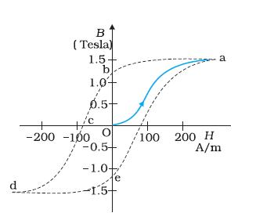
The graph shows the variation of B with H for a ferromagnetic material.
What does each of the following represent in the fig. (i) Ob (ii) Oc
Should the area of the graph be less or more in case of a soft iron and why?

13. Remote sensing satellites take photographs at night time also. Which waves are associated in taking the photographs . Mention any other two uses of these radiations.

14. The formation of Rainbow is based on three phenomena of which two are refraction, dispersion. Name the third phenomenon. Write any two other applications of this phenomenon.

15. Why potentiometer is preferred over voltmeter for comparing emf ’s of primary cells.
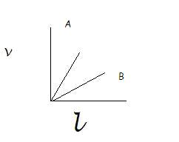
The graph shows the variation of potential difference vs length of the the wire for two potentiometers A and B. Which one will you prefer for comparing emf’s of two primary cells and why?

16. If radiation of frequency 8.8 X 10¹⁴ Hz is incident on a metal surface of threshold frequency 4 X 10¹⁴Hz, then find the value of stopping potential.

OR

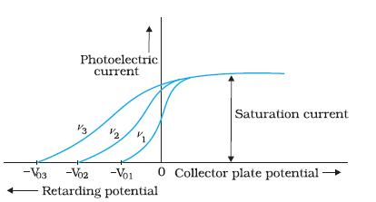

In the above graph of collector plate potential vs photoelectric current for a metal for three different frequencies of incident radiations, arrange the frequencies in the increasing order . What remains the same for all these radiations. For which radiation the max.kinetic energy of photo electron is maximum.
17. In a Geiger-Marsden experiment, what is the distance of closest approach to the nucleus of Gold (Z=79) of a 7.7 MeV α-particle before it comes momentarily to rest and reverses its direction?

18.

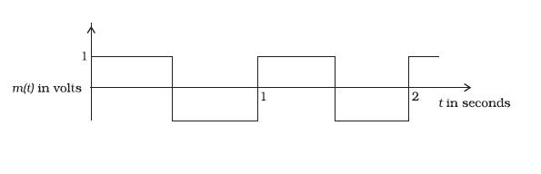
A modulating signal is a square wave as shown in the fig. The carrier wave is given by C(t)= 2sin(8πt). (a)Sketch the amplitude modulated wave for the above message signal. (b) What is the modulation index.
19.
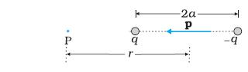
Derive an expression for the electric field at a point P due to the system of charges given in the fig. What is the angle between the Electric field and vector p in the fig. If point P is taken on the right of the fig. does the angle change?

20. State Gauss’s law. Using this law , derive an expression for electric field due to a line of charge having linear charge density λ.

21. Determine the currents I₁ , I₂ , I₃ in the following network using Kirchhoff’s laws.

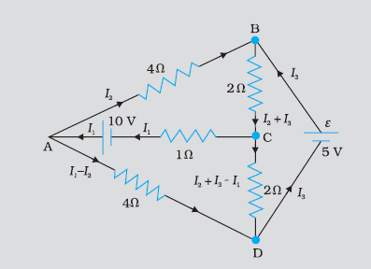
OR

A battery of emf 9V and negligible internal resistance is connected to a 3KΩ resistor. The potential drop across a part of the resistor (between points A and B) is measured by (a) a 20KΩ voltmeter (b) a 1KΩ voltmeter In (c) both the voltmeters are connected across AB as showin in the fig. In which case would you get the (i) highest (ii) lowest reading . If point B is at the end of the resistor , would your answer change. Explain.
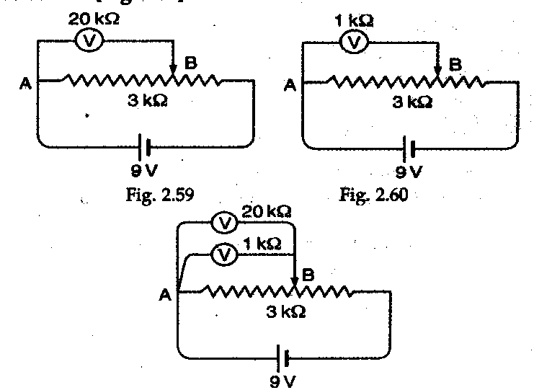

22.
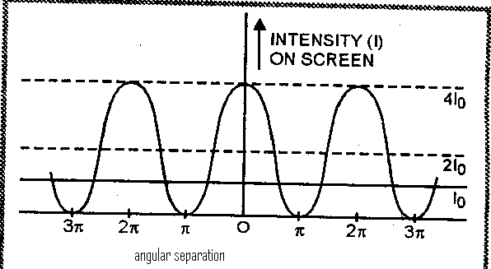
What phenomenon is associated with the above graph. This phenomenon is observed in one experiment . Name the experiment. If one of the slits is closed in that experiment , draw the variation in the above graph. Write any two differences between the above two phenomena.

23. An alternating source of emf v = v₀ sinωt is applied across a series combination of an inductor of inductance L and a resistance R. Derive an expression for the instantaneous current flowing in the cirucuit. Obtain the phase relation ship between current and voltage for the combination.

24. A card sheet divided into squares each of size 1sqmm is being viewed at a dstance of 9 cm through a magnifying glass ( a converging lens of focal length 10 cm) held close to the eye.
(a) What is the magnification produced by the lens?
(b) What is the angular magnification (magnifying power) of the lens?
(c) Is the magnification in (a) equal to the magnifying power in (b)? Explain.
25. What is mutual induction? Write the SI unit of coefficient of mutual induction .
Also , derive an expression for coefficient of mutual induction for two long solenoids.

26. A 1000 MW fission reactor consumes half of its fuel in 5.00 y. How much ₉₂ U ²³⁵did it contain initially? Assume that the reactor operates 80% of the time, that all the energy generated arises from the fission of ₉₂ U ²³⁵and that this nuclide is consumed only by the fission process.

27. Draw a block diagram of a simple modulator for producing AM wave . Show analytically the characteristics of band pass filter required for production of AM wave.

28. Two circular coils X and Y having radii R and R/2 respectively are placed in horizontal plane with their centres coinciding with each other. Coil X has a current I flowing through it in the clockwise sense. What must be the current in coil Y to make the total magnetic field at the common centre of the two coils, zero? With the same currents flowing in the two coils, if the coil Y is now lifted vertically upwards through a distance R, what would be the net magnetic field at the centre of coil Y?
OR
What is the relationship between the current and the magnetic moment of a current carrying circular loop? Use the expression to derive the relation between the magnetic moment of an electron moving in a circle and its related angular momentum?
(ii) A muon is a particle that has the same charge as an electron but is 200 times heavier than it. If we had an atom in which the muon revolves around a proton instead of an electron, what would be the magnetic moment of the muon in the ground state of such an atom?

29. State and explain Huygen’s principle. Name the type of wavefront that corresponds to a beam of light
(i) coming from a convex lens when a point source is placed at its focus.
(ii) coming from a very far off source
(iii) diverging radially from a point source
On the basis of Huygen’s principle prove the laws of reflection of light.
OR

With the help of a suitable ray diagram , derive the mirror formula for a convex mirror.
The image of a small electric bulb fixed on the wall of a room is to be obtained on the opposite wall three metre away by means of a large convex lens. What is the maximum possible focal length of lens required for the purpose?

30. Draw a labeled circuit diagram for a common emitter amplifier using n-p-n transistor.
Explain the working of amplifier. Write down the expression for its voltage gain. What is the phase difference between input and out put signals.
You are given the two circuits as shown in Fig. Show that circuit (a) acts as OR gate while the circuit (b) acts as AND gate.

OR

Draw a circuit diagram to show the use of transistor as an oscillator . Explain how the positive feed back is provided in the circuit. Write the expression for the frequency of oscillations produced.
Which gate is known as universal gate and why. Use these gates to obtain the basic gates.

Paper Submitted by: K.Chandrasekhar
Email : chandrasekhar_koride@yahoo.com
Ph No. : 9949936325

