Guess Paper – 2010
Class – X
Subject – Maths

Section 1
Q 1 The H.C.F and l.c in of two number are
50 and 250 reflectively . it the first number
Is desisted by 2 , the questions is 50, find the
Reckoned number.

Q2 it p and q are the zeroes of ploy normal an2 -5x+c find the value of a and c , given that p+q = pq =10

Q3 find the dir criminated of quid artic education n2 + (a+b)n-c2 =0 and hence find the nature of its roots

Q4 Determiner so that 4 k +8 , 2k2 +3k+6 ,
3k2 +4k+4 are three con seductive terms of an a f

Q5 qf cos20 . +2 cosq = k , find k
Sen70 sin(90-q) 2
Q6 find the length of p k

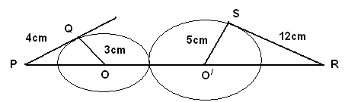

Q7 In adjoining figure RS11DB11PQ
CP =PD=11 and DR = RA=3 find x and y
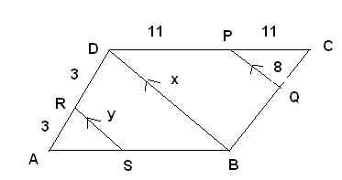
Q8 An archery target has three consecutive circular regions. The diameter of the region are the ratio 1:2:3 what is the ratio of their areas?

Q9 If μ_{i} = x_{i}-25 , Σ f_{i} μ_{i} =20 , Σ fi =100. find the value of x
10
_ _
Q10 If E denotes the complement ary of an event E, What is value of p (E) +p(E)

Section B

Q11 If – 4 is a root of the quadratic equation x² +px –4=0 and quadratic
Equation x2 + px +k=0 has equal roots find the the value of k
_
Q12 If 3secA-2cosB = /3 and B=30º. find the value of A; and hence find the value of
cos (A-B)

Q13 The coordinates of the mid points of line joining the points (2p+2,3) & (4+2q+1) are (2p,2q) find the value of p & q

Q14 In the figure , quadrilateral ABCD is circumscribed & AD DC ; find x if radius of in circle is 10 cm 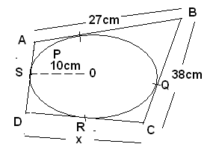

Q15 There are 2 boys more than the number of girls in a chess club. A member of the
Club is to be chosen at random to participate in a tournament. Each member is equally likely to be chosen if the probability that a girl is chosen is 3 , how many girls and how many boys are theree in club 7

section c

Q16 prove that /2+/5 is an irrational number

Q17 Each of two A.P 3,5,7 … and 4,7,10…. are continued to 100 terms find
how many terms are identical

Q18 Using the quadratic formula , solve the equation
a²b².x²–(4 b⁴ –3 a⁴)x –12a²b²=0

Q19 find the value of k for the which the following pair of linear equations
6x +10y=0 , kx+20y=0 has a non -zero solution

Q20 prove that
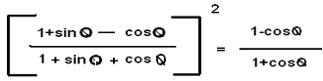

Q21 The vertices of a triangle are (2,a) , (1/b) and (c²,-3)
- prove the its centroid cannot lie on y-axis
- find the conditions that the centroid may lie on the x- axis

Q22 If x₁ ,x₂ x₃ are in A.P and y₁,y₂,y₃ are also in A.P then prove that the points
(x₁,y₁) ,(x₂,y₂), (x₃,y₃₎ are collinear .

Q23 In the adjoining figure, M is the mid point of side CD of parallelogram
ABCD.The line BM is drawn intersecting AC in L and AD Produced in E. prove that EL =2 BL
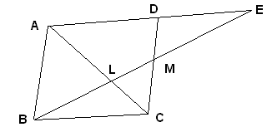

Q24 Construct ΔABC in which AB=6.5 cm, BC= 3.4 cm &AC=4.6cm.
Draw ΔAB’C’ΔΑΒC such that AB/AB’=5/4 Write steps of
Construction.

Q25 A right triangle with sides 3 cm an 4 cm is revolved around its hypotenuse.
find the volume of double one thus generated

SECTION – D

Q26 Draw graph of following equations on same graph paper 2x +y =2;
2x+y = 4. Find the coordinate of the vertices of two triangles formed by two graph lines and the coordinate axis. Compare their areas & hypotenuses

Q27 The angles of elevation of an aeroplane flying in a horizontal straight line,
from a fixed point at four successive observations are α ,β ,γ and δ, the observations being taken at equal intervals of time . Assuming that the speed
of aeroplane is uniform, show that 3(cot²β –cot²γ) =( cot²α-cot²δ)

Q28 State & prove Basic proportionality theorem” & by using it, do following
in figure DE11AC and DC11AP prove that

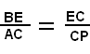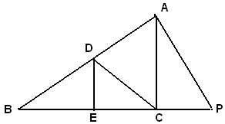

Q29 The adjoining figure shows a bottle closed with a cork. find the capacity of
The closed bottle. Give your answer in terms of π

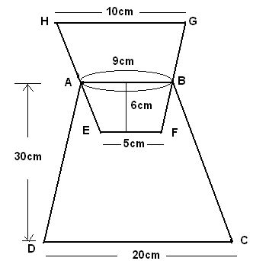

Q30 An incomplete distribution families according to their expenditure per week
is given bellow the median and mode for the distribution are Rs 25 and Rs 24 respectively calculate nursing frequencies

Expenditure | 0-10 | 10-20 | 20-30 | 30-40 | 40-50
No of families | 14 | x | 27 | y | 15

Paper Submitted by: Manoj Gupta
Email : deepaksharma@snsp.org
Ph No.: 9896084098

