Guess Paper – 2010
Class – XII
Subject – Informatics Practices (065)

Time Allowed: 3 Hours Max. Marks: 70

Instructions:
- All questions are compulsory.
- Answer the questions after carefully reading the text.
- Please check that this question paper contains 7 questions in three Sections.
- Please write down the complete serial number of the question before attempting it.

SECTION A

- Answer the following questions:
(a) What is OSS? How is it different from Proprietary software? 2
(b) Define Data Warehousing using suitable example? What is its role & significance for today’s industries? 2
(c) Define Entity, Relationship and Attributes? Identify the type of relationship represented in the following statements and draw an Entity Relationship Diagram to sketch it: “A Student can issue multiple books from the library”. 2
(d) What do you mean by SDLC? Name its essential components? What is the significance of phase ‘System Review and Maintenance’ in SDLC? 2
(e) What is Client Server Computing? Explain with example? How many types of client/server architecture are possible & name them? 2

- Answer the following questions:
(a) Write the names of any two properties which are common and different to the listbox object and combobox object? 2
(b) What is parent form and child form in MDI application? Write code to create new child forms at runtime. 2
(c) What do you understand by the term data aware controls? Name any two data aware controls? 2
(d) How is a function procedure similar to and different from a sub procedure? How a sub procedure and function procedure may be called? 2
(e) What is nested loop and infinite loop? Give one example of any one. 2

- Answer the following question:
- What is a Protocol? What is the difference between TCP and IP protocol? 2
- What are Cursor attributes? What do these attributes evaluate to when associated with IMPLICIT cursors? 2
(c) What is a trigger? Name two types of triggers available in PL/SQL? Write one point of similarity and difference between trigger and procedure. 2
(d) Define following terms: i) Primary Key ii) Cardinality 2
(e) What are PL/SQL blocks? How many types of PL/SQL block definition exist? Explain with suitable examples. 2

SECTION B

4. Read the following case study and answer the questions that follow:
The Hot & Taste restaurant has computerized its billing. The following the data entry screen used at their outlet. The outlet offers two different types of foods, vegetarian and non-vegetarian. The price of a regular vegetarian THALI meals is Rs.150/- and that of a non vegetarian THALI meals is Rs.290/-. The user can choose to have four different types of extra supplements if he wants. Each extra supplement costs Rs. 40/-.

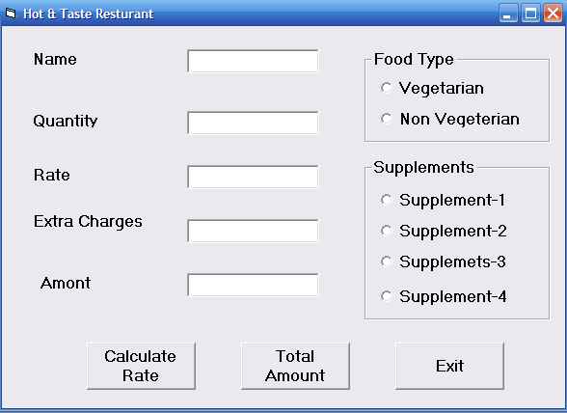

The list for the above form is as follows:

Object type | Object name
Form | Frmrestro
Text box | Txtname  Txtqty  Txtrate  Txtextracharge  Txtamount
Option button | Optveg  Optnonveg
Command button | Cmdcalrate  Cmdcalamount  Cmdexit
Check box | Chksup1  Chksup2  Chksup3  Chksup4

(a) Write the commands to disable the textboxes txtrate, txtextracharge, txtamount and cmdcalrate, and invisible the cmdcalamount and set the focus on textbox txtname. 2
(b) Write the code for cmdcalrate to calculate the rate of the food and display it in txtrate depending on the type of food selected by the customer. It should also enable the cmdcalamount button. 2
(c) Write the code for cmdcalamount to calculate the total amount and display it on txtamount. The total amount is calculated by first finding the cost of extra supplements selected by the customer. Remember that each extra supplement costs Rs. 40/- therefore if the customer selects 2 supplements then extra charge will be Rs. 80/-. Then add it to the rate and multiply the resultant amount by the quantity ordered. If the quantity is more than 10 give 15% discount on extra charge. 4
(d) Write the code for cmdexit to close the application , before closing the application it should display a message “ Do you really want to close the program(yes/no)? ”. If user select yes it should close the program otherwise set the focus on textbox txtname. 2

5. Answer the following questions:
(a) Change the following code using Do until loop without affecting the output. 2
For I = 1 To 50 Step 4
b = I
c = b - 1
d = b + c
If d < 0 Then
d = 0
End If
Print b; c
Next
Print d
(b) Give the output of the following statements: 2
Dim st As String, I As Integer
st = "Indica Tata"
For I = 1 To Len(st) - 1
If Mid(st, I, 1) = Space(1) Then
Mid(st, I, 1) = "BY"
Print st;
End If
Next
(c) Find the output of the following code segment: 2
Sum=0
For I = 1 to 2
For J = 0 to I
Sum = Sum + (I+J)
Next J
Next I
Print Sum
(d) Find the error from the following code segment and rewrite the corrected code underlining the correction made: 2
Function try (P1 As Integer And P2 As Integer)
If P1=P2 then
try= 0
Otherwise P1> P2 then
try= -1
Else
try= 1
Function End

(e) Write a VB procedure which takes a number as argument and displays the reverse of the number. For example if the argument passed is 1357 it should display 7531. 2

SECTION-C

6. Answer the following questions:
(a) Find the errors in the following PL/SQL code and rewrite the corrected code underlining the correction made: 2
CREATE AS WELL AS REPLACE PROCEDURE IncrMarks (rno number) return number
As
Begin:
Update student
Set marks= marks + 0.02 * marks
Where rollno := rno
End;
(b) Write the output produced by the following part of code in PL/SQL. 2
DECLARE
P NUMBER;
Q NUMBER;
BEGIN
P := 5;
FOR Q IN 1..4
LOOP
P := P + Q;
If MOD(P,3)= 0 then
DBMS_OUTPUT.PUT_LINE(P);
Else
DBMS_OUTPUT.PUT_LINE(Q);
End If;
END LOOP;
END;
(c) Write the output produced by the following part of code in PL/SQL. 2
DECLARE
num NUMBER;
counter NUMBER;
BEGIN
counter :=8;
num:=4;
While counter>4 Loop
num:=num-2;
counter:=counter-1
If counter>4 then
Dbms_Output.Put_Line(counter);
End if;
End loop;
DBMS_OUTPUT.PUT_LINE(num);
END;
(d) Write a PL/SQL function CHK_YEAR that accepts a date from the user and returns 1 if the year is a leap year and otherwise returns 0. 4

7. Answer the questions based on the table MOVIE given below:

TABLE: MOVIE
Column Name | Data Type | Size | Constraint | DESCRIPTION
MOVIE_CODE | Number | 8 | Primary key | Identification code of movie
MOVIE_NAME | Varchar2 | 25 | Not null | Name of movie
DIRECTOR | Varchar2 | 25 | Not null | Name of director
MOVIE_TYPE | Varchar2 | 20 |  | Type of movie  (Comedy/ Action/ Thriller)
RELEASED_DATE | Date |  | Check > sysdate | Released date of movie
AWARD_WON | Number | 2 |  | No of awards won by Movie.
MOVIE_COST | Number | (15,2) | Default 5,00,00,000 | Cost of Movie

(a) Write the SQL command to create the above table MOVIE with constraints. 2
(b) Write the SQL command to display name of movie, director’s name and movie cost of comedy movies in descending order of awards won. 2
(c) Write a PL/SQL code to display the records of those movies which are released on a particular date entered by the user. 3
(d) Create a Trigger to display “WOW! So many awards” if award won entered in the table movie are more than 5. 3

Paper Submitted By : Mohd. Hashim
Email: hashim_mbd@yahoo.co.in
Ph No.: 9950589919

