Sample Paper – 2010
Class – X
Subject – Mathematics

Time : 3 Hr. M.M. : 80
General instructions:-
1. All Questions are compulsory.
2. The question paper consists of 30 questions divided into 4 sections A, B, C, and D. Section A contain 10 questions of 01 marks each, section B contain 5 questions of 02 marks each, section C contain 10 questions of 03 marks each, and section D contain 5 question of 06 marks
3. All questions in section A are to be answered in one word, one sentence or as per the exact requirement of the question.

SECTION –A

1. If tan 2A = cot (A – 18°), where 2A is an acute angle, find the value of A
2. Three cubes each of sides 5 cm are joined end to end .Find the surface area of the resulting solid
3. Find the angle of elevation of the sun (Sun’s altitude) when the length of shadow of a vertical pole is equal to its height
4. Find the length of the arc of a circle with radius 6cm if the angle of sector is 60.
5. Given H.C.F (306, 657) = 9, find L.C.M (306, 657).
6. A cylinder, a cone and a hemisphere are of equal base and have the same height. What is
the ratio in their volumes?
7. For what value of k , the following pair of linear equations has infinitely many solutions?
10x + 5y – (k-5) = 0
20x + 10y – k = 0
8. In ABC , if DE||BC , AD = x, DB = x – 2, AE = x + 2 and EC = x – 1, then find the value of x.
9 Justify the statement: “Tossing a coin is a fair way of deciding which team should get the batting first at the beginning of a cricket game.”

10 What is the perimeter of a semi circular protractor whose diameter is 14cm?

SECTION – B

11 Determine an A.P. whose 3rd term is 16 and when 5th term is subtracted from 7th term,
we get 12.
12 Show that the sum and product of two irrational numbers 7 + √5 and 7 - √5 are rational numbers
13 If ∝ and β are the zeroes of the polynomial f(x)=x² –5x+k such that ∝-β=1,find the value of k.
14 If θ is a positive acute angle such that sec θ = cosec60°, then find the value of 2 cos² θ-1.
15 The diameter of a metallic sphere is 6 cm. It is melted and drawn into a wire having diameter of the cross-section as 0.2 cm. Find the length of the wire?

SECTION –C

16If the area of a triangle formed by (x, 2x), (-2, 6) and (3,1) is 5 square units, then find the value of x.
.17 Construct a triangle with sides 4cm, 5cm and 6 cm and then another triangle whose sides are of the corresponding sides of the first triangle.
18 The diameter of a metallic sphere is 6 cm. It is melted and drawn into a wire having diameter of the cross-section as 0.2 cm. Find the length of the wire?
19 Use a single graph and draw the graph of the following equations:
2y – x – 8 = 0,
y – 2x – 1 = 0
Calculate the area of the triangle so formed. Also, find the co-ordinates of the points where the lines intersect the ‘y’ axis.
20 For what of a and b does the following pair of linear equations have an infinite number of solutions?
2x+3y =7
a(x+y)-b(x-y) =3a + b – 2
21 If the points [a,0],[0,b], [1,1] are collinear.show that b+a =ab.
22 Prove that the opposites sides of a quadrilateral circumscribing a circle subtend supplementary angles at the centre of the circle. .
22 Prove that: $\frac{\text{cos}θ−\text{sin}θ+1}{\text{cos}θ+\text{sin}θ−1}$ = cosec θ + cot θ

OR

Prove that: 3 (sin ⁴ θ + cos ⁴ θ ) - 2 ( sin ⁶ θ + cos ⁶ θ ) = 1
.23 ABC is a right triangle at C , P and Q are points on the sides CA and CB respectively which divides these sides in the ratio 1:2 .prove that 9[AQ²+BP²]=13AB²
24 find the area of the shaded region.
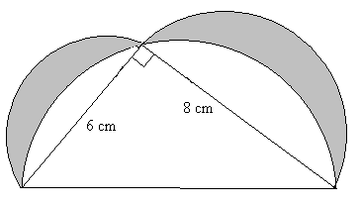
25 A spiral is made up of successive semicircles, with centre alternately at A and B, starting with centre at A, of radii 0.5 cm, 1.0 cm, 1.5 cm, 2.0 cm, . . ….. as shown in fig. What is the total length of such a spiral made up of thirteen consecutive semicircles?(Take π= )

SECTION – D

26 A bucket of height 8cm. and made up of copper sheet is in the form of frustrum of a
right circular cone with radii of its lower and upper ends as 3 cm and 9 cm respectively.
Calculate :
i) the height of the cone of which the bucket is a part
ii) the volume of water which can be filled in the bucket.
iii) the area of copper sheet required to make the bucket
27 The interior of building is in the form of a right circular cylinder of radius 7m and height 6m,surmounted by a right circular cone of same radius and of vertical angle 60°. Find the
cost of painting the building from inside at the rate of Rs 30/m²

28 As observed from the top of a lighthouse, 100 m high above sea level, the angle of depression of a ship sailing directly towards it, changes from 30° to 60°, Determine the distance travelled by the ship sailing directly towards it, changes from 30° to 60°. Determine the distance traveled by the ship during the period of observation.( use √ 3= 1.732)

29 State and prove Pythagoras theorem. Using the above theorem, Prove the following.
In the given figure PQR is a right triangle right angled at Q. If QS=SR, show that PR²=4PS²-3PQ². 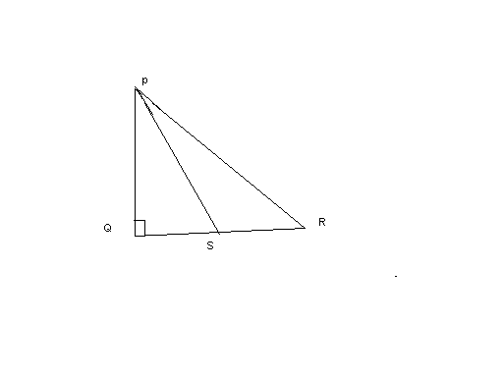
30. Calculate Median ,mean and mode of the following data:
Marks obtained | No. of students
Less than 20 | 0
Less than 30 | 4
Less than 40 | 16
Less than 50 | 30
Less than 60 | 46
Less than 70 | 66
Less than 80 | 82
Less than 90 | 92
Less than 100 | 100

Paper Submitted by: Rajendra singh rathore
Fast track coaching institute
97,chand bihari nagar khatipura jaipur
Rajasthan
India
Contact no 9413444243
0141 2532264

E – mail ; rsrathore3112@gmail.com

