Sample Paper – 2010
Class – X
Subject - INTRODUCTORY INFORMATION TECHNOLOGY

Time Allowed 2.30 hrs. Maximum Marks: 40

Ques 1
- What do understand by ‘Data Inconsistency’ and Data Redundancy? Explain with example. 2
- Which two views can a table be opened in? How are these views different from one another? 1
- What is the importance of primary key in a table? Can you have multiple primary keys in a table? Why or Why not? 2
- What do you understand by ‘REQUIRED VALUES’ for a field? On which type of fields can this property be applied? 1
- You entered a value as 0.66 in a Number field having percent format. But in place of displaying 66%; it is displaying100%.Can you find out a reason? 1
- What is the meaning of Default value for a field in Ms-Access? Explain with example. 1
- Frame a input Mask for a PIN code field keeping in mind the given below instructions: 1
- The Sample code is 10-09-1234.
- The first two digits are optional.
- The second two digits are compulsory.
- The literal characters storage is necessary.
- Mask should be look like @@-@@-@@@@ When user start entering the data in datasheet view.
- Last digits must be required.
- Differentiate between Text field and Currency field. 1

Ques 2
- Expand the following terms: 1
( i) URL (ii) SMTP
- What do you understand by ‘Netsurfing’? 1
- Give difference between web address and E-Mail address. 1
- What is uploading and downloading a file? 1
- What do you understand by remote login? 1
- What are the three components of client server computing? Explain them. 1
- What is DNS? 1
- Write a short note on e-shopping? 1
- How can you ensure that you will be able to again visit a web page that you have liked greatly without having to remember its URL. 1
- Differentiate between Cc and Bcc? 1

Ques 3
a) Is it possible to view a HTML page stored in the hard disk of your computer? If yes, what is the method
of viewing the same? 2
- What are the roles of following options in a web browser? 1
  - Refresh/Reload
  - Home
- What is wrong in the following code? Write the correct one also. 1
<p font face=”Arial” color=”blue”>
- Differentiate between Container Element and Empty Element? 2
- Write the expansions of following tags used in HTML: 2
i)<UL> ii)<P> iii)<U> iv)<BR>
f) Can we insert BMP image in web page? Also specify which types of images can be inserted? 2
g) What is the purpose of using TYPE and START attributes used in Lists? Give example to support your
answer. 2

Ques4.Write down the HTML code to generate a page in the format and style given below: 8

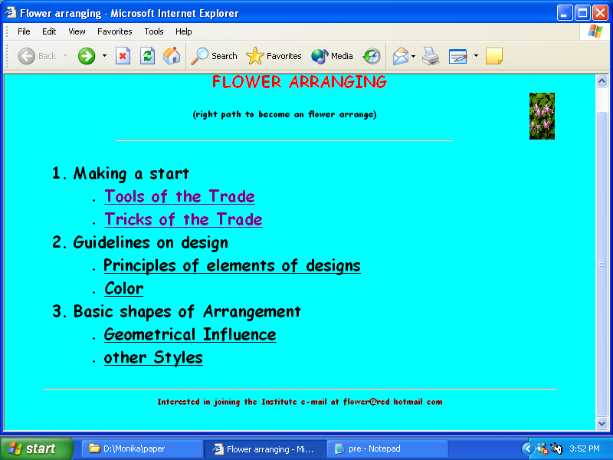

Special Notes:
- Title of the page is ‘Flower Arranging’.
- The background of the page is “Aqua”, top margin is 30 and left margin is 50.
- All Font face used for the page is “Comic Sons MS” and Size=2.
- The Main Heading color is “Red”.
- The link color is “grey”.
- Image used is “flower1.gif”.
- Pages linked with
Tools of the Trade as Make1.html
Tricks of the Trade as Make2.html
Principles Elements of design as Guid1.html
Color as Guid2.html
Geometrical Influence as Bos1.html
Other Styles as Bos2.html
- Bottom message is center aligned , size is 2 and color is maroon

Note: - You can use any other attribute which are not otherwise mentioned above to produce a similar output.

Paper Submitted by: Sunil Kumar
Email : mr_parmarsunil@rediffmail.com
Ph No. 09812100604

