Sample Paper – 2010
Class – X
Subject – Mathematics

Time: Three hours Max. Marks: 80
General Instructions

1. All Questions are compulsory.
2. The question paper consists of thirty questions divided into 4 sections A, B, C and D. Section A comprises of ten questions of 01 mark each, section B comprises of five questions of 02 marks each, section C comprises of ten questions of 03 marks each and section D comprises of five questions of 06 marks each.
3. All questions in Section A are to be answered in one word, one sentence or as per the exact requirement of the question.
4. There is no overall choice. However, internal choice has been provided in one question of 02 marks each, three questions of 03 marks each and two questions of 06 marks each. You have to attempt only one of the alternatives in all such questions.
5. In question on construction, drawings should be neat and exactly as per the given measurements.
6. Use of calculators is not permitted.
Section: A
1. Without actual division, state whether is a terminating or non terminating
decimal. Justify your answer.
2. The sum and product of the zeroes of a quadratic polynomial are 3 and -2
respectively. What is the quadratic polynomial?
3. Find the roots of the equation 2x²+x-6=0
4. Given that, sinA= Prove that sin²A+Cos²A=1
5. Find the number of terms in the A.P. 7,15, 23,….,247
6. A cylinder, a cone and a hemisphere are of equal base and have the same
Height, What is the ratio in their volumes?
7. Two Concentric circles of radii 5cm and 3 cm. Find the length of the chord of
the larger circle which touches the smaller circles.

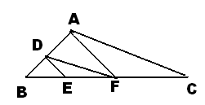
8. In fig, DE AC and DF AE, prove that

9. A coin is tossed thrice. Find the probability of getting exactly two heads.
10. A student draws both less than and more than cumulative frequency curves
in a graph sheet. Both the curves meet at (38.5, 25). Find the total
frequency and median of such distribution.
Section: B
11. Solve for x and y
12. If tan(A+B) = and tan (A-B) = Find A and B.
13. Find a point on the y-axis which is equidistant from the points A (6,5) and
B (-4,3).
14. ∆ABC is an isosceles triangle, in which AB=AC, circumscribed about a circle.
Show that BC is bisected at the point of contact P.
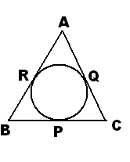

15. A bag contains 5 red, 7, green and 8 white balls. One ball is drawn at random
from the bag, find the probability of getting
(i) A white ball or a green ball. (ii) Neither a green ball not a red ball.
(OR)
One card is drawn from a well shuffled deck of 52 playing cards. Find the
probability of getting (i) a non-face card (ii) A black king or a red queen.
Section: C
16 Using Euclid’s division algorithm, find the HCF of 72, 126 and 168.
OR
Prove that is an irrational number 5+

17. If two zeroes of the polynomial are , find
the other zeroes of the polynomial.
18. Draw the graph of the following pair of linear equations
x + 3y = 6
2x - 3y = 12
Hence find the area of the region bounded by the
x = 0, y = 0 and 2x - 3y = 12
19. If the sum of first n terms of an AP is given by Find the first
term, common difference and nth term.
20. Prove that:
(OR)
Prove that:
21 Observe the triangle with vertices (0,-5), (3, 0) and (-3,-4) is scalene,
Isosceles or equilateral. Justify your answer. Also find its area.
22. If the points A (6,1), B(8,2), C(9,4) and D(p,3) are the vertices of a
Parallelogram, taken in order, finds the value of p and hence finds its area
also.
23. Construct a ABC in which CA = 6cm, AB = 5cm and BAC = 45°, then
construct a triangle similar to the given triangle whose sides are of the
corresponding sides of the ABC.
24. Prove that opposite sides of a quadrilateral circumscribing a circle subtend
supplementary angles at the centre of the circle.
25 A square field and an equilateral triangular park have equal perimeters. If the
cost of ploughing the field at rate of Rs 5/ m² is Rs 720, find the cost of
maintaining the park at the rate of Rs 10/ m².
(OR)
The area of an equilateral triangle ABC is 17320.5cm². With each vertex of
the triangle as centre, a circle is drawn with radius equal to half the length of
the side of the triangle. Find the area of the shaded region
(use )

Section: D
26. An express train takes 1 hour less than a passenger train to travel 132km between two places. If the average speeds of the express train is 11km/hr more than that of the passenger train find the average speed of the two trains.
(OR)
A motor boat whose speed is 18km/hr in still water takes 1hr more to go 24km upstream than to return downstream to the same spot. Find the speed of the stream.
27. From the top of a building 100 m high, the angles of depression of the top and bottom of a tower are observed to be 45° and 60° respectively. Find the height of the tower. Also find the distance between the foot of the building and bottom of the tower.
(OR)
The angle of elevation of the top a tower at a point on the level ground is 30°. After walking a distance of 100m towards the foot of the tower along the horizontal line through the foot of the tower on the same level ground, the angle of elevation of the top of the tower is 60°.Find the height of the tower.

28 Prove that in a right triangle, the square of the hypotenuse is equal to the sum of the squares of the other two sides. Using this, solve the following:
O is any point inside a rectangle ABCD. Prove that OB²+OD²= OA²+OC²

29. A container shaped like a right circular cylinder having diameter 12cm and height 15cm is full of ice cream. The ice cream is to be filled into cones of height 12cm a diameter 6cmhemispherical shape on the top. Find the number of such cones which can be filled with ice creams?

30. The following distribution gives the daily income of 50 workers of a factory.
Daily Income (in Rs) | 100-120 | 120-140 | 140-260 | 160-180 | 180-200
Number of workers | 12 | 14 | 8 | 6 | 10

Find the mean, median and mode.

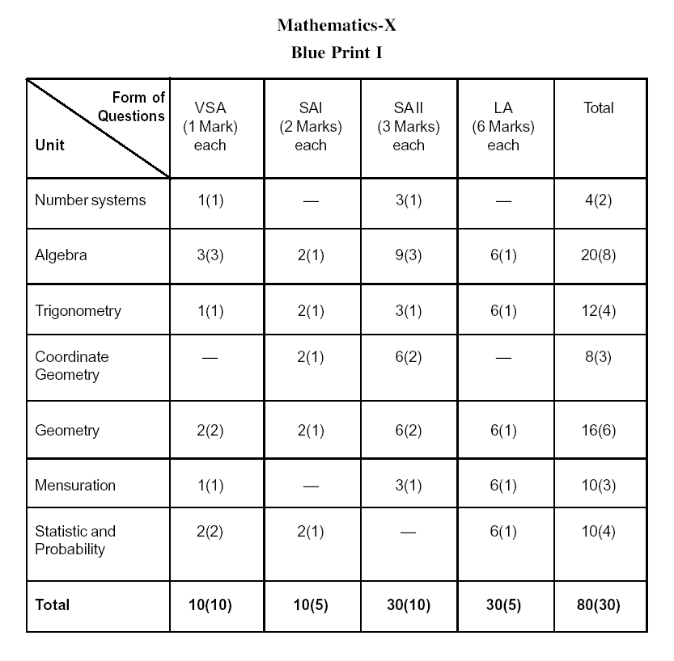
Paper Submitted by: V.ESWARAN
Email : v.eswar@yahoo.com
Ph No. 9461677289

