Sample Paper – 2010
Class – XII
Subject – Informatics Practice

MM 70 TIME 3hrs
Note: (i) This question paper is divided into 3 sections
(ii) Section A consists of 30 Marks.
(iii) Section B and Section C are of 20 marks.
(iv) Answer the questions after carefully reading the text.

==============================================
[SECTION - A]
Q.1) Answer the following questions:
a) How is a back-end linked to a database and a server?[2]
b) What is the difference between Freeware & Free
software? [2]
c) What is Object Oriented Modeling Technique ? Why
UML is used? [2]
d) Explain term with suitable example –
i) Data Dictionary ii) Data Warehousing
iii) Data Mining iv) Meta Data [2]
e) Why are the following software used for? [2]
i) Linux ii) Tomcat
Q.2) Answer the following questions:
a) Differentiate Public Sub and Private Sub. [2]
b) Explain the following: [2]
i) RAD ii) ADO
c) What are events? What are event procedures? How are they related? [2]
d) Explain Record Set and Types of recordSet [2]
e) What are parameters? Write the difference between actual
and formal parameters with example. [2]
Q.3) Answer the following questions:
a) Explain the function SUBSTR() and INSTR() with a
suitable example. [2]
b) Write the syntax to create an explicit cursor and Trigger. [2]
c) Differentiate between %Type and %rowType. Explain
with example. [2]
d) What is the difference between Anonymous block and Named
block? Give example also. [2]
e) What is transaction? Why do we use commit and rollback
statements. Explain in brief with the help of an example.[2]
-----------------------------------------------------------------------

[SECTION – B]
Q.4) Read the following case study and answer the questions that follow:
Mr. Anil Sharma of High Income Finance Company needs to calculate the interest and amount due from his clients. He asks his software programmer to design an interest calculator which will calculate the compound interest and amount due if a person takes a loan for 5, 10 or 15 years. The programmer opts for Visual Basic Language to develop this and create the following form:
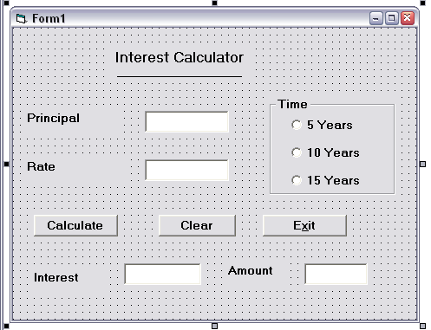

Object Type | Object Name | Description
Form | frmInterest Calc | The main form object
Text Box | TxtPrincipal  txtRate  txtInterest  txtAmount | To enter the principal  To enter the interest rate  To display the compound  interest  To display the amount due
Comand Button | cmdResult  cmdGrade  cmdClear  cmdExit | Button for calculation  Button for grade  Button for clear the text boxes  For close

- Write the code to disable the textboxes txtInterest and txtAmount in the form load event of frmInterestCalc [2]

- Write the code for cmdClear command button to clear all the textboxes and set default choice in the Option Buttons as 5 years. Also set the focus to txtPrincipal. [2]

- Write the code for the Change event of the textboxes txtPrincipal and txtRate to ensure that the user enters only numeric values in them. [2]

- Write the code for the Click event of the command button cmdCalculate to calculate the compound interest and amount depending on the principal, rate and time. The compound interest is calculated as P * (1 + R / 100) ^ T and amount as (Principal + Compound Interest). [4]

Q.5) Answer the following questions –

a) Which three programming constructs are supported by every
programming language. Explain with examples. [2]

b) Find the errors from the following code segment and rewrite
the corrected code underlining the correction made. [2]
x = 5
Do While x <= 10
If x Mod 2 = 0
Display x
Loop
k = k + 1
End If
c) Find the output of the following code segment [2]
Dim work As Integer, i As Integer
work = 10
i = o
Do While work < 20
Print work * i
i = i + 2
If i = 8 Then
work = 20
Else
work = work - 3
End If
Loop

- Write a PL-SQL code to find the sum of series
S = a + ar¹ + ar² + ar³+ ar⁴ [4]
------------------------------------------------------------------------------

[ SECTION – C]
Q.6) Read the questions given below and answer accordingly.

a) Find the errors of the following code segment. [2]

create or replace procedure area_circle(radius real)
area real;
begin;
area = 22/7 x radius x radius
print ('The area is = ', area);
end;

b) Find the output produced by the following PL/SQL code–[2]

DECLARE
Y NUMBER;
X NUMBER;
BEGIN
Y :=15;
FOR X IN 11..15
loop
if x>15 then
dbms_output.put_line (y);
else
dbms_output.put_line (x);
end if ;
y := y-1;
end loop;
END;

c) Write the query for the following – [2]
  - to display all the procedures and functions you have
created.
  - to view the source code of the procedure.

d) Write a PL-SQL script that uses cursor FOR loop that
determines the top five highest paid employees from EMP
table. Be sure to incorporate the usage of the appropriate
cursor attributes. Print these five employees details on the
screen. [4]

Q.7) Answer the questions based on the table EMPLOYEE
given below:

EMPNO | ENAME | SALARY
101 | RAJ | 10000
102 | SUMIT | 20000
103 | PAWAN | 30000
104 | ANIL | 40000

- Write the SQL command to display employee number and employee name whose salary are exactly 10000, 20000, 40000. [1]

- Write the SQL command to display the employee name and salary of all the employees in decreasing order of salary field. [1]

- Write a Procedure raise_sal which creates the salary of an employee. It accepts an employee number and salary increase amount. It uses the employee number to find the current salary from the employee table and update the salary. Insert the details of the record in the table EMP_AUDIT (fields are EMPNO, INFO) if no such employee exist in the department [4]

- Create a trigger to display the salary difference when an employee information is changed. [4]

Paper Submitted by: Harpreet Singh
Email : happymphilcs@rediffmail.com
Ph No. : 09950213099
KENDRIYA VIDYALAYA JHALAWAR(RAJASTHAN)

