SAMPLE PAPER - 2010
CLASS – XII
SUBJECT – Chemistry

PREBOARD
BLUE PRINT
S.NO | CHAPTERS | V.S.A(1) | S.A.(2) | S.A.(3) | L.A.(5) | TOTAL
1 | SOLID STATE | 1X(1) | NIL | 1X(3) | NIL | 4
2 | SOLUTIONS | NIL | 1X(2) | 1X(3) | NIL | 5
3 | ELECTROCHEMISTRY | NIL | 1X(2) | 1X(3) | NIL | 5
4 | CHEMICAL KINETICS | NIL | 1X(2) | 1X(3) | NIL | 5
5 | SURFACE CHEMISTRY | 1X(1) | NIL | 1X(3) | NIL | 4
6 | GENERAL PRINCIPLES | NIL | NIL | 1X(3) | NIL | 3
7 | p-BLOCK ELEMENTS | 1X(1) | 1X(2) | NIL | 1X(5) | 8
8 | d- and-f-BLOCK ELEMENTS | NIL | NIL | NIL | 1X(5) | 5
9 | COORDINATION COMPOUNDS | 1X(1) | 1X(2) | NIL | NIL | 3
10 | HALOALKANES AND HALOARENES | 1X(1) | NIL | 1X(3) | NIL | 4
11 | ALCOHOLS,PHENOLS AND ETHERS | NIL | 2X(2) | NIL | NIL | 4
12 | ALDEHYDES, KETONES AND CARBOXYLIC ACIDS | 1X(1) | NIL | NIL | 1X(5) | 6
13 | ORGANIC COMPOUNDS CONTAINING NITROGEN | 1X(1) | NIL | 1X(3) | NIL | 4
14 | BIOMOLECULES | NIL | 2X(2) | NIL | NIL | 4
15 | POLYMERS | 1X(1) | 1X(2) | NIL | NIL | 3
16 | CHEMISTRY IN DAILY LIFE | NIL | NIL | 1X(3) | NIL | 3
 |  | 8 | 20 | 27 | 15

Time: 3 hrs. .
General instructions:
All questions are compulsory.
Marks for each question are indicated against it.
Questions number 1to 8 are very short –answer questions, carrying 1 mark each. Answer these in one word or about one sentence each.
Questions number9 to18 are short –answer questions, carrying 2 marks each. Answer these in about 30 words each.
Questions number19 to27 are short –answer questions, carrying 3 marks each. Answer these in about 40 words each.
Questions number28 to30 are long-answer questions of 5 marks each. Answer these in about 70 words each.
Use log tables, if necessary. Use of calculators is not permitted.
QUESTIONS:
1 Why glass is called super cooled liquid? (1)
2 Which type of adsorption increases on increasing temperature?(1)
3 Why nitrogen is highly unreactive at room temperature? (1)
4 What are Heteroleptic complexes? Give example.(1)
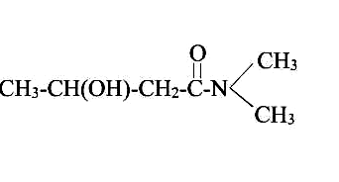
5 Write IUPAC name of the following compound: (1)

6 Write one method which is used to obtain pure silicon. (1)
7 Why amines are basic in nature? (1)
8 Write the names of the monomers of nylon. (1)
9 What is elevation in boiling point? Write expression.(2)
10. What is specific conductivity? What is the effect of dilution on it? (2)
11 How is activation energy related to rate of reaction? (2)
12.Write two disproportion reactions involving elements of p-Block.. (2)
13 What is CFSE? Does it gives any idea about the type of complex formed? (2)
14Carry out the following conversions:
- Phenol to Toluene
- Benzene tobenzaldehyde (2)
15 Which vitamin is called asThiamine? What are its sources? What is the disease caused by the deficiency of this vitamin? (2)
16 What are essential and non-essential amino acids? Give examples (2)
17 Compound A(molecular formulaC₃H₈O) is treated with acidified potassium dichromate to form a product B of molecular formula C₃H₆O . B on warming with ammoniacal silver nitrate solution forms shining silver mirror. Identify A and B and write the reactions involved.(2)
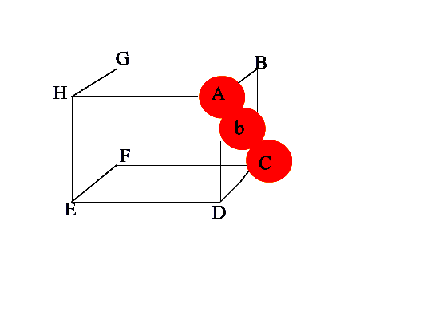
18 What are step growth and chain growth polymers? (2)
19 Calculate the packing efficiency of the following type of cubic lattice.
20 19.5 g of CH₂FCOOH is dissolved in 500 g of water. The depression in the freezing point of water observed is 1.0⁰C. Calculate the van’t Hoff factor and dissociation constant of fluoroacetic acid. (3)
21 0.2964 g of copper was deposited on passage of a current of 0.5 ampere for 30 minutes through a solution of copper sulphate. Calculate the atomic mass of copper. (3)
22 A drug becomes ineffective after 30% decomposition. The original concentration of a sample was 5mg/ml which becomes 4.2mg/ml during 20 months. Assuming the decomposition of first order, calculate the expiry time of the drug in months. What is the half life of the product? (3)
23 (a) If an electric field is applied to a colloidal sol, the dispersed phase particles are found to move towards the electrode of opposite charge. If however, the dispersed phase is made stationary, the dispersion medium is found to move in the opposite direction. What is the term used for such movement of dispersion medium ?
(b) A sol is prepared by addition to excess AgNO3 solution in KI solution. What charge is likely to develop on the colloidal particles ?
(c) Out of glucose, urea and dodecyl trimethyl ammonium chloride, which one forms micelles in aqueous solution above certain concentration ? (3)

24 Observe the given graph carefully and answer the following questions:
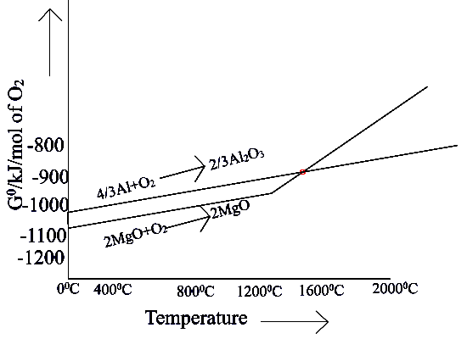

- What is the sign of ΔG⁰ when Mg reduces Al₂O₃? What does it indicate about the spontaneity of reaction?
- What is the sign of ΔG⁰ when Al reduces MgO? What does it indicate about the spontaneity of reaction?
- At which temperature non-spontaneous reaction becomes spontaneous?
- What is above graph called?
- What type of reactions are shown by this graph?
- What is the point called where two curves intersect? (3)
25 Write following name reactions:
(i) Swarts reaction (ii) Sandmeyer reaction (iii) Gatterman reaction (3)
26 Give reasons:
- Ethylamine is more basic than aniline.
- 3⁰ Amines are more basic than 1⁰ amines.
- Methyl amine is a good complexing agent. (3)
27 What are Tranquilizers? Give examples? (3)
28 A white waxy solid (A) when burnt in air forms a compound (B). Element (A) on heating in the excess of a gas (C) gave a compound (D). Compound (D) fumes in moist air and oxidizes metals like silver and tin. Compound (D) on heating decomposes to give back gas (C). Identify A, B, C and D and write the reactions involved. (5)
OR
(a)Give reasons:
- S₂ is paramagnetic in vapour phase.
- PCl₅ fumes in moist air.
- Ozone is thermodynamically unstable.
(b) Draw the structures of XeF₆ and IF₇.
29(a) How do you account for the following:
(i) The transition elements exhibit high enthalpies of atomization.
(ii) The 4d and 5d series of the transition metals have more frequent metal-metal bonding in their compounds than do the 3d metals.
(iii)There is a greater range of oxidation states among the actinoids than in the lanthanoids.
(b) Write the complete chemical equation for each of the following:
(i) An alkaline solution of KMnO₄ reacts with an iodide.
(ii) Acidic KMnO₄ reacts with hydrogen sulphide. (5)
OR
Describe the steps involved in the preparation of either potassium dichromate from sodium chromate or potassium permanganate from manganese dioxide.
30 How do you account for the following?
Give reasons:
- Oxidation of toluene with CrO₃ to Benzaldehyde is carried out in presence of acetic anhydride
- Although Aldehydes are easily oxidisable yet propanal can conveniently be prepared by the oxidation of propanol by acidic dichromate.
- In the preparation of acetaldehyde from ethanol by oxidation, it is distilled out as it is formed.
- Formation of oximes and other ammonia derivatives from carbonyl compounds require slightly acidic medium for maximum rate.
- Benzaldehyde does not undergo aldol condensation whereas acetaldehyde does.(5)
OR
Acetaldehyde undergoes a reaction to form a product which exhibits properties of aldehydes and alcohols.
- Name the reaction and give equation.
- Write the structural formula of the product formed.
- What are the reagents other than acetaldehyde required for the reaction to take place?
- Why acetaldehyde gives this reaction?
- What happens if acetaldehyde is reacted with acetone? (5)

Paper Submitted By:- Mohini Belani
Email :- mohinibelani@yahoo.co.in
Phone No. 07544-273314

