GUESS PAPER - 2010
Class - XII
SUBJECT – Physics

Q-1 Give expression for the average value of the a c voltage
V = V0 Sin ⎤t
Over the time interval t = 0 and t =

Ans: 1

Q-2 Cells, each of emf 1.5V and internal resistance, are arranged in m rows each containing n cells connected in series, as shown. Calculate the values of n and m for which this combination would send maximum current through an external resistance of 1.5 Ω

Ans:2 The equivalent internal resistance of each row of n cells in series = nr.
The net equivalent internal resistance of the combination =

Net equivalent emf of the combination = n x E (E = emf of one cell)
Current drawn by R

For maximum current, the denominator should be minimum.

This happens when,

Q-3 Four point charges are placed at the four corners of a square in the two ways (i) and (ii) as shown below. Will the
(i) Electric field
(ii) Electric potential, at the centre of the square, be the same or different in the two configurations and why?

Ans:3 (i) Potential is same (=zero) in both cases ½
(ii) Electric field is different in the two cases. ½
(iii) Correct explanation

Q-4 Two capacitors with capacity C1 and C2 are charged to potential V1 and V2 respectively and then connected in parallel. Calculate the common potential across the combination, the charge on each capacitor, the electrostatic energy stored in the system and the change in the electrostatic energy from its initial value.
Ans:4

Charges :
Energy stored =

Change in energy stored

Q-5 Show that during the charging of a parallel plate capacitor, the rate of change of charge on each plate equal times the rate of change of electric flux linked with it. What is the name given to the
term ?

Ans:5

Q-6 What is the angle between the directions of electric field at any (i) axial point and (ii) equatorial point due to an electric dipole?

Ans:6 1800 or antiparallel

Q-7 The I-V characteristics of a resistor are observed to deviate from a straight line for higher values of current as shown below. Why?
Ans: 7 the daughter element
(Release of energy is accompanied by an increase of B.E)

Q-8 For the circuit shown here, calculate the potential difference between points B and D

Ans:8
We can draw the circuit explicitly as shown. The current distribution can be taken as shown. Applying Kirchoff’s second law to loops BADB and DCBD, respectively, we get the equations:

- 2I₁ + 2 - 1 - 1x I₁ - 2I₂ = 0 or 3 I₁+ 2 I₂ = 1
and, -3(I₁- I₂) + 3 - 1- 1 x (I₁- I₂) + 2 I₂ = 0 or 4 I₁- 6 I₁ = 2
Solving, we get I₁ = and I₂ =

P.D. between B and D

(Point B is at a higher potential w. r. t. point D)

Q-9 The graph shown here, shows the variation of the total energy (E) stored in a capacitor against the value of the capacitance(C) itself. Which of the two - the charge on the capacitor or the potential used to charge it is kept constant for this graph?

(The graph is showing ),

Hence Q the charge on capacitors is kept constant

Q-10 The two graphs drawn below, show the variation of electrostatic potential (V) with (r being distance of the field point from the point charge) for two point charges q1 and q2.

(i) What are the signs of the two charges?
(ii) Which of the two charges has a larger magnitude and why?

Ans10: (i) q₁ is a negative charge and q₂ is a positive charge.
(ii)
Slope of the V v/s graph is

Since the slope of the graph for q1 has a larger magnitude, has the larger magnitude of the two.
Q-11 Obtain an expression for the capacitance of a parallel plate (air) capacitor. The given figure shows a network of five capacitors connected to a 100V supply. Calculate the total charge and energy stored in the network.

Ans11:
Derivation of expression for capacitance C =

Net capacitance =
Energy stored (W) =

= 0.02 J
Charge q = CV
Q-12 Use Gauss’s law to obtain an expression for the electric field due to an infinitely long straight uniformly charged wire.

Electric field in the above figure is directed along + X direction and given by Ex = 5Ax + 2B, where E is in NC-1 and
x is in meter, A and B are constants with dimensions
Talking and B = 5NC-1 calculate.
(i) the electric flux through the cube.
(ii) net charge enclosed within the cube.

Ans12:
Derivation of Diagram
E = 5Ax + 2 B = 50 x + 10
Electric flux through the face with point M on it
Similarly, flux through the face having point ‘N’ on it.
(Flux through all other faces will be Zero)
- Total flux through the cube

(ii)

- What do you meant by the fringing of the field effect involved in parallel plate capacitor?

- Define Electric Flux. Using Gauss theorem Find an expression for Electric field due to line charge distribution of charges.

- AB is 1m long uniform wire of 10Ω resistance. Calculate the potential gradient along AB and length AO when galvanometer shows no deflection.

- What is quantization of charge? What is its cause? Can a body have a charge of 18*10⁻²⁰ C?

- What are electric field lines? Mention 4 properties

- State coulomb’s law in vector form and give the value and units of Єo. Explain superposition principle using a suitable figure.

- Derive the value of electric field at the axial and equatorial point of a dipole made of charges +q and –q placed a distance 2a apart.

- Draw electric field lines for uniform electric field. How can this type of electric field be created. A dipole is made of +2μC and -2μC placed 5mm apart. Find its dipole moment and derive the expression for the torque acting on it when it is placed in a uniform electric field.

- A charge of 5C is placed at the origin and –10C is placed at the point x = 30. Find a point on the x axis at which (a) Electric field is zero (b) Potential is zero

- Two capacitors when joined in series give a net capacitance of 2F and when these capacitors are joined in parallel, the net is 9F. Find the values of the two individual capacitors

- If electric field intensity is zero at a given point, will the electric potential be necessary zero at that point?
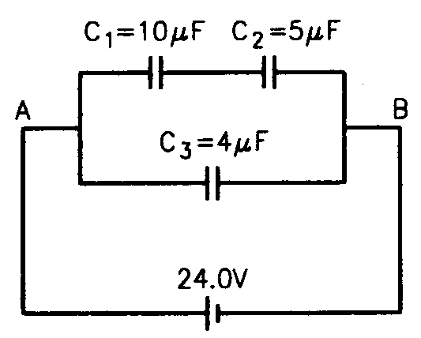
- (i) Using Gauss theorem, derive an expression for the electric field intensity at any point outside a charged spherical shell.
(ii) Find the equivalent capacitance (between points A and B) and charge on the three capacitors shown in figure.

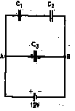
- Using Gauss theorem, derive an expression for the electric field intensity at any point due to a uniformly charged infinite plane sheet.

- Find the equivalent capacitance between points A and B and the charges on each capacitor for the circuit shown in figure. Use C₁ = 4.00 μF, C₂ = 6.00 μF, C₃ = 3.00 μF and V = 12.0 V.

Paper Submitted by:
Name: Sachin
Email :sachin07022001@yahoo.com
Phone No. 01360-252573

