Guess Paper – 2010
Class – X
Subject – Maths

Time allowed: 3 hours Max. Marks : 80

General Instructions:-
- All Questions are compulsory.

- The question paper consist thirty questions divided into 4 sections A, B, C and D. Section A comprises of ten questions of 1 mark each, Section B comprises of five questions of 2 marks each, Sections C comprises ten question of 3 marks each and Section D comprises of five questions of 6 marks each.

- All questions of Section A are to be answered in one word, one sentence or as per the exact requirement of the question.

- There is no overall choice. However, internal choice has been provided in one question of 2 marks each, three questions of 3 marks each and two questions of 6 marks each. You have to attempt only one of the alternatives in all such questions.

- In question on construction, drawing should be neat and exactly as per given measurements.
- Use of calculators is not permitted.

SECTION – A
1 For what value of k the quadratic equation x² - kx + 4 = 0 has equal roots.
2 Cards each marked with one of the numbers 2, 3, 4,……20 are place in a box and mixed thoroughly. One card is drawn at random from the box. What is the probability of getting an even prime number?

3 If tan θ = 1, find the value of sec θ + cosec θ
4 Find the LCM of 6, 72 and 120/
5 If the product of zeroes of the quadratic polynomial Pix) = (k – 2)x² -4x + k is 3, find k.
6 Which term of the AP: 21, 18, 13,………. is – 81?
7 ABC is an equilateral triangle of side ‘2a’. Find its altitudes.
8 In fig. PA is a tangent from an external point P to a circle with centre O. If ∠ POB = 115º then find ∠ APO.
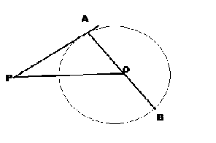
9 If the perimeter and the area of circle are numerically equal, then what is its radius?
10 Write the lower limit of the median class in the following frequency distribution:
Classes | 0 – 50 | 50 – 100 | 100 – 150 | 150 – 200 | 200 – 250 | 250 – 300
Frequency | 9 | 8 | 5 | 12 | 7 | 9
SECTION – B
11 A box contains 110 discs which are numbered from 1 to 110. If one disc is drawn at random from the box, find the probability it is bears
(i) a two – digit number (ii) a perfect square.
12 Find the value of cos 45º geometrically.
OR
If A and B are angles of a right angled triangle ABC, right angled at C, Prove that
sin² A + sin² B = 1

13 What real number should be subtracted from the polynomial 3x³ + 10x² - 14x + 9 so that polynomial 3x – 2 divide it exactly?
14 Prove that the tangents drawn at the ends of a diameter of a circle are parallel.
15 If A and B are (-2, - 2) and (2, - 4) respectively, find the coordinates of P such that AP = 3 AB and P lies on the line segment AB. 7
SECTION – C
16 If Q (0, 1) is equidistant from P ( 5, - 3) and R (x, 6), find the value of x. Also, find distance QR and PR.
17 Draw a pair of tangents to a circle of radius 5 cm which are inclined to each other at an angle of 60º.
18 Prove that the sum of the squares of the sides of a rhombus is equal to the sum of the square of its diagonals.

19 “A Median of a triangle divides it into two triangles of equal areas”. Verify the result of ΔABC whose vertices are A (5, 2), B(4, - 6) and C (3, - 2).
OR
The line joining of the points (2, 1) and (5, - 8) is trisected at the points P and Q. If point P lies on the line 2x – y + k = 0, find the value of k.

20 Prove: cos θ – sin θ + 1 = cosec θ + cot θ
cos θ + sin θ – 1

21 In fig, two circular flower beds have been shown on two sides of square lawn ABCD of side 56 cm. If the centre of each circular flower bed is the point of intersection O of the diagonals of the square lawn, find the sum of the area of the lawn and the flower beds.
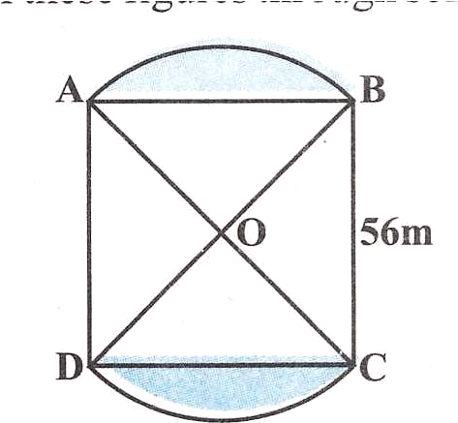
22 Solve for x: 1 + 1 + 1 = 1
a b x a + b + x
OR
If (-5) is the root of the quadratic equation 2x² + px – 15 and the quadratic equation p(x² + x ) + k = 0 has equal roots, then find the value of p and k.

23 Solve the following equations graphically:
3x + 2y – 11 = 0 and 2x - 3y + 10 = 0
Shade the region bonded by these lines and x – axis.

24 Show that any positive odd integer is of the form 4q + 1 or 4q + 3 where q is positive integer.
OR
Show that √3 is irrational number, with the help of this show that 2 - 3√3 also irrational number.
25 In an AP: an = 4, d = 2, Sn = - 14, find n and a.
SECTION – D
26 A boat goes 30 km upstream and 44 km downstream in 10 hors. In 13 hours, it can go 40 km upstream and 55 km downstream. Determine the speed of the stream and that of the boat in still water.
OR
In the flight of 3000 km, an aircraft was slowed due to bad whether. Its average speed for the trip was reduced by 100 km/hr and consequently time of flight increased by one hour. Find the original duration of flight.

27 Prove in a triangle, if the square on one side is equal to sum of the squares on other two sides, the angle opposite to the first side is a right angle.
ABC is an isosceles triangle with AC = BC. If AB² = 2AC², prove that ABC is a right triangle.

28 A pole 5 m high is fixed on the top of a tower. The angle of elevation of the top of the pole observed from a point A on the ground is 60º and the angle of depression of point A from the top of the tower is 45º. Find the height of the tower and distance between foot of the tower and point A. (Use √ 3 = 1.732)
OR
An aeroplane flying horizontally at a height of 2,100 m above the ground is observed at an elevation of 60◦ and after 10 seconds, the elevation is observed to be 30◦. Find the speed of the aeroplane in km/hr.

29 A bucket made up a metal sheet is in the form of frustum of a cone of height 16 cm with diameter of its lower and upper ends as 16 cm and 40 cm. Find the volume of the bucket in liters. Also, find the cost of the bucket if the cost of metal sheet used is Rs. 25 per 100 cm². (use ∏= 3.14)

30 The lengths of 40 leaves of a plant are measure correct to the nearest mm, and the data obtained is represnted in the following table:

Length (mm) | 118 – 126 | 127 – 135 | 136 – 144 | 145 – 153 | 154 – 162 | 163 – 171 | 172 – 180
No. of leaves | 3 | 5 | 9 | 12 | 5 | 4 | 2
Find Mean, Median and Mode.

Paper Submitted by: Trilochan Wadhwa
Email : wadhwadost@indiatimes.com
Ph No.: 25176448

