Sample Paper – 2010
Class – XII
Subject – Chemistry

PREBOARD
BLUE PRINT
S.NO | CHAPTERS | V.S.A(1) | S.A.(2) | S.A.(3) | L.A.(5) | TOTAL
1 | SOLID STATE | 1X(1) | NIL | 1X(3) | NIL | 4
2 | SOLUTIONS | NIL | 1X(2) | 1X(3) | NIL | 5
3 | ELECTROCHEMISTRY | NIL | 1X(2) | 1X(3) | NIL | 5
4 | CHEMICAL KINETICS | NIL | 1X(2) | 1X(3) | NIL | 5
5 | SURFACE CHEMISTRY | 1X(1) | NIL | 1X(3) | NIL | 4
6 | GENERAL PRINCIPLES | NIL | NIL | 1X(3) | NIL | 3
7 | p-BLOCK ELEMENTS | 1X(1) | 1X(2) | NIL | 1X(5) | 8
8 | d- and-f-BLOCK ELEMENTS | NIL | NIL | NIL | 1X(5) | 5
9 | COORDINATION COMPOUNDS | 1X(1) | 1X(2) | NIL | NIL | 3
10 | HALOALKANES AND HALOARENES | 1X(1) | NIL | 1X(3) | NIL | 4
11 | ALCOHOLS,PHENOLS AND ETHERS | NIL | 2X(2) | NIL | NIL | 4
12 | ALDEHYDES, KETONES AND CARBOXYLIC ACIDS | 1X(1) | NIL | NIL | 1X(5) | 6
13 | ORGANIC COMPOUNDS CONTAINING NITROGEN | 1X(1) | NIL | 1X(3) | NIL | 4
14 | BIOMOLECULES | NIL | 2X(2) | NIL | NIL | 4
15 | POLYMERS | 1X(1) | 1X(2) | NIL | NIL | 3
16 | CHEMISTRY IN DAILY LIFE | NIL | NIL | 1X(3) | NIL | 3
 |  | 8 | 20 | 27 | 15

Time: 3 hrs. .
General instructions:
All questions are compulsory.
Marks for each question are indicated against it.
Questions number 1to 8 are very short –answer questions, carrying 1 mark each. Answer these in one word or about one sentence each.
Questions number9 to18 are short –answer questions, carrying 2 marks each. Answer these in about 30 words each.
Questions number19 to27 are short –answer questions, carrying 3 marks each. Answer these in about 40 words each.
Questions number28 to30 are long-answer questions of 5 marks each. Answer these in about 70 words each.
Use log tables, if necessary. Use of calculators is not permitted.

QUESTIONS:

1 Which form of silicon is used to convert sunlight into electricity? (1)
2 What is the sign of ΔS for adsorption process? (1)
3 Why nitrogen is restricted to a maximum covalency of 4, though it has 5 valence electrons? (1)
4 What are Homoleptic complexes? Give example.(1)
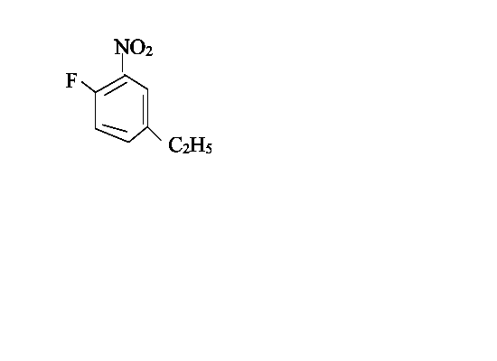
5 Write IUPAC name of the following compound:

6 Write one method which is used to purify carbonyl compounds. (1)
7 What are mixed amines? Give one example. (1)
8 Write the names of the monomers of Glyptal. (1)
9 What is osmosis? Can this process be reversed? What are the conditions required? (2)
10. What is limiting molar conductivity? What are 1-1, 2-1, 2-2 electrolytes? (2)
11 Write a short note on collision theory of chemical reactions. (2)
12. Can PCl₅ acts as oxidizing agent? Justify your answer by giving reactions. (2)
13 What is spectrochemical series? Does it gives any idea about Δ₀ in CFT? (2)
14Carry out the following conversions:
- Phenol to 4-nitroanisole
- Benzene to benzoquinone (2)
15 Which vitamin is called as Riboflavin? What are its sources? What is the disease caused by the deficiency of this vitamin? (2)
16 What are reducing and non-reducing sugars? Give examples (2)
17 An organic compound (A) with molecular formula C₃H₆O is not readily oxidized. It gives on reduction C₃H₈O (B) which on reaction with HBr gives a bromide (C). Grignard reagent obtained from (C) reacts with (A) to give C₆H₁₄O (D). Identify the compounds from (A) to (D). (2)
18 What are homopolymers and copolymers? Can homopolymers be of addition as well as condensation type? Give some examples to justify your answers. (2)
19 Calculate the packing efficiency of Body centered cubic cell. (3)
20 Calculate the depression in the freezing point of water when 10 g of CH₃CH₂CHClCOOH is added to 250 g of water. Ka = 1.4 x 10⁻³ K_{f} = 1.86 K kg mol⁻¹. (3)
21 Explain how rusting of iron can be envisaged as setting up of an electrochemical cell? (3)
22 The time required for 10% completion of a first order reaction at 298K is equal to that required for its 25% completion at 308K. If the value of A is 4X10¹⁰s⁻¹, calculate the K at 318 K and Ea. (3)

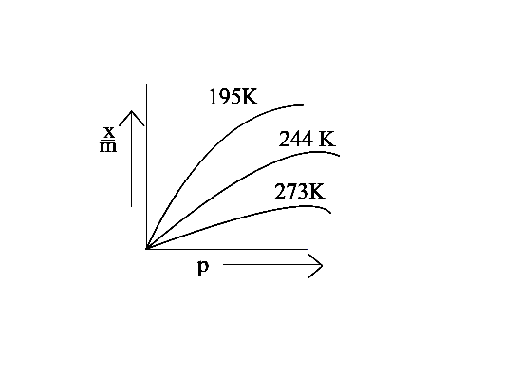
23 Observe the graph carefully and answer the following questions:
- What is the name given to the graph?
- What is x/m?
- At which temperature adsorption is maximum?
- At which temperature adsorption is minimum?
- What is the effect of pressure on adsorption?
- Why adsorption achieves saturation at high pressure? (3)
24 Observe the given graph carefully and answer the following questions:
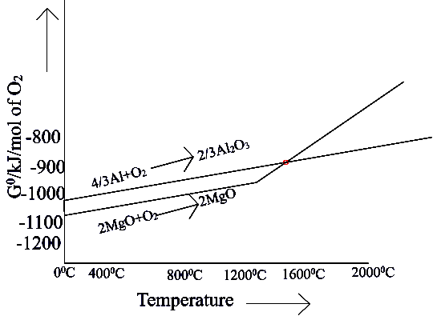

- What is the sign of ΔG⁰ when Mg reduces Al₂O₃? What does it indicate about the spontaneity of reaction?
- What is the sign of ΔG⁰ when Al reduces MgO? What does it indicate about the spontaneity of reaction?
- At which temperature non-spontaneous reaction becomes spontaneous?
- What is above graph called?
- What type of reactions are shown by this graph?
- What is the point called where two curves intersect? (3)
25 Write following name reactions:
(i) Wurtz synthesis (ii) Fittig reaction (iii) Wurtz-Fittig reaction (3)
26 Give reasons:
- Why are amines basic in nature?
- Ethylamine is more basic than aniline.
- Tertiary Amines are more basic than primary amines. (3)
27 What are analgesics? How are they classified? (3)
28 A white inorganic powder (A) which sublimes ,when treated with another white alkaline compound (B) gives a gas (C). Gas (C) on reaction with another gas (D) which is highly inflammable gives compound (E). Compound (E) is also obtained when compound (A) reacts with an alkali (F). Compound (F) turns milky when carbon dioxide gas is passed through it. Compound (A) gives brown ppt when treated with NaOH and another compound (X). Compound(E) gives dense white fumes with HCl. Identify (A), (B), (C), (D), (E), (F) and (X) and write the reactions involved. (5)
OR
(a)Give reasons:
- R₃P=O exist but R₃N=O does not.
- The HNH angle value is higher than HPH, HAsH, and HSbH angles.
- Nitrogen shows catenation property less than Phosphorous.
(b) Draw the structures of H₃PO₄ and XeOF₄ .
29 A green chromium compound (A) on fusion with alkali gives a yellow compound (B) which on acidification gives an orange coloured compound (C). ‘C’ on treatment with NH₄Cl gives an orange coloured product (D), which on heating decomposes to give back (A). Identify A, B, C, D. Write equations for reactions. (5)
OR
Give reasons:
(i) Cr⁺² is a strong reducing agent whereas Mn⁺²is not.
(ii) The transition metal ions such as Cu⁺¹,Ag⁺and Sc³⁺are colourless.
(iii) The enthalpies of atomization of transition metals of 3d series do not follow a regular trend throughout the series.
(iv) The radius of Fe⁺²(Z=26) is less than that of Mn⁺²(Z=25)
(v)Chemistry of actinides is much more complicated than that of lanthanoids.
30 How do you account for the following?
- Boiling points of aldehydes lie between parent alkanes and corresponding alcohols.
- Aldehydes and ketones have high dipole moments.
- NaHSO₃ is used for the purification of aldehydes and ketones.
- Iodoform is obtained by the reaction of acetone with hypoiodite but not with iodide.
- Hydrazones of aldehydes and ketones are not prepared in highly acidic medium.

OR
Q2 Identify A to E.
CH≡CH A B C D E

Paper Submitted by: Mohini Belani
Email Id: mohinibelani@yahoo.co.in
Ph No:. 07544-273314

