Chemistry
CLASS :XI
Instructions:
- Do all the questions.
- All questions are of 5 marks.
- You have to attempt 5 marks from each question .

Q1. (A) Name the metals which are associated with the following process:
  - Aluminothermy
  - Bessemer converter 1+1
Or
- Complete the following reactions:
RX + AgNO₂ → ? + ?
RCOOAg + Br₂ → ? 1+1
(B) Outline the principles of refining of metals by the following methods:
- Electrolytic Refining
- Zone Refining
- Vapour Phase Refining 1+1+1
Or
(B) Give the general formula for
- Oxides of first group
- Halides of second Group
- Hydrides of first group. 1+1+1

Q2. (A) Differentiate between
- Precision and Accuracy
- Gram Molecular Mass and Gram Atomic Mass 1+1
Or
(A) How many moles of NaOH are in there 27 mL of 0.15 M NaOH? 2
(B) Zinc and Hydrochloric acid react according to the reaction:
Zn(s) + 2 HCl → ZnCl₂ (aq) + H₂(g)
If 0.30 mol Zn is added to hydrochloric acid containing 0.52 mol HCl, how many moles of H₂ are produced? 3

Q3. (A) Give the stick, condensed and bond line formulae for C₄H₁₀O. 2
Or
(A) Discuss the stability of Carbocations. 2
Or
- Explain
  - Hyperconjugation Effect
  - Electromeric Effect 1+1
(B) Give the IUPAC names of the following compounds:
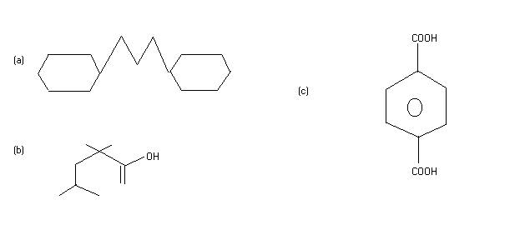 1+1+1
Or
(B) Discuss the Permutit method for removal of the hardness of water. 3
Q4. (A) What is the relationship between the members of the following pairs of structures? Are they identical, structural or geometrical, or resonance contributors?
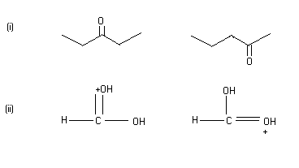 2

Or
- Give the test for the quality detection for Nitrogen and Sulphur. 2
Or
- Explain that how the quantity of Halogen is detected in the Organic Compound. 2
- Explain one of the methods to determine the molecular mass of the organic compound. (It should not be Mass Spectrometry method). 3
Or
(B)An acid of molecular mass 104 contains 34.6% carbon and 3.85% Hydrogen. Suggest a structure for the acid. 3

Q5. (A) Calculate the density of ammonia at 30⁰C and 5 bar pressure. 2
Or
(A) Differentiate between Ideal Gas and Real gas. 2
(B) Define
- Vapour Pressure
- Coefficient of Viscosity
- Surface Tension 1+1+1
Or
- Define
  - Isobars
  - Isotones
  - Isotopes 1+1+1

Q6. (A) Explain the spectrum of the Hydrogen. 2
Or
(A) Comment:
- Bohr’s Orbits are called Stationary Orbits
- Energy of electron in nth orbit of Hydrogen is negative 1+1
Or
- Explain
  - Zeeman Effect
  - Stark Effect 1+1

(B) Differentiate between Absorption Spectrum and Emission Spectrum. 3
Or
(B) Calculate the energy of one mole of photons having frequency 5 * 10¹⁴ Hz. 3

Q7. (A) Which of the following pairs of elements would you expect to have lower ionization energy?
- Cl or F
- K or Ar 2
Or
(A) Give the Isoelectronic Species of Na⁺, Cl⁻, Fe³⁺ and Cu²⁺ 2
(B) Explain the variation of any two from Atomic Radii, Ionization Enthalpy and Electron affinity along a Period and a Group. 3

Q8. (A) Derive the relation for pressure-volume work. 2 Or
  - Define:
    - State Function
    - State Variables 1+1
Or
- Explain just the outline principle of Bomb Calorimeter. 2
- The enthalpy change for the reaction,
N₂ + 3 H₂ → 2NH₃ is -92.2 KJ. Calculate the enthalpy of formation of ammonia. 3
Or
(B) Balance the following equation in the acidic medium:
MnO₄⁻ + Fe²⁺ → Mn²⁺ + Fe³⁺ 3

Q9. (A) Differentiate between sigma and Pi bonds. 2
Or
(A) Discuss hybridization in BF₃ and SF₆. 2
(B) Explain the postulates of VSEPR theory. 3
Or
(B) Explain Born- Haber Cycle for lattice enthalpies. 3
Or
(B) The solubility product of silver bromide is 3.3 * 10⁻¹³. Calculate its Solubility. 3

Q10. (A) Name four major Green House gases. 2
Or
- Define
  - Vinylic Halides
  - Allylic Halides 1+1
Or
(A) Explain E-Z system of nomenclature for Geometrical Isomers. 2
Or
- Explain Borax Bead Test give the uses of Boron. 2
- Compare all the three allotropes of Carbon. 3
Or
(B) Explain Down’s Cell for the extraction of Sodium. 3
Or

(B) Explain:
- Homolytic Fission and Heterolytic Fission
- Difference between Cetane Number and Octane Number 3
Or
(B) Explain( Any Three)
Sandmeyer Reaction
Gattermann Koch Reaction
Wurtz Reaction
Markownikoff’s Rule
Saytzeff’s Rule
Hoffmann Ammonolysis Reaction 1+1+1

