Sample Paper – 2010
Class – XII
Subject – Informatics Practices

Sub : I.P Marks : 70
Time : 3 hours
________________________________________________________________________
Note: This Question paper is divided into 3 sections.
Section A consists of 30 marks
Section B and Section C consists of 20 marks each.
Answer the questions after carefully reading the text.
________________________________________________________________________

SECTION – A
I. Answer the following questions :
a. Explain the terms front end and back end technology with one example each. 2m.
b.Name the essential components of SDLC .explain any two in brief. 4m
c. what do you understand by term Many to One relationship. 2m
d. expand the terms ER , UML 2m
II. Answer the following questions :
a.How do you specify comments in Visual Basic.how do you break a long line of code to a new line. 2m
b.Differentiate between if then and if-then- else conditional statements in VB with examples. 2m
c.What are built in Functions? What are different types of built in functions of VB 2m
d. Differentiate using a suitable example between msgbox() and input box( ) 4m

III. Answer the following questions :
a.how do you restrict duplicate rows in SQL query ? 2m
b. what is the classification of sql statements 2m
c.what is the default option of Create Table command 2m
d. whats is the use of INNSTEAD OF TRIGGER . give example. 4m

SECTION B

4.Read the following case study and answer the questions that follow :
ABC public school arranges a special demo class for class 2 students demonstrating geometrical
Shapes. They make an application using visual basic shape control tool . initially they designed the basic
Application as shown below.
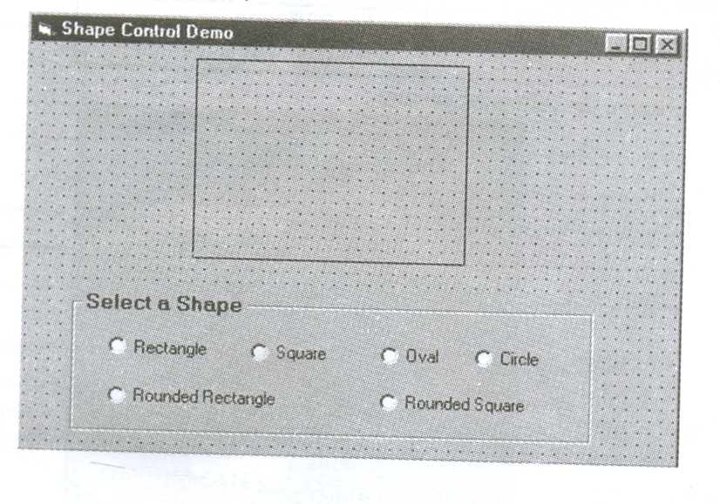

Object type object name description
Form frmshape main form object.
Shape spshape shape control object
Frame frame1 frame control object

a. write a form_load event to set the square object as default object 2m
b. write a procedure for option 1 button to display a rectangle object 2m
c. write a procedure for option 5 button to display a rounded rectangle object 2m
d. write a procedure for option 6 button to display a rounded square object. 2m
e. write a procedure for option 4 button to display a circle object. 2m

5. Answer the following Questions :
a. Find the output for the following code (2m)
Private sub cmddisplay_click( )
dim counter as integer
counter =1
while counter <=20
print IIF(counter mod 3, “###”,”* * * * * *”)
counter = counter +2
Wend
End sub
b. Rewrite the following code segment using for next loop using while wend loop(2m)

x= 1
for j=- 0 to 50 step 2
if (j mod2) = 0 then
print x
else
print x-3
end if
next j

- Write VB application using option buttons to print the following pattern. 4m
AAAAAAA
BBBBBB
CCCCC
DDDD
EEE
FF
G
- change the following code using Do while without effecting the output : 2m
dim arr(5)
counter =1
do until counter > 5
arr(counter) = counter * counter
if counter = 2 then
print arr(counter)
end if
counter = counter + 1
loop

Section C
6.Read the questions given below and answer accordingly.

- write the output produced by the following pl/sql code : 2m
declare
x number;
y number;
BEGIN
Y:=10;
For X in 1…4
Loop
If mod(x,2) = 0 then
Y= y-x;
Else
Y = y+2*x;
End if;
Dbms_output.put_line(y);
End loop;
End;
- find the errors and rewrite the correct code : 2m
declare
cursor c1 is select * from employee for salary >15000;
T1 integer :=0;
Begin
For rec in c1
Loop
Dbms_output(‘no of records’ || to_char(c1%countrows));
T1 := t1 + rec.salary;
Loop end
DBMS_output.put(‘total = ‘|| T);
End
c. differentiate between disabling and dropping trigger with example. 2m
d. write a pl/sql function chck_year that accepts date from the user and return 1 if the year is a leap year
and returns 0 otherwise. 4m

7.Answer the question based on Metro table given below :
Table : Metro
Column name data type size constraint description
Mt_no number 4 PK Metro number
Mt_origin varchar2 15 NN origin station
Mt_dest varchar2 15 NN destination station
Mt_KM number 3 check (>10) total kms from origin to destination
Mt_time number 4,2 DEFAULT 11.00 time of the metro to start from origin st.
Mt_Cap number 3 no of seats in metro.

a. write the sql command to display the different destinations without repetition. 2m
b. write the sql command to display number of metros starting from each Mt_origin 2m
c. write the plsql code to create a stored procedure time to display the details of all the metros which
start at a particular time of the day which is entered by the user. The time should be accepted as a
parameter. 4m

d. create the above table Metro with constraints as shown above. 2m.

Paper Submitted By : Venu
Email Id : venu_cdff@yahoo.com
Ph No. : 9989720820

