Sample Paper – 2010
Class – X
Subject – INFORMATION TECHNOLOGY

_____________________________________________________________________
Time: 2.5 hrs. Max. Marks: 40
______________________________________________________________________
Q1. Answer the following questions:
- Define Database Management System. Write one example. 1
- What happens when you enter numbers in a Text data type field? 1
- Write one example of data field for which you would required property to yes. 1
- Which property should be set if it is required that “Delhi” is automatically entered in the City field when a new record is created? 1
- When is Memo data type preferred over Text data type for a field? 2
- A table named School (containing data of students of the whole school) is created where each record consist of several fields including Admission no.(Admission Number), Roll no (Roll Number) and Name. Which field out of these three should be set as Primary Key and why? 2
- What is the relationship between Validation Rule and Validation Text properties? Show with example.
2
Q2. Answer the following questions:
- Expand the following acronyms: (i) WWW (ii) HTTP 1
- What is the role of Internet Service Provider? 1
- What are Newsgroups? 1
- Write the web extensions( top level domain names) given to websites of the following types of organizations: (i) Educational (ii) Government 1
- Write one advantage and one limitation of E-Mail over traditional mail. 1
- Name the two main parts of E-Mail address with the help of one example. 1
- What is Protocol? Name any one protocol used on internet. 2
- How is the Refresh/Reload option different from stop option in a Web Browser? 2

Q3. Answer the following questions:
- What is Hyperlink? 1
- List any two types of alignment that can be applied on a paragraph in HTML. 1
- What does <BODY> tag in HTML contain? 1
- List any one attribute of <HR> tag. 1
- Write the use of the following tags with example: 2
    - <LI>
    - <A>
    - <SUP>
    - <VLINK>
- Where can a comment are placed in an HTML document? How is it useful? 2
- Which tag and attributes are used to jump to 2
    - A new Page
    - Another location in the same page
- Identify error(s) in the following HTML code. Also write the correct code. 2
<OL>type= “a” start. “d”>

Q4. Write the complete HTML code to generate a page in the format and style below?
Special Notes: 8
- Title of the Page is “Hurricanes Hunters”.
- The Headings “HURRICANES” and “HURRICANES EXPLORERS” are center aligned and with levels 1 and 2 respectively.
- Background color is “Light Blue” and Text Color is “Dark Blue”.
- Use “TREBUCHET” for text font. Size of text is 5.
- Use Horizontal Ruler wherever required.
- Image used is from the file “aeroplane.jpg”
- Link color of page is Magenta; Visited link is displayed in Green and Active link in Red.
- The pages are linked as follows:
Home as home.html
Katrina as Katrina.html
Hurricanes in the Past as old.html
Faq about Hurricanes as faqs.html
Note: You can use any other attributes that are not otherwise mentioned above to
produce a similar output.
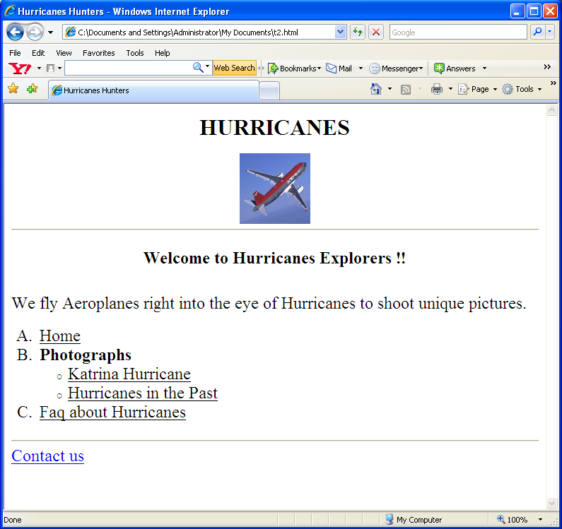

Paper Submitted by: Amit
Email : av55427@gmail.com
Ph No.: 9896462367

