Guess Paper – 2010
Class – IX
Subject – Maths

- State true or false:
  - There are infinitely many natural numbers between 1 and 2.
  - The difference between any two consecutive natural numbers is one.
  - The sum of two irrational numbers is always irrational.
  - All prime numbers are odd numbers.
  - All decimal numbers with non terminating decimal parts are irrational
numbers.

- Insert 3 rational numbers between 4 and 5.

- Insert 4 rational numbers between $\frac{2}{5}$and $\frac{3}{5}$.
- Express 3 & -2 in the form of $\frac{p}{q}$, where p and q are integers and q0.
- Give two irrational numbers whose difference is (i) rational (ii) irrational.

- Locate the points representing $\sqrt{2}$+1 and $\sqrt{2}$-1 on the number line.

- Classify the following rational number into numbers with
  - Terminating decimal expansion
  - Non-terminating decimal expansion.
    - $\frac{1}{4}$
    - $$\frac{1}{3}$$
    - $$\frac{3}{5}$$
    - $$\frac{3}{7}$$

- Write two numbers whose decimal expansion are non-terminating and non-repeating.

- Convert the following decimal numbers into rational number in the form $\frac{p}{q}$:

  - 0.008
  - 1.205
  - 0.001
  - 3.2125

- Convert the following decimal numbers into rational numbers in the form $\frac{p}{q}$:
  - $$\overline{0\text{.}\text{312}}$$
  - $$\overline{0\text{.}\text{092}}$$
  - $$\overline{0\text{.}\text{12345}}$$
  - 0.4
  - $$2\text{.}\text{21}\overline{\text{347}}$$

- Find the sum of $\left(3+4\sqrt{3}+5\sqrt{2}\right)$.

- Simplify:
  - $$\left(5\sqrt{2}+7\sqrt{3}\right)−\left(3\sqrt{2}+2\sqrt{3}\right)$$
  - $$\left(5\sqrt{2}×2\sqrt{\text{10}}×5\sqrt{\text{15}}\right)$$
  - $$\left(5\sqrt{3}×7\sqrt{3}×2\sqrt{2}×3\sqrt{2}\right)$$
  - $$\frac{6\sqrt{3}}{2\sqrt{3}}$$

- Find the simplest rationalizing factors of the following irrationals:
  - $$\sqrt{8}$$
  - $$3\sqrt{\text{18}}$$
  - $$5\sqrt{\text{12}}$$
  - $$7\sqrt{7}$$

- Rationalize the denominators of the following:
  - $$\frac{1}{\sqrt{3}}$$
  - $$\frac{2}{\sqrt{3}−\sqrt{2}}$$
  - $$\frac{1}{\sqrt{3}−1}$$

- If a=$3\sqrt{\text{12}}+2\sqrt{\text{18}}$ and b=$\sqrt{2}+\sqrt{3}$, find the value of
    - a+b
    - a-b
    - 2a+3b
    - 5a-4b

- Rationalize the denominators:
  - $$\frac{5\sqrt{3}}{\sqrt{\text{10}}−\sqrt{3}}$$
  - $$\frac{3\sqrt{2}}{\sqrt{6}−\sqrt{2}}$$
- Evaluate:
  - $4^{−5}×4^{8}×4^{7}$
  - $$5^{7}×5^{3}÷5^{−2}$$
  - $${\left(3^{2}\right)}^{3}×{\left(3^{−2}\right)}^{2}$$
  - $${\left(\frac{\text{56}}{\text{28}}\right)}^{0}×\frac{1}{1}×{\left(\frac{2}{5}\right)}^{2}×\frac{9}{\text{16}}$$

- Find the point representing $\sqrt{\text{35}}$on the number line geometrically.

- In the figure, PQ =12, QS = 6 and PR is the diameter of the semicircle. Find PR.
S
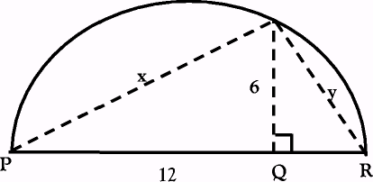

- In the figure, 'O' is the origin of the number line ' l'. AB = 1 unit and AB l. The semi circle with centre origin and radius OB intersects the line at ‘C' and 'D'. Find the numbers represented by ‘C' and 'D'.
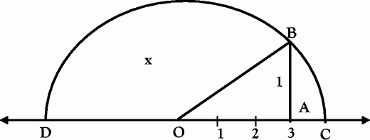

Paper Submitted by: Mohan
Email : basnetenator@gmail.com
Ph No. : 97189069757

