Sample Paper – 2010
Class – IX
Subject – Maths

TIME:3 Hrs M.M.-80

General Instructions
- QNO.1 to QNO.12 are MCQ type [QNO.1-8 carry 1 mark each and 9-12 carry 2 mark each]
- QNO.13 to Q19 carry 2 marks each
- QNO.20 to Q29 carry 3 marks each
- QNO.30 to Q34 carry 5 marks each

(SECTION A)

Q1.A Rational Number inserted between two rational number R and S is given by –
a) R b) R+S
S 2
c) R-2 d) None of these
2

Q2.Let p(x) be a polynomial, if p(a)=0 , then x=a is called:
(a) Power of the polynomial (b) Degree of the polynomial
(c) Zero of the polynomial (d) Coefficient of the polynomial

Q3.Angles forming a linear pair can be
(a) Both acute angles (b) Both obtuse angles
(c) Either acute angles or obtuse angles
(d) One acute angles or obtuse angles

Q4.In a Right ABC ,right angled at A
(a) AB is the longest side (b) BC is the longest side
(c) AC is the longest side (d) BC is the shortest side

Q5.If E,F,G and H are respectively the mid points of the parallelogram ABCD,then area(EFGH) is equal to
(a)Ar(ABCD) (b) 2×Ar(ABCD)
(c)1 Ar(ABCD) (d)None of these
2

Q6.The number of circle(s) passing through three Non-collinear points is
(a) One (b)Two (c)Three (d)None of these

Q7.Total surface area of hollow cylinder is
(a) 2π(R+r)(R-r)h
(b) 2π(R-r)(R+r-h)
(c) 2π(R+r)(h+R-r)
(d) 2π(R+r)(h+R+r)

Q8.The arithmetic mean of first of first ten odd natural number is
(a)9 (b)10 (c)11 (d)12

Q9.If x² +y²+z² =50 and xy+yz+zx=7 ,then x+y+z is equal to
- + 7 (b)+ 8 (c) 36 (d)49

Q10.In fig., XY is a line parallel to side BC of ABC, BE ⎜⎜AC and CF⎜⎜AB meet XY in E and F respectively .Also EX=FY, then Ar( ABE) is equal to
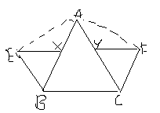
(a) Ar (ABC)
(b) Ar (ACF)
(c) Ar ( XEB) +Ar (YFC)
(d) None of these

Q11.In a parallelogram ABCD ,AB=12cm .The altitudes corresponding to the sides AB and AD are respectively 8cm and 6cm , then AD is equal to
(a)6cm (b)12cm (c)16cm (d)15cm

Q12.The volume of a right circular cone is 100π cm³ and its height is 12cm.
Then its curved surface area is
(a)62π cm² (b)64π cm² (c)65π cm² (d)67π cm²

(SECTION-B)

Q13.Express the following in the form of p 15.712
q

Q14.In fig. If BA⎜⎜DF, AD⎜⎜FG, BAC=65⁰ and ACB=55⁰ ,then find FGH
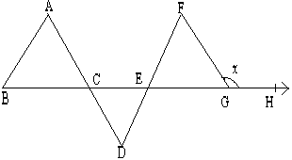

Q15.Sides AB and AC are extended to points P and Q respectively such that BP=CQ.If PBC=115⁰ and QCB =120⁰ ,show that AQ>AP
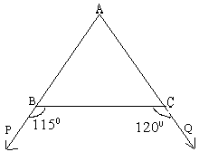

Q16.In given fig., shows a cyclic quadrilateral ABCD with QB as diameter of circle. If ADC=140⁰ ,find BAC
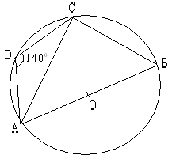
Q17.If two equal chords of a circle within the circle, Prove that the line joining the point of intersection to the centre makes equal angles with the centre.

Q18.The radius and slant height of a cone are in the ratio 3:5.If its curved surface area is 135 π cm², find its radius?

Q19.The median of following observations arranged in ascending order is 24.Find the value of x if the observations are:
14, 18, x+2, x+4, 30, 34

(SECTION C)

Q20.Locate number on the number line

Q21.Find the remainder when 3x⁴+2x³-1x²-1x+2 is divided by x+2
3 9 27 3

Q22.In fig. show that AB⎜⎜EF
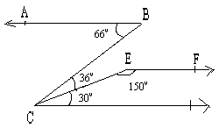

Q23.In fig. ACCF and BDDE. If CF=DE and AE=BF, prove that AC=BD.If AC=BD, which congruence rule can be applied?
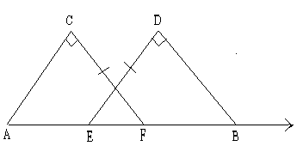
Q24.Show that all the line segments drawn from a given point to a line not on it, the perpendicular line segment is the shortest.

Q25.In fig. ABC, AD is median .O is the mid point of AD. When CO is produced, meet AB at P .Prove that AB=3AP
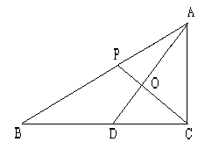

Q26.In fig.Ar ( DRC) =Ar ( DPC) and Ar ( BDP) =Ar ( ARC).Show that both the quadrilaterals ABCD and DCPR are trapeziums.
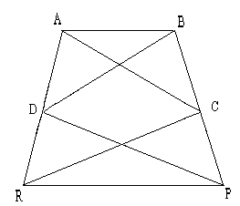

Q27.Prove that an isosceles trapezium is always cyclic.

Q28.The following table shows the marks obtained (out of 30) by 20 students in a unit test.Find the Mean marks

Marks obtained : | 7 | 9 | 14 | 21 | 25
No. of students: | 5 | 2 | 6 | 3 | 4

Q29.A Green house has dimensions 6m×4.5m×4m.It is made entirely of a glass panes (including base) held together with tape. Find
- Area of the glass used
- Length of tape required.
- Cost of glass used at the rate of Rs45 per m²
- Cost of tape used as the rate of Rs.3.50

(SECTION D)

Q30. The angle subtended by an arc at the centre is double the angle subtended by it any point on the remaining part of the circle. Prove it
By using the above theorem calculate the measure of AOC
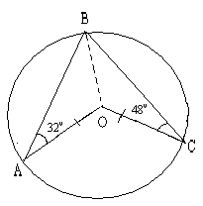

Q31.The following table gives the life times (in hrs) of 400 neon lamps

Life time | 300-400 | 400-500 | 500-600 | 600-700 | 700-800 | 800-900 | 900-1000
No. of lamps | 14 | 56 | 60 | 86 | 74 | 62 | 48

- Represent the given information with the heep of histogram
- How many lamps have a life time of more than 700hrs

Q32.ABCD is a rhombus and P, Q, R, S are the mid points of sides AB,BC,CD and DA respectively. Show that quadrilateral PQRS is a rectangle.

Q33.One hundred and twenty five solid iron spheres ,each of radius r and surface area S are melted to form a solid sphere with surface area S/ .Find the : a)Radius r/ of new sphere b)Ratio S and S/

Q34. Verif y that x3 +y3 +z3 -3xyz= ½ (x+y+z) [(x-y)2+(y-z)2 +(z-x)2] and hence find the value of (27)3 +(-14)3 +(-13)3 .

Paper Submitted by: Manoj Gupta
Email : manojgupta098@gmail.com
Ph No. : 9896084098
Sant Nischal Singh Public School Yamuna Nagar

