Sample Paper – 2010
Class – XII
Subject – Multimedia And Web Technology (067)

Time allowed : 3 hours Maximum Marks: 70
- Candidates must write the Code on the title page of the answer-book.
- Please check that this question paper contains 4 printed pages.
- Code number given on the right hand side of the question paper should be written on the title page of the answer-book by the candidate.
- Please check that this question paper contains 7 questions.
Please write down the serial number of the question before attempting it
_____________________________________________________________________________________
1.
- Differentiate between HEAD and TITLE tag. Give example. 1
- What is the method of using comment line in a HTML code ? 1
- What is the difference between an explicit and implicit tag ? 1
- Differentiate between <OL> and <UL>tag.Give example. 1
- Explain with example ROWSPAN and COLSPAN. 1.5
- How HREF (link to object) different from NAME (link from object) . Give example 1.5
- What is the use of IMG TAG ? Name all the attributes of IMG TAG . 2
- What is the difference between <P> and <BR> tag? 1

2 . Question given below are based on HTML:
Write the HTML code to generate a Web Page in the format given below :
Consider the following while writing the HTML code :
1. Background colour of the page should be “Yellow”, text colour should be blue and visited link colour
should be “Green”. 1
2. Title of the page is “Radio India”. 1
3. Text colour of main heading on the page should be “Maroon”. 1
4. Font face of text in the page should be “Arial”. 1
5. Picture used in the page is the file “music.jpg”. 1
6. Use the concept of nested list to display the given list. 1
7. Pages linked to : 2
Film Music as “film.html”
Classical Music as “class.html”
Sports as “sports.html”
8. The table should have a caption “Listener’s Choice - Top 5", a border of 2 pixels and the background colour of the first row should be “Aqua”. 2

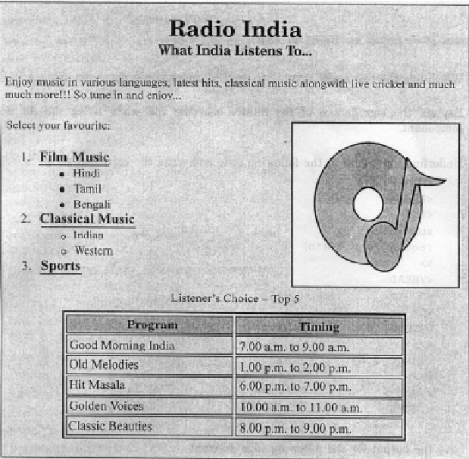
3.
- What is FRAMESET ? 1
- Write HTML code to generate two frame in the format shown below . 2*2

home.html | Announcement .html
production.html
Contect.html
Contect.html | News.html | links.html
Aboutus.html | News.html | links.html

c) Define <TEXTAREA> and <SELECT> with example. 2
d) write HTML code to create following form. 3
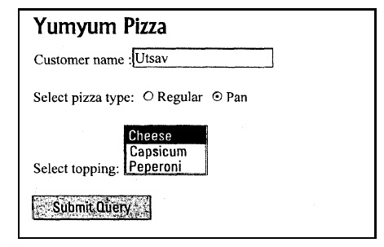
4.
- How the server side scripting is different from client side scripting. 2
- What is variant data type ? Write any two sun type. 2
- Define selection , iteration construct with example. 2
- Differentiate between Local and Global scope of a variable in VbScript. 2
- What is comment in VBScript ? Explain with an example ? 2

5. a Change the following script using Do while …….. loop without affecting the output: 2

<Script language="VBScript">
sub result()
dim i, r, rev ,k
k=1023456789
for i = 1 to 10 step 1
r=k mod 10
rev=rev*10+r
k=k\10
next
end sub
</SCRIPT>
b) Give the output for the following script code: 2
<Script Language="VBScript">
sub result()
dim feb1,feb2,feb3,i
i=1
feb1=1
feb2=2
document.write( feb1 & “<br>” & feb2)
do while i<3
feb3=feb1+feb2
document.write(feb3)
feb1=feb1+2
i=i+1
loop
end sub
</Script>

c)Rewrite the following code after correcting the errors: 2
<”script language” =vbscript>
sub result()
dim N1,N2,SUM
N1=5
N2 =10
For I=N1 upto N2 skip 2
IF N1>N2 THEN
N1+N2=SUM
NEXT
end sub
</script>

d). Create a form in HTML as given and write a VBScript code for the OK command button to calculate total marks , Percentage , Grade . Where 4
Total Marks = sum of selected five subject according to stream
Percentage = Total Marks / 5
Grade Calculate using if statements as follow

Percentage | Grade
>95 | A+
>85 | A
>75 | B+
>65 | B
<65 | Fail

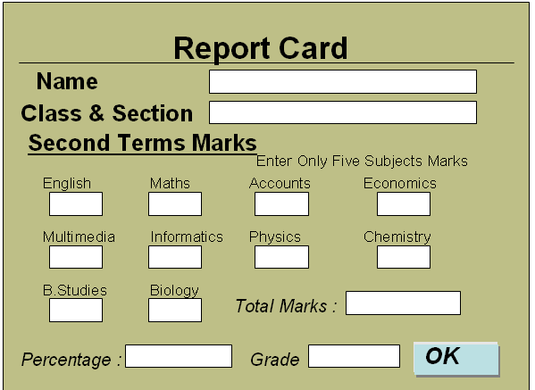
6.
- What are the five key decisions involved in creating a new image ? 2
- Expand the following 2
    - PICT ii . JPEG iii. GIF iv. BMP
- Define the following image editing tools 2
    - Blur Tool ii. Sharpen Tool iii. Smudge Tool iv. Dodge Tool
- What are Filters ? Name any two filter name. 2
- How the Rubber Stamp Tool is different from Pattern Stamp tool. 2

7.
- What is sound forge ? Write down the steps top create a new sound forge file. 2
- What is animation ? What is illusion movement ? 2
- Expand PDF . Name any five uses of PDF. 2
- What is image tracing ? What is tracing process ? 2
- What is the powerful feature of PhotoShop ? what are the primary image types and how do they differ ? 2
Paper Submitted by: Sudhir Dwivedi
Email : sudhirdwi@gmail.com
Phone No. 9873690129

