Guess Paper – 2010
Class – X
Subject – Mathematics
(Question numbers Ito 10 carry I mark each.)
- The graph of y =f(x) is shown below. Find the number of zeroes of f(x).
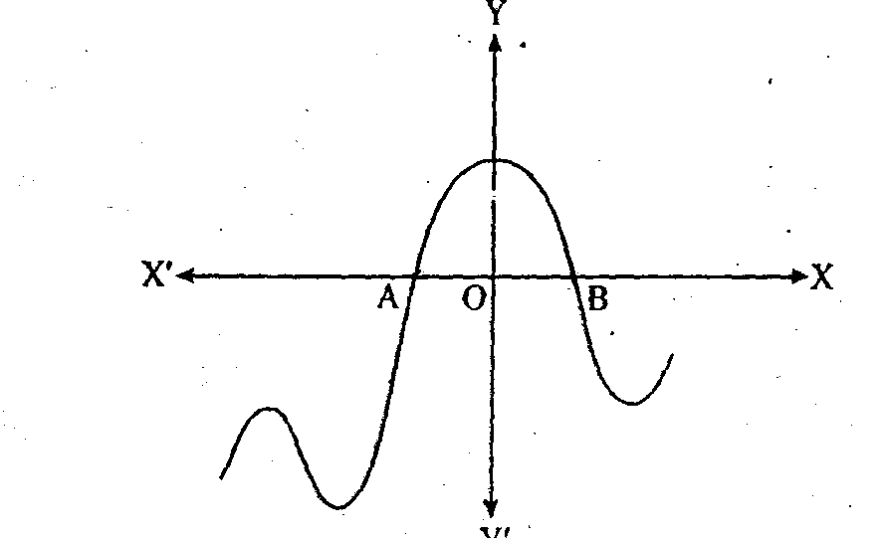
- What is the nature of roots of the quadratic equation 4x²+5x-1.
- State the Fundamental Theorem of Arithmetic.
- If the following figure is a sector of a circle of radius 21 cm. Find the perimeter of the sector.
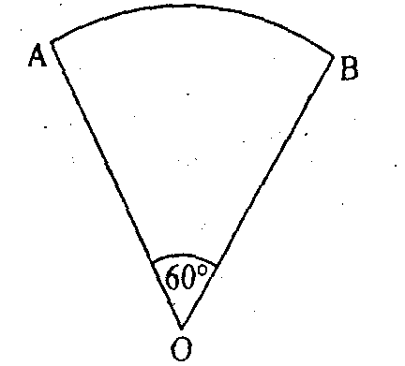
- Give an example of polynomials p(x), g(x), q(x) and r(x), which satisfies the division algorithm and degree r(x) = o.
Or
If x-2 is a factor of x³-ax²+3x-2 find a
- The length of tangent from a point A at a distance 9cm from the centre is 4n cm. What will be the radius of the circle?
- What is the distance between two parallel tangents of a circle of the radius 4.5 cm?
- A card is drawn from a well-shuffled deck of 52 playing cards. Find the probability of drawing a face card. (Jack, Queen and King).
- From a point 20√3 m away from the foot of a tower, the angle of elevation of the top of the tower is 30°. Find the height of tower.
- Write the relationship between mean, median and mode for a moderately skewed distribution.
( Section B)

Question numbers 11 to 15 carry 2 marks each.
- lfsin (A + B) = I and cos (A —B) = l,find angles A and B. Hence, evaluate
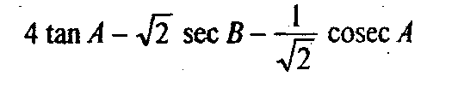
Or
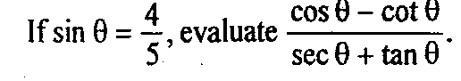
- Jf the distances of P(x, y) from A(a + b, a—b) and B(a — b, a + b) are equal ,prove that bx = ay.

- 13. A box contains 20 balls bearing numbers 1,2,3,4 20. A ball is drawn at random from
the box. What is the probability the number on the ball is (i) an odd number?
(ii) divisible by 2 or 3?
- What must be subtracted from the polynomial fx) = x⁴ + 2x³ —13x² — 12x + 21, so that the resulting polynomial is exactly divisible by x² — 4x + 3?
- In figure, PB and QA are perpendiculars to segment AB. If PO = 5 cm, QO = 7cm and area (APOB) = 150 cm², find the area (AQOA).
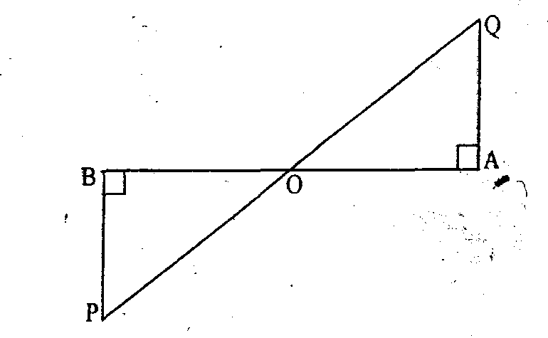
( Section C)
Question numbers 16 to 25 carry 3 marks each.
- What can you say about the prime factorization of the denominator of the following rational
34.12345 (ii) 36.5678
Or
Find the HCF and LCM of 144, 180 and 192 by prime factorization method.
- Find the number of coins, 1.5 cm in diameter and 0.2 cm thick, to be melted to form a right circular cylinder of height 10 cm and diameter 4.5 cm.
- Draw a right triangle ABC in which AC= AB =4.5cm and A = 90°. Draw a triangle similar to ∆ABC
with its sides equal to (--)th of the corresponding sides of ∆ ABC.
- In ∆PQR, QM ┴ PR and PR²-PQ² =QR². Prove that QM² =PMx MR.
- Determine the ratio in which the point (—3,p) divides the line segment joining the points
(—5,— 4) and (—2, 3). Hence find the value of p.
- Evaluate:
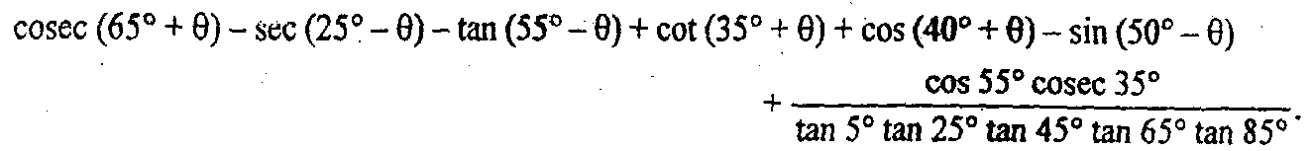
- Find graphically, the vertices of the triangle formed by the x-axis and the lines
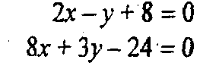
- Find the number of terms of the AP: 84, 81,78 so that their sum is 810.
Or
Derive the formula for the sum of first n terms of an AP whose first term is ‘a’ and the common difference is’d.
- .24 Students of a class are made to stand in rows. If one student is extra in a row, there would be 2 rows less. If one student is less in a row, there would be 3 more rows. Find the number of students in the class.
Or

If the roots of the equation:
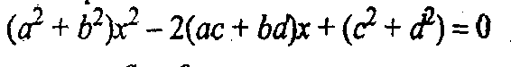
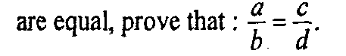
- Prove that the points A(—3, 0), B(1, —3) and C(4, 1) are the vertices of an isosceles right triangle.
(Section’D)
Question numbers 26 to 30 carry 6 marks each.
- Prove that the lengths of tangents drawn from an external point to a circle are equal.
Using the above result, prove the following:In figure, ifAB = AC, próvë that BE = EC.
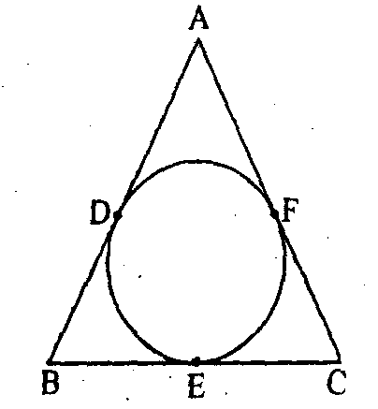
- A bucket is in the form of a frustum of a cone with a capacity of 12308.8 cm³ of water. The radii of the top and bottom circular ends are 20cm and 12cm, find the height of the bucket and the area of the metal sheet used in its making. [Use ∏ = 3.14]
Or
The decorative block shown n figure, is made of two solids ——a cube and a hemisphere. The base of the block is a cube with edge 5 cm, and the hemisphere fixed on the top has a diameter 4.2 cm. Find the total surface area of the block.
- From the top of a hill, the angles of depression of two consecutive kilometer stones due east are found to be 30° and 45°. Find the height of the hill.
Or
The angle of elevation of a jet plane from a point A on the ground is 60°. After a flight of 15 seconds, the angle of elevation changes to 30°. If the jet plane is flying at a constant height of √l500 m, find the speed of the jet plane.
- One-fourth of a herd of camels was seen in the forest. Twice the square root of the herd had gone to mountain and the remaining 15 camels were seen on the bank of a river. Find the total number of camels.
- The following distribution gives the state-wise teacher-student ratio in higher secondary schools of India. Find the mode and mean of this data.
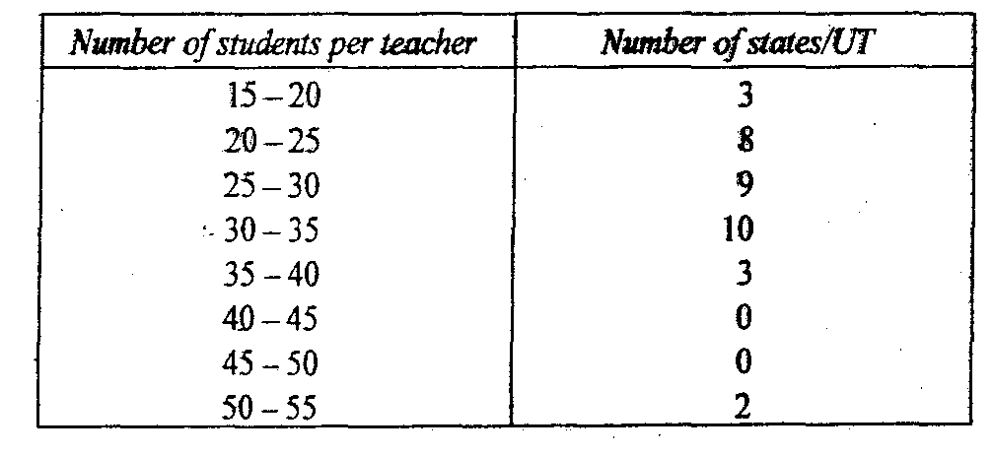

Paper Submitted By :
Name : abhijeet sengupta
Email : dev_173@india.com
Phone No. 9413563717

